 | Parts no. | Item: PRO 800,900
 | R0024 | Screw M6x15 ss
 | R0346 | Gypsy cover
 | R0121 | Sus washer 18x1.5
 | Gypsy refer to the chart below
 | A0002 | Torque Limiter(12)(24)
 | R0072 | Oil sealant
 | R0161 | Water sealant | H
 | R0023 | Screw M5x15 ss
 | R0073S | Release Arm Sus
 | R0025 | Screw m6X45 ss
 | R0015 | Tension arm holder
 | R0013S | Tension arm Sus
 | R0029 | Tension spring
 | R0066 | Housing
 | R0109 | Sticker
 | R0074-2 | Main drive shaft
 | R0075 | Ball bearing
 | R0086 | S Clip Φ18
 | R0104 | Clutch spring | F
 | R0076 | Chutch | F
 | R0095-I | 6x15Key
 | R0077 | Gear spring
 | R0078 | Gear #4
 | R0117 | washer
 | R0085 | Gear cover
 | R0003 | Bush bearing
 | R0017-5 | Water sealant
 | R0113 | Screw M6x30
 | R0150 | Washer
 | R0083 | Shaft #3
 | R0099 | Bush
 | R0098 | Washer
 | R0079 | Gear #3
 | R0020 | M5x15
 | A0019 | Clutch Solenoid Set | F
 | R0065 | Screw M3x4 | F
 | A0017 | Connector | F
 | R0111 | Screw M4x20
 | R0115 | Washer
 | R0084 | Shaft #2
 | R0100-8.5 | Bush
 | R0149 | Washer
 | R0080 | Gear #2
 | R0100-3.5 | Bush
 | R0081 | Gear #2-1 | E
 | R0404 | E/B hub
 | R0126 | H700Motor | 8
 | R0006 | Motor front Bracket
 | R0019 | Screw M5x10
 | R0153 | Screw M3x15
 | A0010H | Electric Brake
 | R0125 | Tunnel Socket_M
 | R0124 | Tunnel Socket_P
 | R0130-3 | 900Motor | 9
 | R0125 | H700 motor socket | 8
 | R0090-2 | Motor tie
 | R0110 | Screw M5x8
 | R0097 | Buttom cover
 | R0021 | Screw M3x6 ss
63 | A0024 | Free Fall Switch

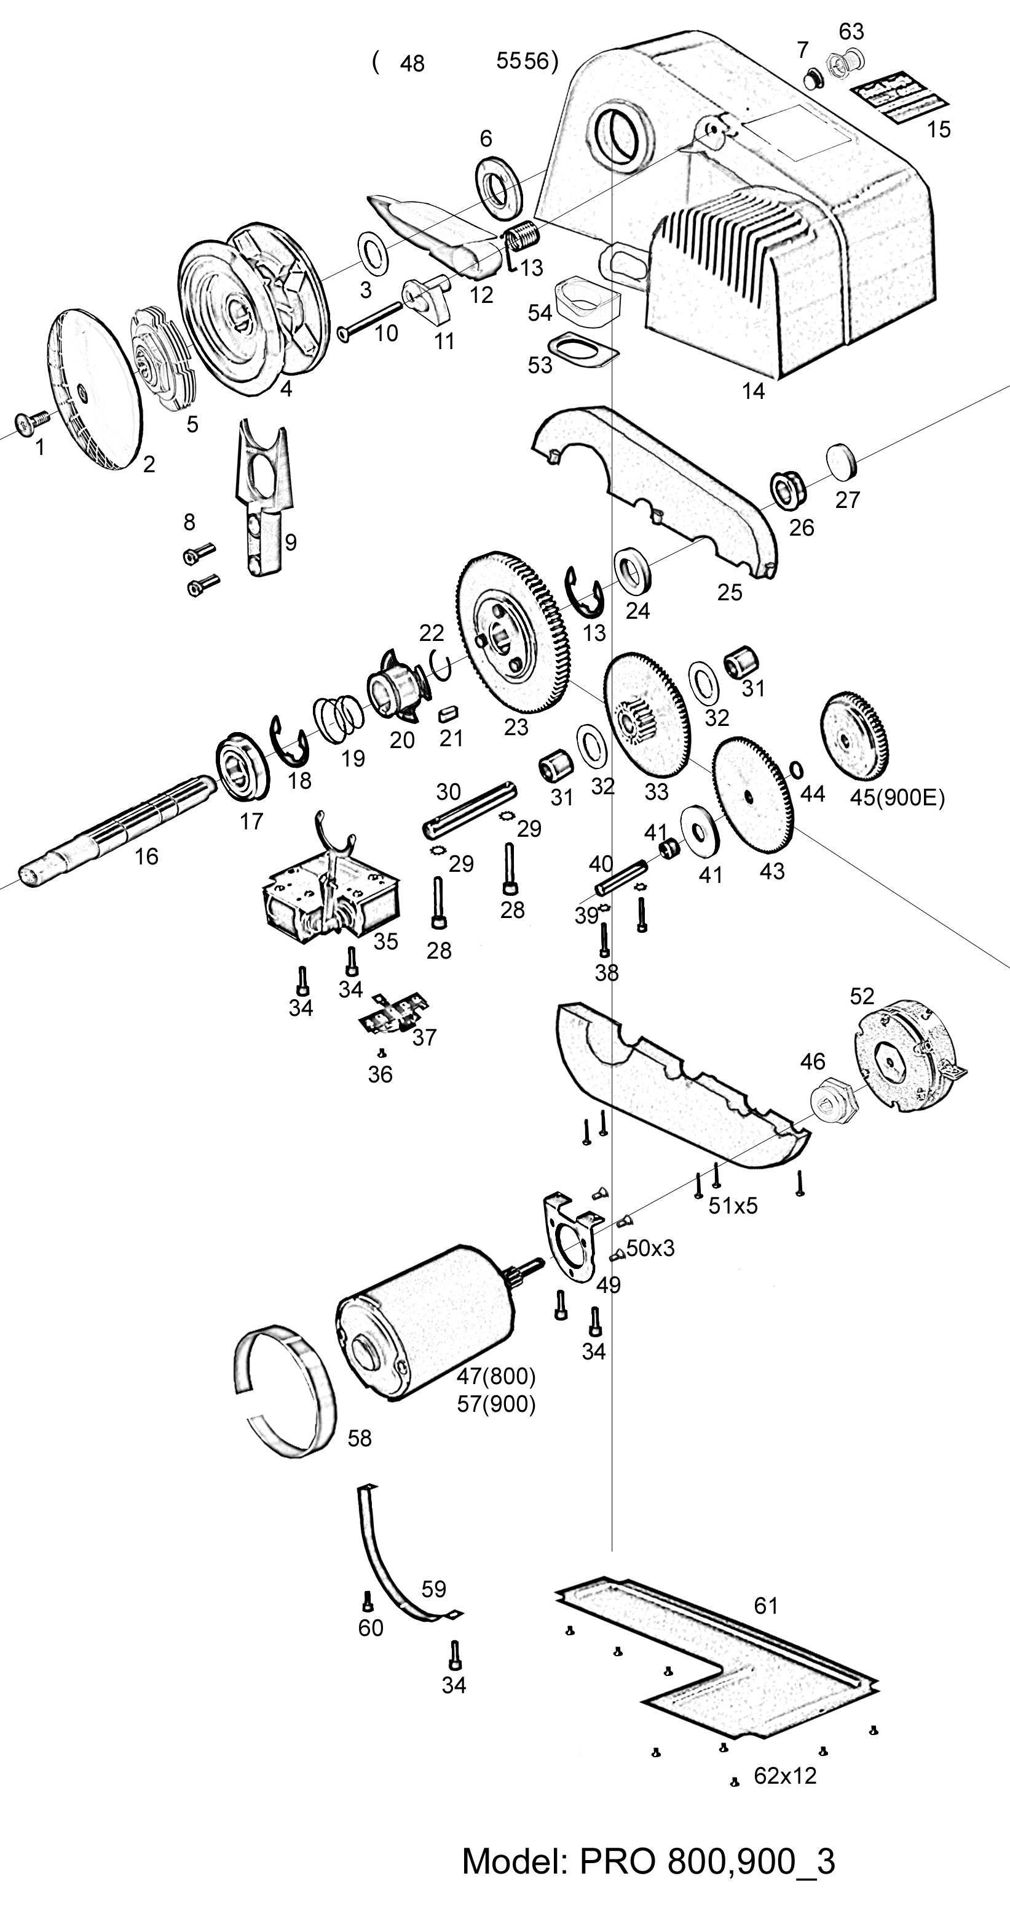
Gypsy | Suit Chain | Suit Rope
R0014-B | 6mm | 12mm,1/2”
R0156-2 | 7mm, 1/4” | 12mm, 1/2”
R0067-2 | 8mm, 5/16” | 12~14mm

PRO 800/900 series V3.0(current model)

