Owners Installation, Operation Manual

Please read this user manual carefully before using the product



MODEL: PRO 800H(c) Power out with sus gypsy
PRO 800F(c) Free fall with sus gypsy
PRO 900E(c) Free fall with sus gypsy
PRO 900M(c) Free fall with sus gypsy

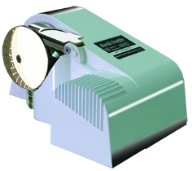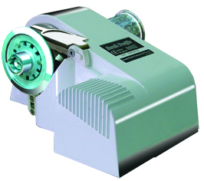

04/2013

South Pacific Industrial Pty Ltd. Australia
TEL: +61 (0)2 9659 2889 FAX: +61 (0)2 9634 5368
e-mail:info@southpacific.com.au
www.southpacific.com.au
CONTENTS

I FEATURES
II PACKAGE CONTENTS
III SPECIFICATIONS
IV INSTALLATION
V OPERATION
VI MAINTENANCE
VII WARRANTY
VIII IMPORTANT INFORMATION
IX PARTS LIST

I FEATURES

Efficient spur gears, low current draw, high output power
Heavy duty DC motor with long life and high output torque
Heat radiating system can prevent motor overheating
Build-in torque limiter for extra protection
Stainless steel Gypsy takes both rope and chain
Selectable free fall or power out mode (free fall model only)
Compact one-piece housing to ensure water resistance
Aluminum alloy housing with powder coated finish
Strong structure ensures long performance life
Simple deck mounting with no parts under deck

II PACKAGE CONTENTS

- WINDLASS x 1
- CONTROL DEVICE x 1
- USER MANUAL x 1
- MOUNTING TEMPLATE x 1
- ACCESSORIES : Thread rod M8 X 100mm x 4
Nut M8 x 4
Washer M8 x 4
Spring Washer M8 x 4

III SPECIFICATIONS
800 SERIES | 800H / 800F
Suit Boats Size | 6~9 m (20~30 ft)
Comparable Model | 700W Model
Operating Voltage | 12V DC
Max. Working Load | 300 kg (700 lb)
Typical Working Load | 45 kg (100 lb)
Retrieval Speed | 19 m/min (63 ft/min)
Pay-Out Speed 800H  800F | Power-out 22 m/min (73 ft/min)  free fall or power out
Continuous Working Time | 20 min.
Typical Current Draw | 18 amp
Motor Type / Efficiency | Permanent Magnet / 74 %
Motor Wattage I/O | 700W / 300W
Gear Type / Efficiency | Spur Gear / 92%~98%
Chain Size | 6, 7, 8 mm, 1/4”, 5/16”
Rope Size | 12 ~ 14mm (1/2”~ 9/16”)  Three strand, medium lay
Dimension(LxWxH) | 304 mm x 197mm x 153mm  12” x 7.75” x 6”
Weight 800H / 800F | 7.8 kg (17lb) / 8.2 kg (18lb)

900 SERIES | 900 EXPRESS | 900 MIGHTY
Suit Boats Size | 8.4~10.5m(28~35ft) | 8.4~13.5m(28~45ft)
Comparable Model | 700W model | 1100W model
Operating Voltage | 12V DC or 24V DC
Max Working Load | 320 kg (700lb) | 500 kg (1100lb)
Typical Working Load | 50 kg (110 lb) | 72 kg (160lb)
Retrieval Speed | 30 m(100ft)/min | 18 m(60ft)/min
Pay-Out Speed | free fall or power out
Continuous Working Time | Max. 20 min.
Typical Current Draw | 25 amp(12V) or 13 amp(24V)
Motor Type / Efficiency | permanent magnet / 82 %
Motor Wattage I/O | 1100W / 450W
Gear Type / Efficiency | spur gear / 92%~98%
Chain Size | 6, 7, 8 mm, 1/4”, 5/16”
Rope Size | 12 mm ~ 14 mm (1/2” ~ 9/16”)  three strand, medium lay
Dimension(LxWxH) | 304 mm x 197 mm x 153mm  12” x 7.75” x 6”
Weight | 9.2 kg (20.4lb)
South Pacific Industrial Pty Ltd reserves the right to alter or change specifications without notice.

It is very important to choose the correct type of rope and chain, to
ensure proper running of the windlasses.

Rope- Must use three strand, medium-lay. We recommend Filament
Polyester, Premium Nylon or Silver rope(Australia). Do not use soft
rope. Soft rope (either polyester or nylon ) will slip and cause a
rope jam in the gypsy. It will also lock the gypsy and cause circuit
breaker to pop-up often. Please refer to the chart below.
,
Chain- Must ensure that the inside length “p1” is suitable for the gypsy. Otherwise, the chain will get stuck(too small) or slip(too big) in the
gypsy and eventually damage the release arm. Please refer to the chart below.

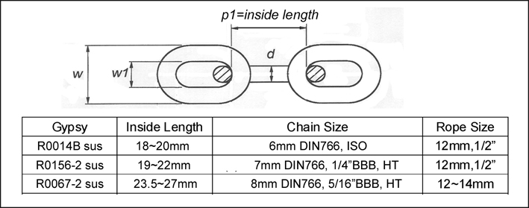

Note: The rope size indicated is its actual diameter measured

IV INSTALLATION (Reference to Video CD)

- TOOLS REQUIRED

a. Electric drill b. Adjustable spanner c. Jig saw
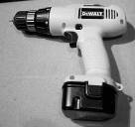 | 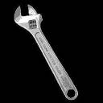 | 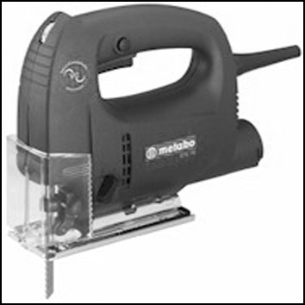

d. File f. Philips head screwdriver g. Silicon glue
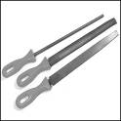 | 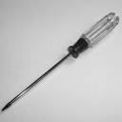 | 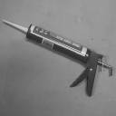

- PLANE

a. First of all, a suitable Bow Roller must be installed to support the anchor, chain and rope.

b. A bollard or snubbing device should be installed between the bow roller and the windlass to tie the rope on while laying anchor or securing the anchor in the fully raised position.
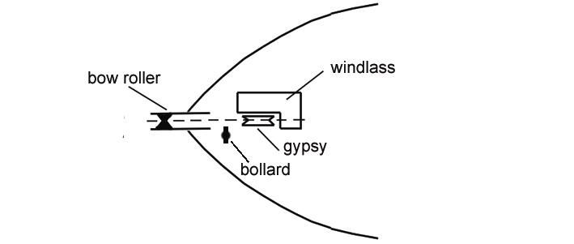
c. If you are using only chain, a chain stopper should be installed between the bow roller and the windlass to take the drag force away from the windlass while being anchored.

d. Make sure the anchor well or the chain locker is deep enough to store chain and rope. The minimum depth is 40cm(11/3 ft) to store about 30 metre(100ft) of rope. If the anchor well is not deep enough the rope will build up very quickly and block the entry.
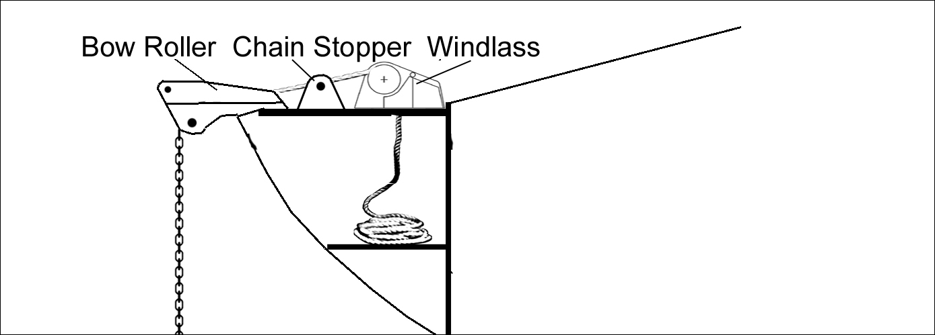

- CONSTRUCTION
  - Place the windlass on the deck and find a suitable position for it, with reference to the vessel’s bow roller, rope and chain locker below.
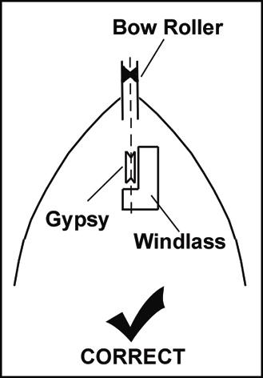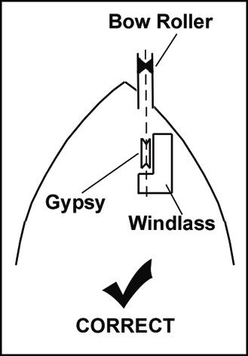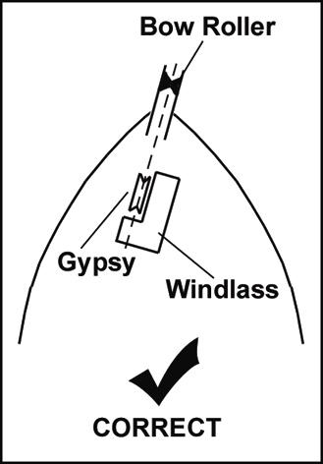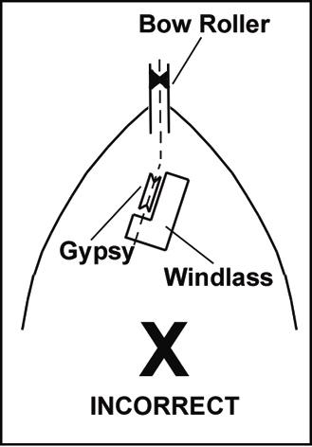

  - Place the mounting template on the deck in the desired position for the windlass and hold it in place using adhesive tape.

  - Use a 10mm (3/8”) diameter drill to make four holes for the mounting thread rods and make a fifth hole to pass power supply cables through.

  - With a jigsaw, cut the hole for the rope and chain to pass through. Use a file to smooth any rough edges. To avoid water absorption by the deck, apply paint to the cut hole edges.

  - Secure thread rod to the base of the windlass, then apply a silion sealant around thread rod. Secure the windlass firmly to the deck from below using the nuts and washers supplied.

  - Mount control device at a suitable position either in the cabin or close to the operating area.

g.g.g | Connect the windlass, control unit and power source using electric cable indicated below. Keep the power supply cable as short as possible. Too thin and/or too much length of electric cable will reduce the performance of the windlass or cause the circuit breaker to work incorrectly  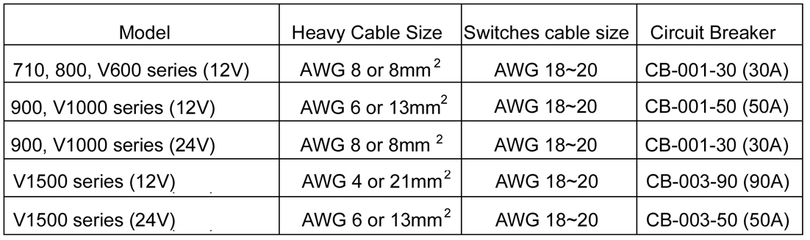  There is one control system that is included in the package, please refer to the connection diagram below.  ◆ Direct control system:  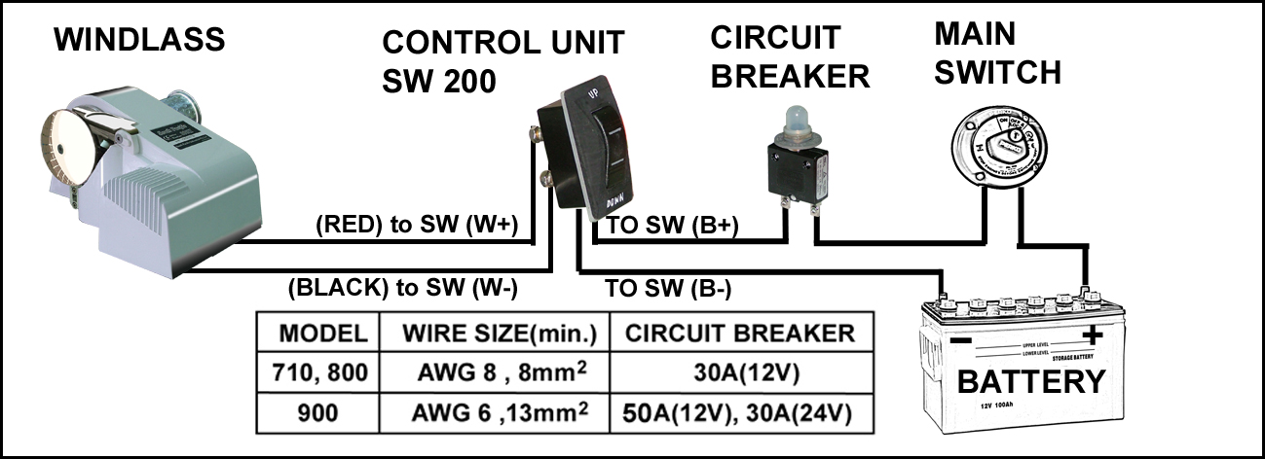  Note: For safety reason, do not connect the power source direct to the battery. Please connect the power cable to the main power switch on your boat.  SW-200 with dynamic brake, can not be parallel.
◆ Indirect control system:

Using foot switches or hand held switch for multiple control, a solenoid K-200 is necessary.

If you have an existing control unit (SW-030 or SW-200), you must remove it before installing this indirect control system. Also, do not attach control unit (SW-030 or SW-200) to K-200 as an up/down switch (SW-025).

The direct control system and indirect control system can not exist concurrently.

If the winding direction is not as desired, please change over the wires from the windlass to the solenoid K-200.
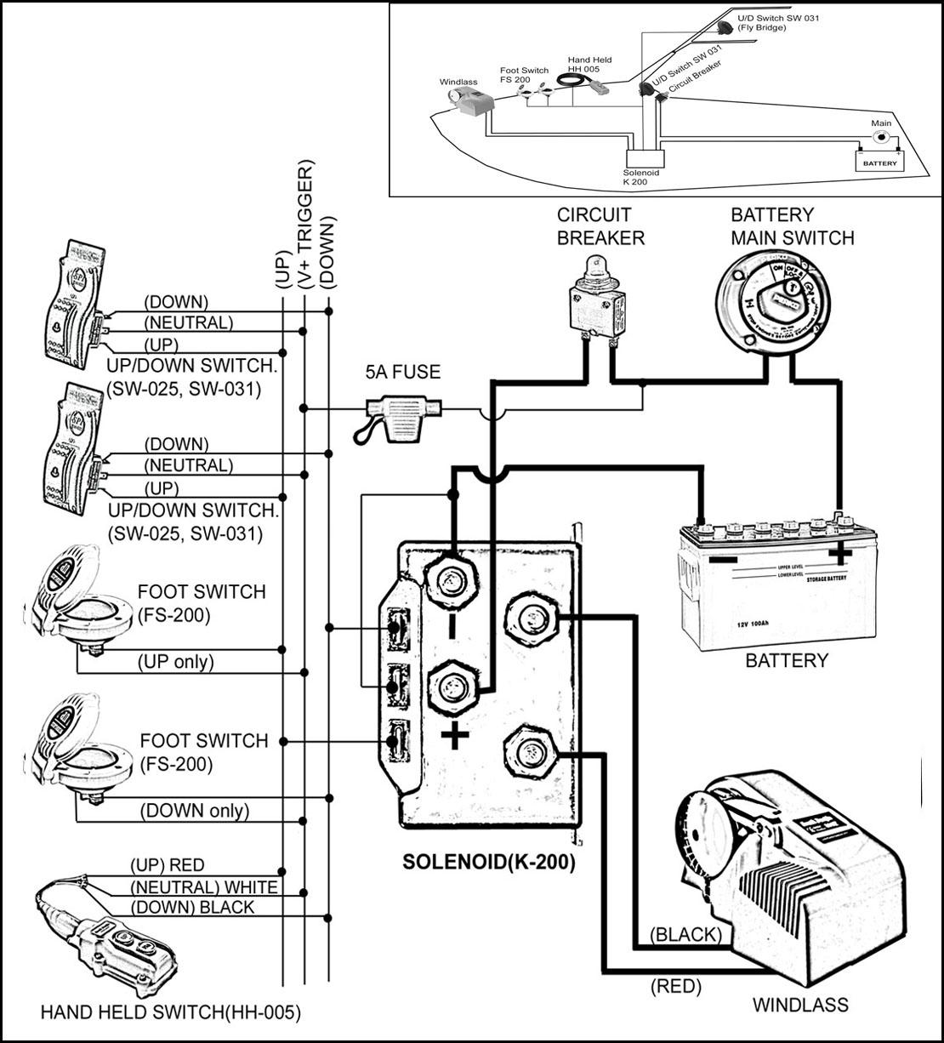

4. TO INSTALL ANCHOR ROPE AND CHAIN
To splice rope to the chain, please follow the steps below. Do not use a hook or shackle.
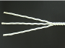
STEP 1:
Unraveling the end of the rope for about 20 cm and secure the end of strands by tape.

STEP 2:
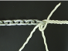
Pass three strands through the last link of the anchor chain. Untwist the rope to raise a strand just below the tie on the standing part of the rope and insert one strand under it, then pull the strand through. Twist the strand to keep it tightly wound as you pull it through.

STEP 3:
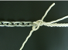
Take the next strand on the left. Tuck it under the next strand to the right of the one under which the first strand was tucked. Pull it through as before.

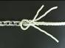
STEP 4:
Now turn the whole eye over. Take the last strand and make the tuck as before under the only strand on the standing part of the rope not used yet. Now stop and ensure that each working strand has gone over a strand and under a strand, and that the whole lot is pulled tight and twisted in its natural sense. No two strands should come from under the same strand.

STEP 5:
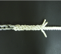
For the remaining rounds of tucks, take each end over one strand and under the next one to the right, in the same order as before.

STEP 6:
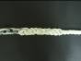
To finish, pull the ends tight. Cut the excess off with a hot knife. A good way to do this is by heating a butter knife with a butane torch, or a gas stove if handy. This cuts and seals the individual strands resulting in an excellent frayless finish.

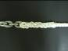
STEP 7:
After you’ve spliceded the rope to the chain, tie both ends of spliced rope to prevent the rope from loosening.

V OPERATING

- During operating, if the circuit breaker bounces it means the motor is overloaded. Press the button to reset.

- For free fall model only: when releasing anchor, press switch “DOWN” once(clutch will stay at open) to free fall the anchor to the sea bed, until the current has drifted the boat to a desired location and the anchor has cast firmly in the sea bed, press the switch “UP” once to engage the clutch.

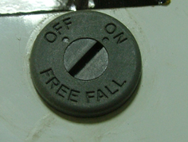
You can set the rotating “free fall” switch(in the right hand side of windlass) by a flat screw driver to be a “on” free fall mode or “off” Power Out mode.

Note: It is normal for the free fall switch can be rotated 360 degree

★Do not use free fall function when using all chain★

- Pay out the rope and chain approximate 2~3 times the water’s depth for a firm casting while being anchored.
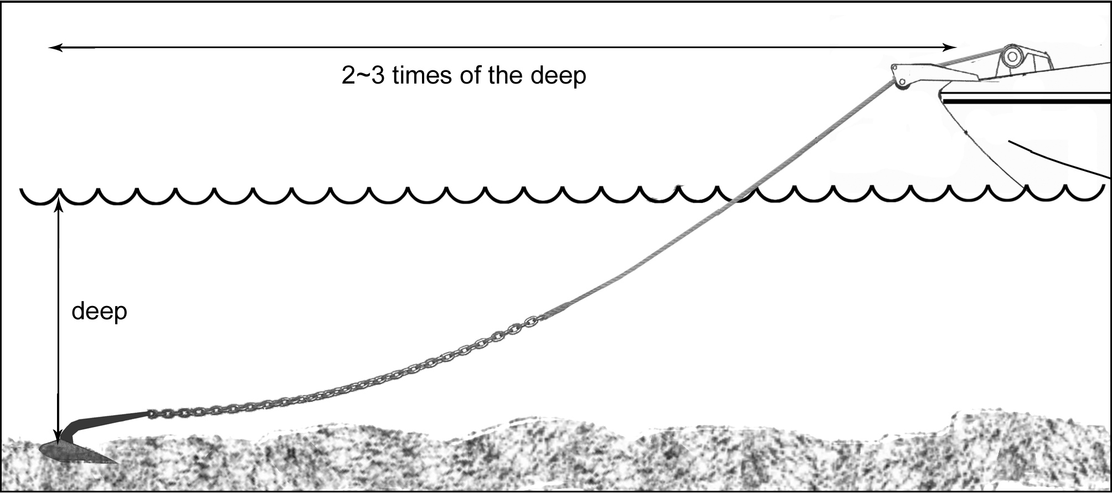
- Keep limbs, fingers clothing and hair clear of the windlass and anchor to avoid possible personal injury during operation.

- Tie the anchor rope firmly to the bollard when the anchor is cast and the boat is moored. Do not allow the windlass to take the force of a boat’s drag. If using all chain, a chain stopper is necessary to be installed between bow roller and windlass to take the force of boat’s drag.

- When retracting the anchor, untie the rope from bollard. Then move the boat to the position just above the anchor by boat’s engine power(not the windlass power)
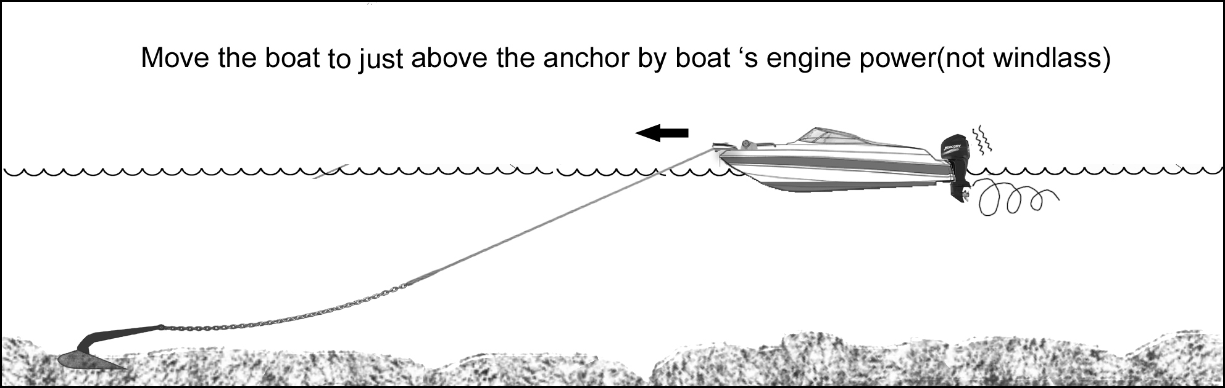
and switch on the windlass to drag it back. When the anchor is close to the bow roller, slow down the roll in by pausing the switch.
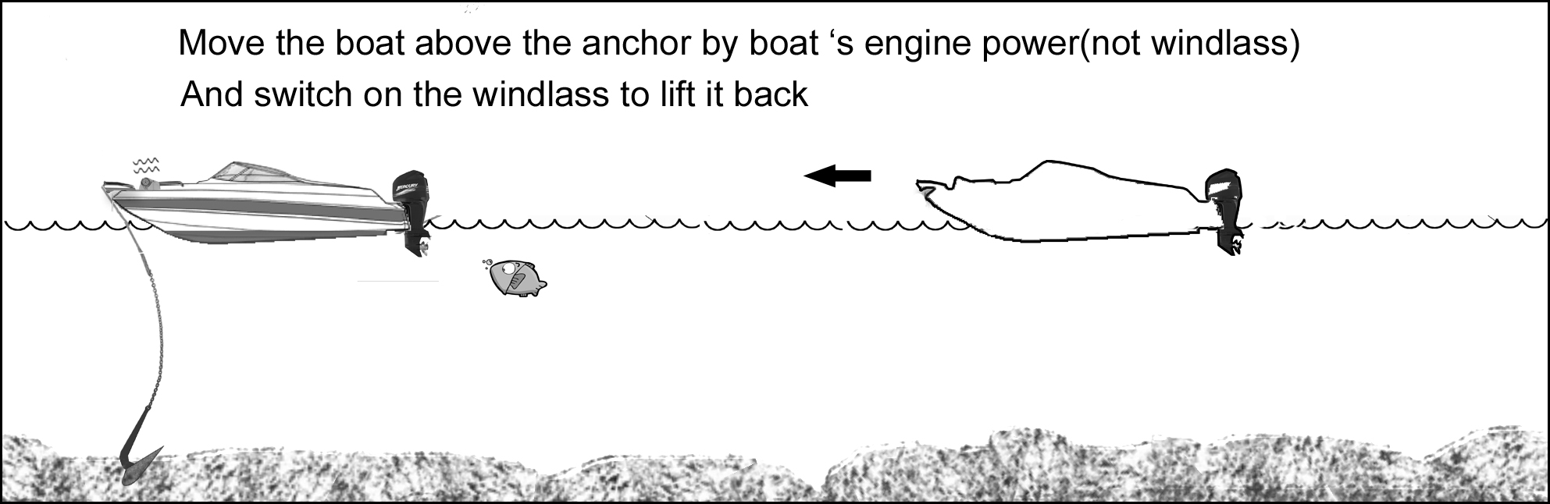
Note: The windlass is designed to lift the anchor rather than to drag the boat or for mooring.

- If the anchor is stuck on the seabed or reef, detach it by the boat’s engine power before operating the windlass or else it may cause damage or the load may overstrain the windlass.

After use, secure the anchor firmly in place in the boat by extra device(such as hook, shackle…) to avoid damage caused by anchor falling during transport.
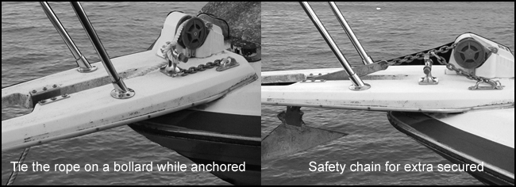

- The anchor windlass is not designed for continuous operation. Do not use for more than 20 minutes at a time under loading. Allow an interval of 20 – 30 minutes after each operation.

- For windlasses with capstan model only:
You may operate gypsy and capstan separately by loosening the nut on the gypsy, until the clutch and the gypsy disengaged and the windlass drive shaft will drive only the capstan.

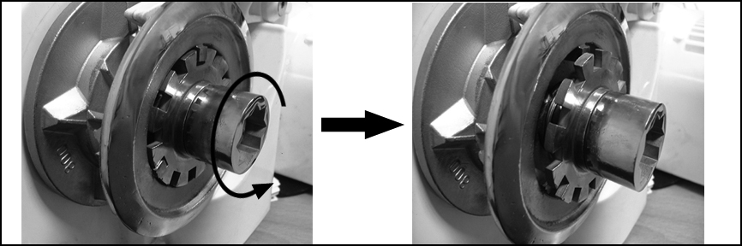

CAUTION: Before release the gypsy clutch you need to secure the anchor chain/rope. Once the gypsy clutch released the gypsy may free spin and cause the anchor fall.

★ OPERATING SAFETY IS THE FIRST PRIORITY ★

VI MAINTENANCE

1 The windlasses come with a grease lubricated gear box. There is no need for extra lubrication.

2 In order to make the windlass perform at optimize capacity and extend its life, use fresh water to wash off salt water after each use.

- Periodically check the electric joiner and the silicon sealant.
VII WARRANTY

- The warranty is deemed as effective only under conditions of normal operation, maintenance and without modification of the product.
- CLAIMS
If the product needs servicing, please send it back (or bring it to us) with the proof of purchase and we will investigate the product free of charge before repairing. However, the cost of postage or removal from the boat will be borne by the owner.

- LIMITATIONS AND EXCLUSIONS
The warranty will be deemed effective only if the windlass is used on a non-commercial basis and will be invalid and excludes the following conditions.
  - Operation exceeds the design specifications
  - Use for purposes other than indicated
  - Disassembly or modification of the product
  - Installation of other parts on the product.
  - Third party products even if associated or used together with this product.

VII IMPORTANT INFORMATION

- In every circumstance, the operator must make safety as the first priority. An inexperienced person or a child should not operate this product. The manufacturer takes no responsibility for any damage, property loss or injury caused from improper operation.

- If a product is accepted for refunding, the manufacturer is not responsible for any renovation of the boat.

IX PARTS LIST
 | No. | Parts Name
 | R0024 | Screw M6x15 ss
 | R0346 | Gypsy cover
 | R0121 | Sus washer 18x1.5
 | Gypsy refer to page 4 | Refer to page 4
 | A0002 | Torque lmiter(12)(24)
 | R0072 | Oil sealant
 | R0161 | Water sealant | H
 | R0023 | Screw M5x15 ss
 | R0073S | Release Arm sus
 | R0025 | Screw m6X45 ss
 | R0015 | Tension arm holder
 | R0013S | Tension arm sus
 | R0029 | Tension spring
 | R0066 | Housing
 | R0109 | Sticker
 | R0074-2 | Main drive shaft
 | R0075 | Ball bearing
 | R0070 | E Clip Φ19
 | R0104 | Clutch spring | F
 | R0076 | Chutch | F
 | R0095-I | 6x15Key
 | R0077 | Gear spring
 | R0078 | Gear #4
 | R0117 | washer
 | R0085 | Gear cover
 | R0003 | Bush bearing
 | R0017-5 | Water sealant
 | R0113 | Screw M6x30
 | R0150 | Washer
 | R0083 | Shaft #3
 | R0099 | Bush
 | R0098 | Washer
 | R0079 | Gear #3
 | R0020 | M5x15
 | A0019 | Clutch Solenoid Set | F
 | R0065 | Screw M3x4 | F
 | A0017 | Connector | F
 | R0111 | Screw M4x20
 | R0115 | Washer
 | R0084 | Shaft #2
 | R0100-8.5 | Bush
 | R0149 | Washer
 | R0080 | Gear #2
 | R0100-3.5 | Bush
 | R0081 | Gear #2-1 | E
 |  |  | 8
 | R0102-2 | H700 Motor | 8
 | R0006 | Motor front Bracket
 | R0019 | Screw M5x10
 | R0153 | Screw M3x15
 | A0010H | Electric Brake
 | R0130 | 900Motor | 9
 | R0125 | H700 motor socket | 8
 | R0090-2 | Motor tie
 | R0164 | Screw M5x8
 | R0097 | Buttom cover
 | R0021 | Screw M3x6 ss
 | A0024 | Free fall switch
 | A0024

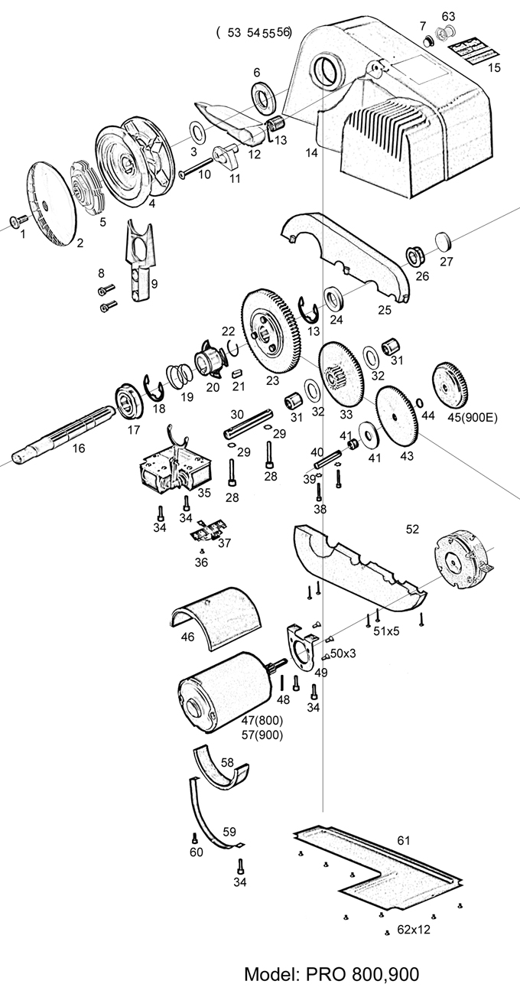

Thank you for choosing South Pacific products

Purchase Date: Model:
Supplier Name:
Address:
Phone: Fax:

