 | Parts No. | Item:PRO 710_2.0
1 | R0024 | Screw M6x15 ss
2 | Gypsy | Refer to the chart below
3 | R0023 | Screw M5x15 ss
4 | R0012-S | Sus Release Arm
5 | R0016 | O-ring
6 | R0001 | Housing
7 | R0025 | Screw M6x45
8 | R0015 | Tension arm holder
9 | R0013 | Tension arm
10 | R0029 | Tension spring
11 | R0041 | Sticker
12 | A0002-(5) | Torque Limiter
13 | R0020 | Screw M5x12
14 | R0006 | Motor front mounting
15 | R0019 | Screw M5x10
16 | R0005-2 | Main drive shaft
17 | R0003 | Bush bearing
18 | R0030 | E Clip Φ15
19 | R0004 | Gear
20 | R0048 | Pin 5x26 | H
21 | R0061 | Pin 5x16 | F
22 | R0059 | Gear spring | F
23 | R0055 | Clutch | F
24 | R0060 | Pin 5x22 | F
25 | R0058 | Clutch spring | F
26 | R0017-6 | Shaft sealant
27 | R0021 | Screw M3x6 ss
28 | R0009 | Bottom cover
30 | R0007 | Motor rear mounting
31 | R0002 | Motor
32 | R0065 | Screw M3x4 | F
33 | A0016 | Connector | F
34 | A0018 | Clutch solenoid Set | F
35 | 6mm SS Gypsy
36 | R0346 | Gypsy Cover
37
38 | A0024 | Free Fall Switch | F
39 | R0247 | M15 Nut | F
40 | R0285 | Gear socket
41 | R0283-1 | Gear Box(U)
42 | R0283-2 | Gear Box(D)

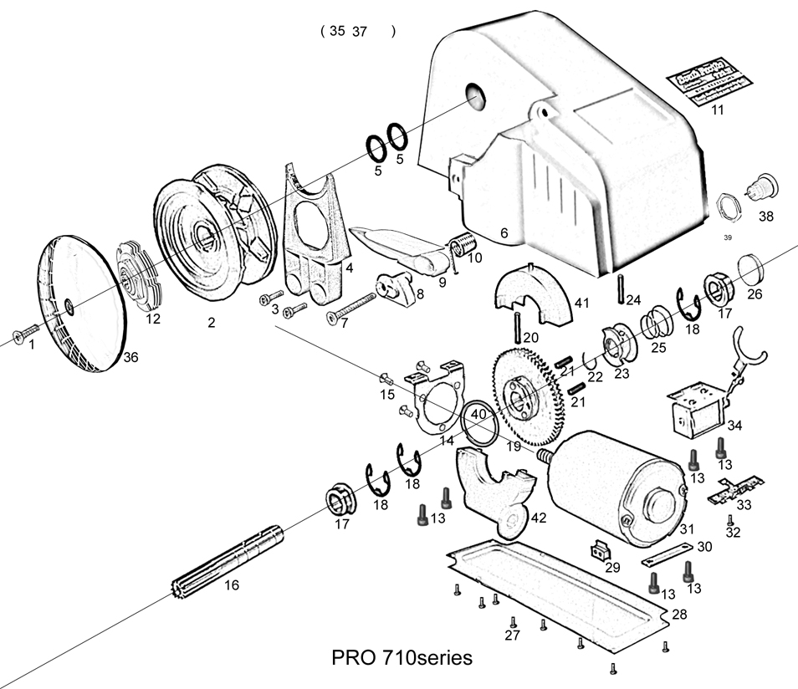
Gypsy | Suit Chain | Suit Rope
R0050 (plastic) | 6mm | 12mm, 1/2”
A0001-2 (plastic) | 7mm, 1/4” | 12mm, 1/2”
R0014-P (sus) | 6mm | 12mm, 1/2”
R0156-2 (sus) | 7mm,1/4” | 12mm, 1/2”

