

Owner’s Installation & Operation Manual
Please read this user manual carefully before using the product

Model: VS1500 & VS1500C
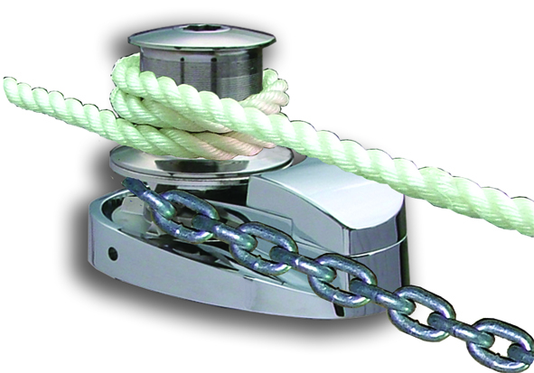
04/2011

South Pacific Industrial Pty Ltd. Australia
TEL: +61 (0)2 9659 2889 FAX: +61 (0)2 9634 5368
e-mail:info@southpacific.com.au
www.southpacific.com.au
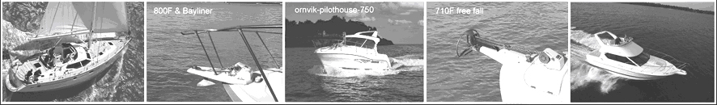

CONTENTS
I FEATURES
II PACKAGE CONTENTS

III SPECIFICATIONS
IV INSTALLATION
V OPERATION
VI MAINTENANCE
VII WARRANTY
VIII IMPORTANT INFORMATION
IX PARTS LIST

I FEATURES

- Self tailing rope and chain stainless steel gypsy
- Efficient spur gears which provide tremendous lifting capacity
- Heavy duty DC motor with long life and high output torque
- High efficient permanent magnet motor with low current draw
- Built-in spring buffer gear can absorb sudden impact
- One-Piece design with no separate parts, easy to install
- Strong structure and long performance life
- Pre install chain counter magnet

II PACKAGE CONTENTS

- WINDLASS  - SOLENOID  - UP/DOWN SWITCH  - USER MANUAL  - MOUNTING TEMPLATE  - HARDWARES : Screw M10 × 100mm  Nut M10  Flat Washer M10  Split Washer M10 | × 1  × 1  × 1  × 1  × 1  × 3  × 3  × 3  × 3

III SPECIFICATIONS
 | VS1500/VS1500C
Suit Boats Size | 40ft ~ 60ft
Handle Anchor Size | 60 lb
Comparable Model | 1500W Model
Input Voltage | DC 12V or 24V
Max. Working Load | 680kg(1500lb)
Typical Working Load | 120kg(265lb)
Retrieval Speed | 16m(53ft)/min.
Pay-out Speed | 18m(60ft)/min.
Continuous Working Time | Max. 15 minute
Typical Current Draw | 45A(12V) or 22A(24V)
Motor Type | Permanent magnet
Motor Wattage I/O | 1500W/700W
Motor Efficiency | 82%
Gear Type / Efficiency | Spur Gear/92%~97%
Chain and Rope Size | Please refer to the chart below
Dimension | 250Lx160Wx340(420)H mm
Weight: without Capstan  with Capstan | 16.0kg(35lb)  18.0kg(40lb)

It is very important to choose the correct type of rope and chain to ensure proper operation of the windlasses.

Rope- Must use three strand, medium-lay. We recommend Filament
Polyester, Premium Nylon or Silver rope (Australia). Do not use soft rope. Soft rope (either polyester or nylon) will slip and cause a
rope jam in the gypsy. It will also lock the gypsy and cause the circuit breaker to pop-up often.

Chain- Must ensure that the inside length p1 is suitable for the gypsy. Otherwise, the chain will jam (too small) or jump (too big) in the gypsy and eventually damage the release arm.

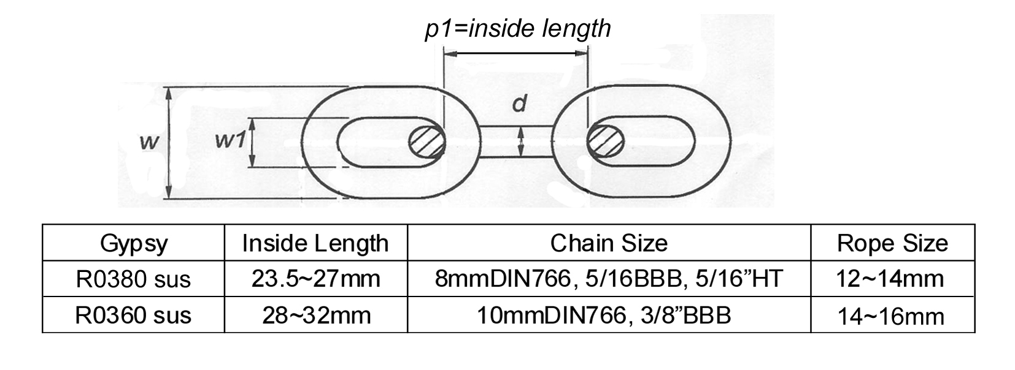
Note: The rope size indicated is its actual diameter measured.
IV INSTALLATION
- TOOLS REQUIRED
Drill Adjust spanner Jig saw File
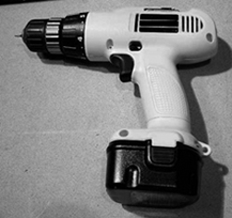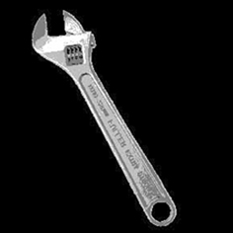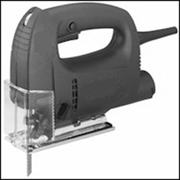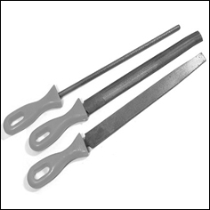
2. PLANE

a. | First of all, a suitable bow roller must be installed to support the anchor, chain and rope.
b. | 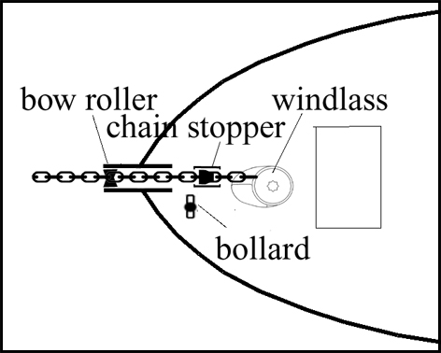  A bollard or snubbing device should be installed between the bow roller and windlass to tie the rope on while anchored or securing the anchor in the fully-raised position.
c. | 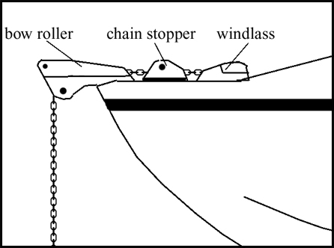  If you are using only chain, a chain stopper should be installed between the bow roller and the windlass to take the drag force away from the windlass while anchored.
d. Ensure there is a drain in the chain locker and always keep it clear to prevent the water level rising and make sure the chain locker is deep enough to store the rope and chain. If the anchor well is not deep enough the rope and chain will build very quickly and block the entrance.

3. CONSTRUCTION
a. | Place the windlass on the deck and find a suitable position for it, with reference to the vessel’s bow roller, rope and chain locker below.
b. | Place the mounting template on the deck in the desired position for the windlass and hold it in place using adhesive tape.
c. | Use a 12mm (1/2") diameter drill to make three holes for the mounting screws.
d. | With a jig saw, cut the hole for the gear box, rope and chain to pass through. Use a file to smooth any rough edges. To avoid water absorption by the deck, apply paint to the cut hole edges
e. | Place the sealant EVA form underneath the base of windlass then insert nut, split lock washer, flat washer into the screw and secure the windlass firmly to the deck from below.  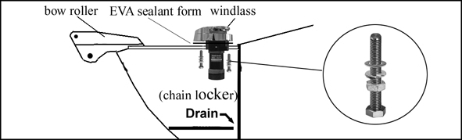
f. | Mount control device at a suitable position either in the cabin or close to the operating area.
g. | Connect the windlass, control unit and power source using electric cable indicated below. Keep the power supply cable as short as possible. Too thin and/or too much length of electric cable will reduce the performance of the windlass or cause the circuit breaker to work incorrectly.  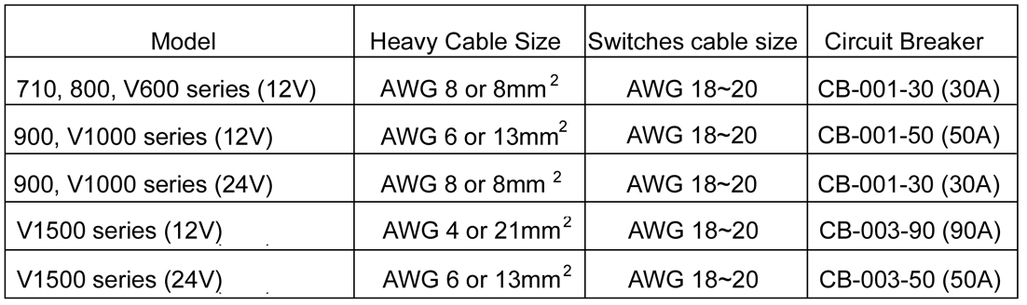
h. | The basic control device is included with the package, please refer to the connection diagram below.  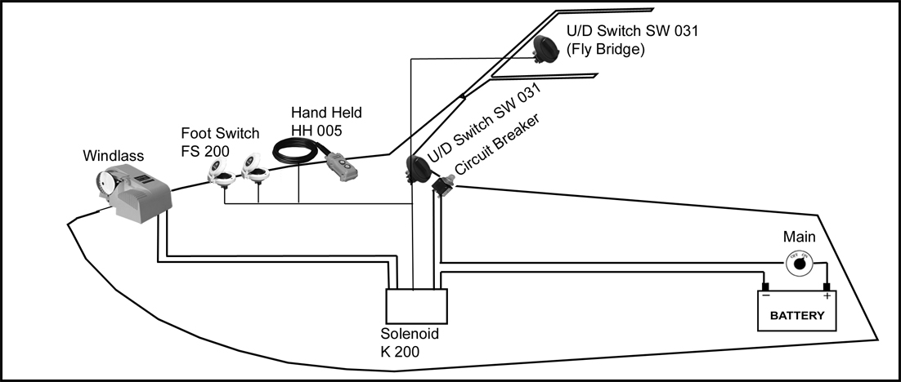  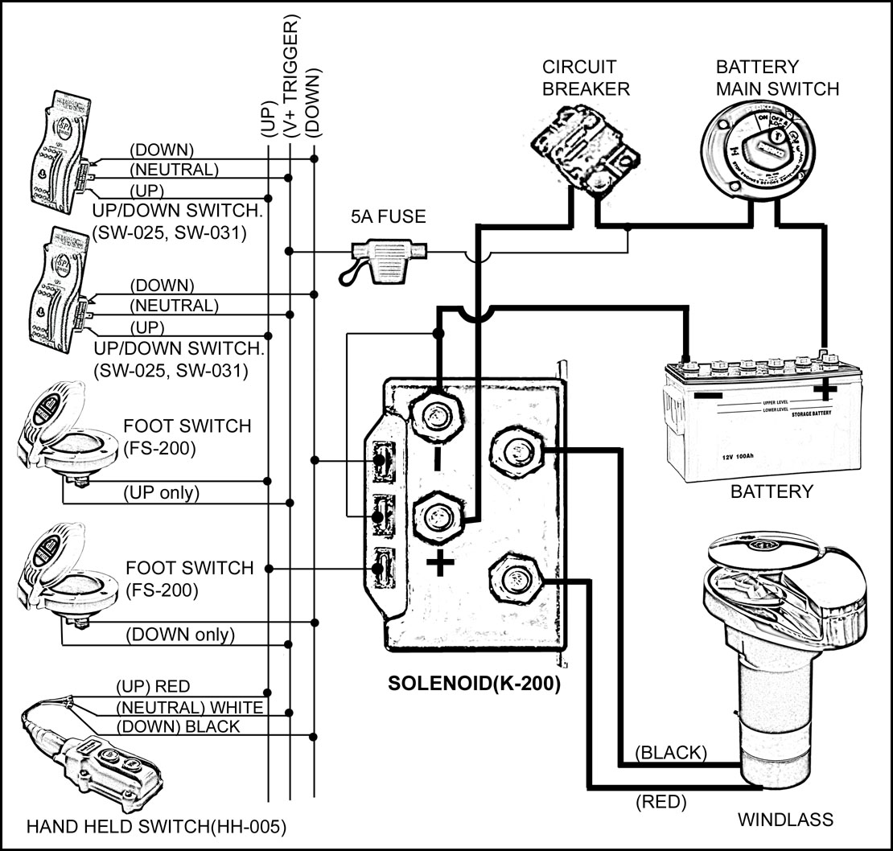
If the winding direction is not as desired, please change over the wires from the windlass to the solenoid K-200.

4. ANCHOR ROPE AND CHAIN
To splice the rope to the chain, please follow the steps below.
Do not use a hook or shackle.
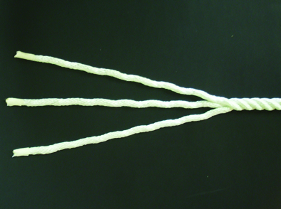 | STEP 1:  Unravel the end of the rope for about 20cm and secure the end of the strands with tape.
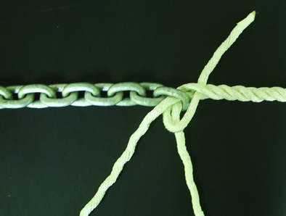 | STEP 2:  Pass three strands through the last link of the anchor chain. Untwist the rope to raise a strand just below the tie on the standing part of the rope and insert one strand under it, then pull the strand through. Twist the strand to keep it tightly wound as you pull it through.
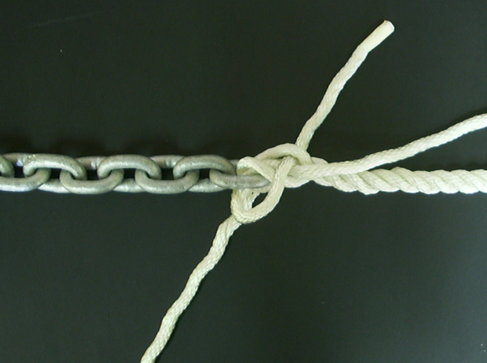 | STEP 3:  Take the next strand on the left. Tuck it under the next strand to the right of the one under which the first strand was tucked. Pull it through as before.
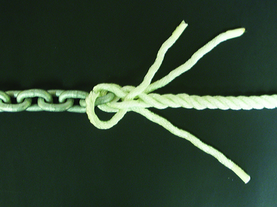 | STEP 4:  Now turn the whole eye over. Take the last strand and make the tuck as before under the only strand on the standing part of the rope not used yet. Stop and ensure that each working strand has gone over a strand and under a strand, and that the whole lot is pulled tight and twisted in its natural sense. No two strands should come from under the same strand.
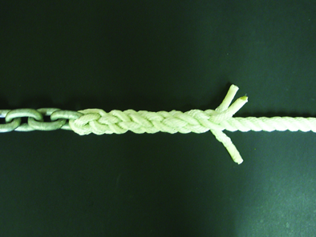 | STEP 5:  For the remained rounds of tucks, take each end over one strand and under the next one to the right, in the same order as before.
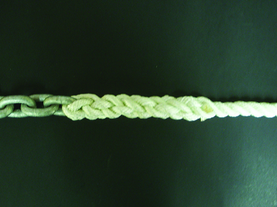 | STEP 6:  To finish, pull the ends tight. Cut the excess off with a hot knife. A good way to do this is by heating a butter knife with a butane torch, or a gas stove if handy. This cuts and seals the individual strands resulting in an excellent fray-less finish.
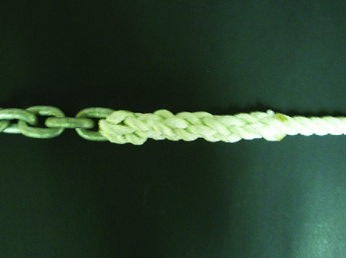 | STEP 7:  After you’ve spliced the rope to the chain, tie both ends of the splice rope to prevent the rope from loosening.

V OPERATING
1. | During operation, if the circuit breaker bounces it means the motor is overloaded. After about 10 seconds, press the button to reset.
2 | Pay out the rope and chain approximate 2~3 times the water’s depth for a firm casting while being anchored.  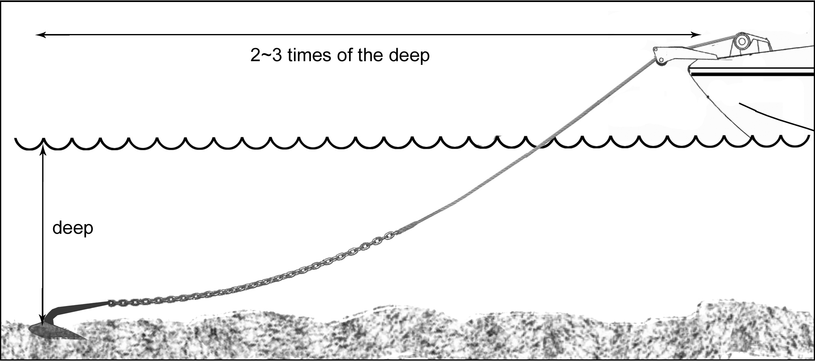
3. | Keep limbs, fingers, clothing and hair clear of the windlass and anchor to avoid possible personal injury during operation.
4. | Tie the anchor rope firmly to the bollard when the anchor is cast and the boat is moored. Do not allow the windlass to take the force of a boat’s drag. If using all chain, a chain stopper is necessary between the bow roller and windlass to take the force of the boat’s drag.
5. | When retracting the anchor, untie the rope from the bollard. Then move the boat to the position just above the anchor by boat ‘s engine power(not by the windlass power)  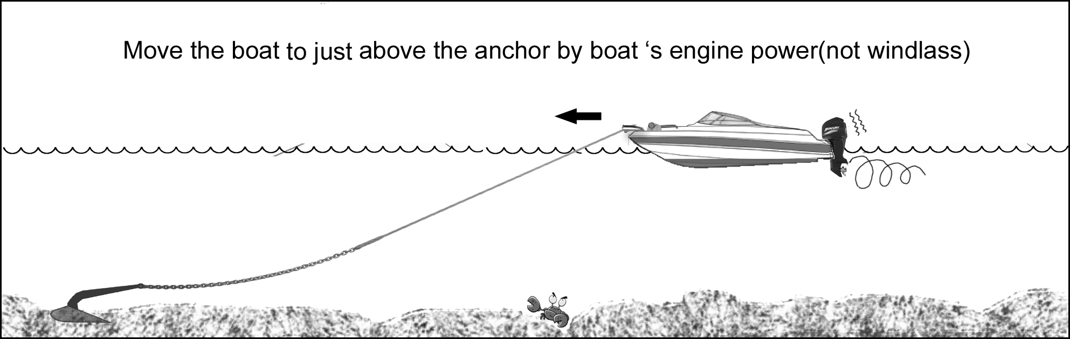  and switch on the windlass to lift it back. When the anchor is close to the bow roller, slow down the roll in by pausing the switch.  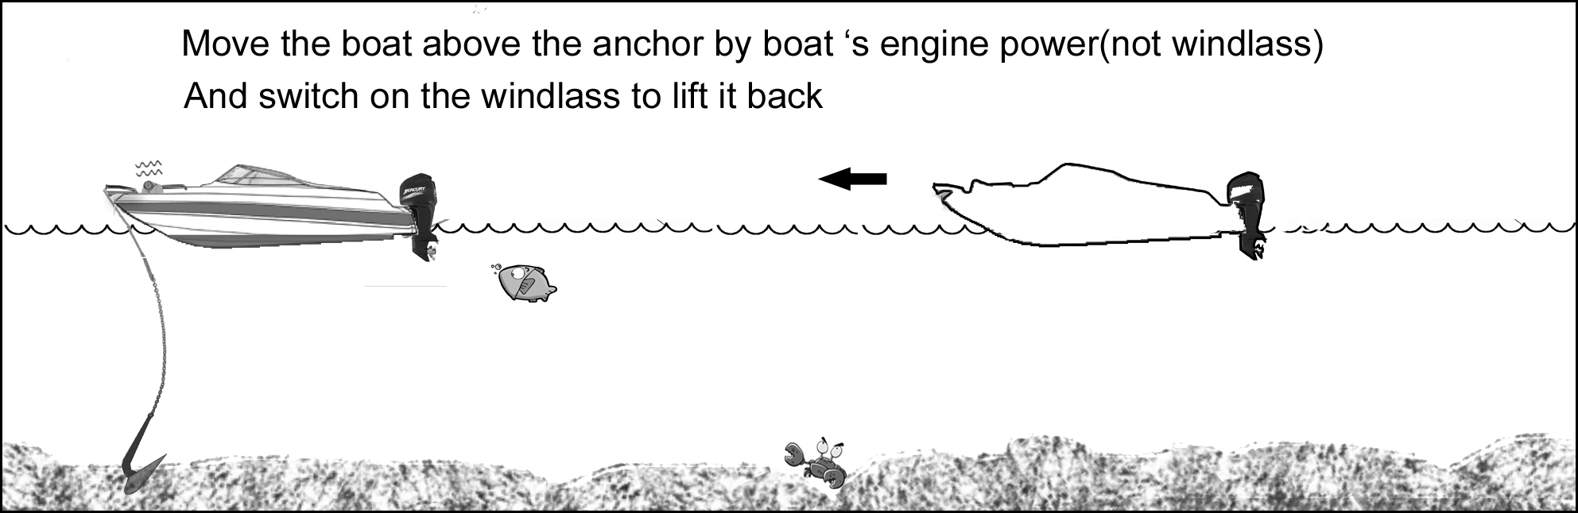  NOTE: The windlass is designed to lift the anchor, rather than to drag the boat or for mooring.
6. | If the anchor is stuck on the seabed or reef, detach it by the boat’s engine power before operating the windlass or else it may cause damage or overstrain the windlass.
7. | After use, secure the anchor firmly in place in the boat by extra devices (such as hook, shackle…) to avoid damage caused by anchor falling during transport or taxi.
8. | The anchor windlass is not designed for continuous operation. Do not use for more than 15 minutes at a time under loading. Allow an interval of 20~30minutes after each operation.
9. | For windlasses with capstan model only:  You may operate gypsy and capstan separately by loosening the nut on the top of the capstan approx. one turn and the windlass drive shaft will turn only the capstan.
10. | Emergency manual retrieval:  If there is a power failure or unit failure, you can loose the nut on the top of windlass and attach a handle bar to the gypsy for manual operation.  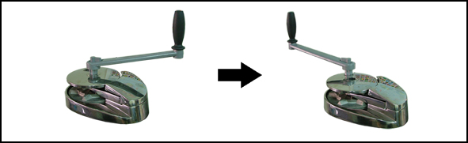
11. | The chain tunnel cover can be opened by lifting it up and turning it sideway.  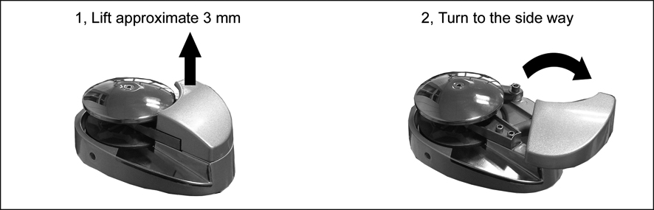

★OPERATING SAFETY IS THE FIRST PRIORITY★

VI MAINTENANCE
1. | The V Series windlasses come with a sealed grease lubricated gear box. There is no need for extra lubrication.
2. | In order to allow the windlass to perform at optimum capacity and extend its life, use fresh water to wash off salt water after each use.
3. | Always keep the chain locker drain clear to prevent water damage on the motor.
VII WARRANTY
1. | The warranty is effective only under conditions of normal operation, maintenance and without modification of the product.
2. | CLAIMS  If the product needs servicing, please send it back (or bring it to us) with the proof of purchase and we will investigate the product free of charge before repairing. However, the cost of postage or removal from the boat will be borne by the owner.
3. | LIMITATIONS AND EXCLUSIONS  The warranty will be deemed effective only if used on a non-commercial basis and will be invalid under the following conditions:  - Operation exceeds the designed specifications  - Use for purposes other than indicated  - Disassembly or modification of the product  - Installation of other parts on the product  - Third party products even if associated or used together with this product.

VIII IMPORTANT INFORMATION
1. | In every circumstance, the operator must make safety the first priority. An inexperienced person or a child should not operate this product. The manufacturer takes no responsibility for any damage, property loss, or injury caused from improper operation.
2. | If a product is accepted for refunding, the manufacturer is not responsible for any renovation of the boat.

IX PARTS LIST:
 | Parts No. | Item: VS1500(C)
1 | R0354-R | Capstan Nut
 | R0354-L | Gypsy Nut
2 | R0353 | Washer M24x0.5 usu
3 | R0378 | Capstan
4 | R0372  Gypsy 6 or 7 or 8mm | Capstan Socket
5 | R0369 | Gypsy Cover
6 | R0360 | Gypsy 10mm
 | R0380 | Gypsy 8mm
7 | R0351-40 | Screw M8x40 sus
8 | R0028 | Washer M8x1.0
9 | R0357-8 | Tension Arm 8mm
 | R0357-10 | Tension Arm 10mm
10 | R0382 | Tension Arm Spring
11 | R0197-15 | Screw M6x15
12 | R0142 | Washer M6x0.5
13 | R0358-8 | Release Arm 8mm
 | R0358-10 | Release Arm 10mm
14 | R0370 | Gypsy Spring
15 | R0375 | Gypsy Hub
16 | R0389 | Oil seal 30x55x7
17 | R0464 | V15 Main Drive Shaft
18 | R0364-C | V15C Main Drive Shaft
19 | R0095-I | Key 6x15
20 | R0356 | Chain Tunnel Cover
21 | R0355 | Base
22 | R0388 | Ball Bearing 30x55x13
23 | R0069-30 | S clip 30mm
24 | R0361 | #4 gear set
25 | R0003-18 | Bush 18mm
26 | R0368 | #3 Shaft
27 | R0366 | #3 Gear
28 | R0349 | Wash M12x0.5
29 | R0027 | Nut M8
30 | R0384 | Spring
31 | R0351-30 | Screw M8x30
32 | R0377 | #2 Shaft Socket
33 | R0367 | #2 Shaft
34 | R0365 | #2 Gear
35 | R0393 | Washer M8x0.3
36 | R0381 | Gear Box Gasket
37 | R0317-15 | Screw M6x15
38 | R0362 | Gear Box
39 | R0197-40 | Screw M6x40(65) sus
40 | R0385 | Motor Gasket
41 | R0359 | Motor
42 | R0390 | Electric Brake
43 | R0350 | Key 4x10
44 | R0069-9 | S-Clip M9
45 | R0391 | O-ring
46 | R0363 | Brake Cover
47 | R0394 | Screw M4x55 sus
48
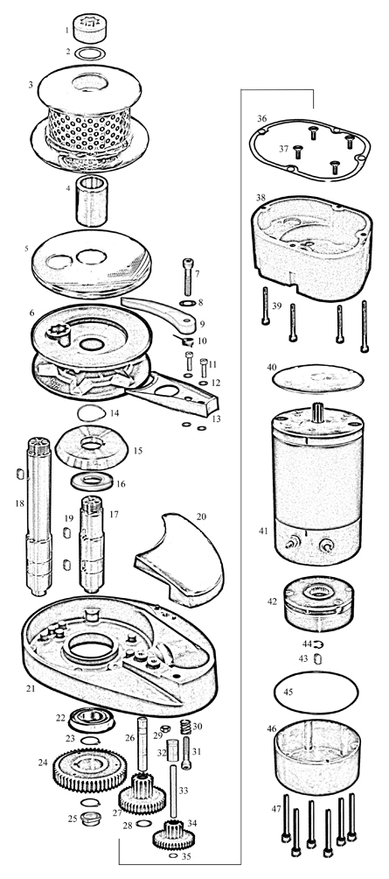

Thank you for choosing South Pacific products

Purchase Date: Model:
Supplier Name:
Address:
Phone: Fax:

