Owners Installation, Operation Manual
Please read this user manual carefully before using the product



Model: PRO 710H Power out with nylon gypsy
PRO 710Hs Power out with sus gypsy
PRO 710F Free fall with nylon gypsy
PRO 710Fs Free fall with sus gypsy

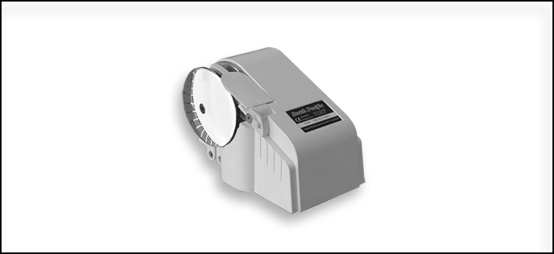

04/2013

South Pacific Industrial Pty Ltd. Australia
TEL: +61 (0)2 9659 2889 FAX: +61 (0)2 9634 5368
e-mail:info@southpacific.com.au
www.southpacific.com.au

CONTENTS

I FEATURES

II PACKAGE CONTENTS

III SPECIFICATIONS

IV INSTALLATION

V OPERATION

VI MAINTENANCE

VII WARRANTY

VIII IMPORTANT INFORMATION

IX PARTS LIST

I FEATURES

- Gypsy can take both chain and rope.
- Build-in torque limiter for extra protection
- Heavy duty DC motor with long life and high output torque
- Selectable free fall or power out mode (for free fall model)
- Aluminum alloy housing with powder coated finish
- Compact one-piece housing to ensure water resistance
- Simple deck mounting with no parts under deck
- Strong structure ensures long performance life
- Step by step installation video CD included

II PACKAGE CONTENTS

- WINDLASS  - CONTROL DEVICE  - USER MANUAL  - MOUNTING TEMPLATE  - ACCESSORIES : Thread rod M8 × 100mm  Nut M8  Washer M8  Spring Washer M8 | × 1  × 1  × 1  × 1  × 4  × 4  × 4  × 4

III SPECIFICATIONS

 | 710H, 710Hs / 710F, 710Fs
Suit Boats Size | 15 ~ 20 ft
Handle Anchor Size | Up to 15 lb
Comparable Model | 300W Model
Input Voltage | DC 12V
Max Working Load | 120kg(265lb)
Typical Working Load | 20kg(44lb)
Retrieval Speed | 17m(57ft)/min.
Pay-out Speed | 22m(73ft)/min. / Free Fall
Continuous Working Time | Max. 15 min.
Typical Current Draw | 15Amp
Motor Type | Permanent magnet
Motor Wattage I/O | 700W/300W
Motor Efficiency | 74%
Gear Type / Efficiency | Worm Gear/55%~88%
Chain Size | 6mm, 7mm, 1/4”
Rope Size | 12mm, 1/2”
Dimension | 230x120x135 mm  9”x4.75”x5.3”
Weight | 4.0kg(8.8lb) / 4.3kg(9.5lb)
South Pacific Industrial Pty Ltd. reserve the right to alter or change specifications without notice

It is very important to choose the correct type of rope and chain,
to ensure proper running of the windlasses.

Rope- Best use three strand, medium-lay. We recommend Filament
Polyester, Premium Nylon or Silver rope(Australia). Do not use soft
rope. Soft rope (either polyester or nylon ) will slip and cause a
rope jam in the gypsy. It will also lock the gypsy and cause circuit
breaker to pop-up often.

Chain- Must ensure that the inside length “p1” is suitable for the gypsy. Otherwise, the chain will get stuck(too small) or slip(too big) in the
gypsy and eventually damage the release arm. Please refer to the chart below.

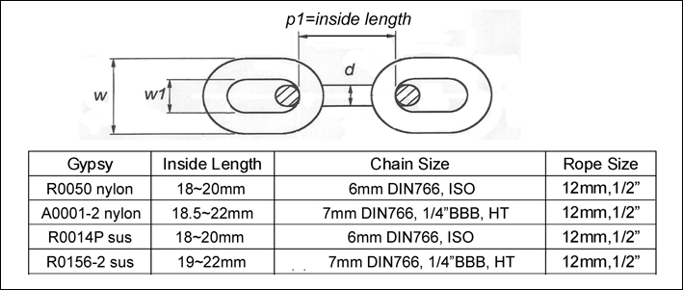
Note: The rope size indicated is its actual diameter measured

Running-In Gears- It is normal in the initial period(under load) to observe a noise and lack of power or circuit breaker to pop-up often, this is caused due to the worm gears Running-In. After about 10 uses, the gears will become smooth, noticing a regain in power and noise reducing effect.

IV INSTALLATION
- TOOLS REQUIRED
a. Electric Drill 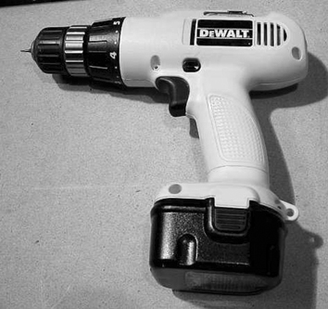 | b. Adjustable spanner  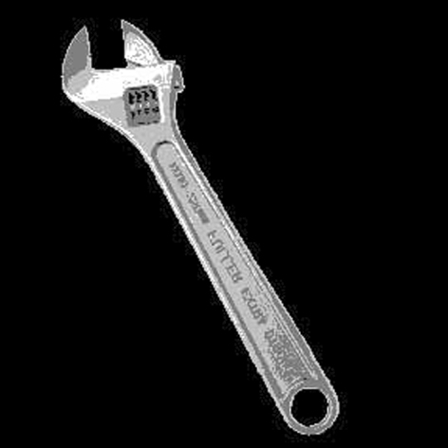 | c. Jig saw  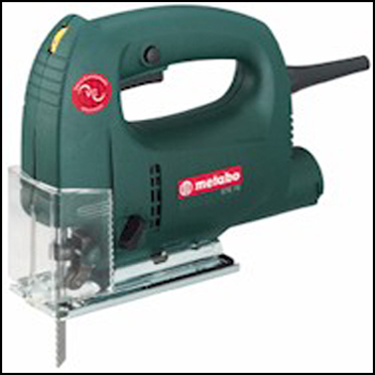
d. File  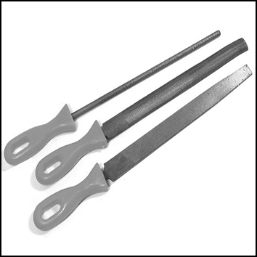 | e. Philips head screwdriver  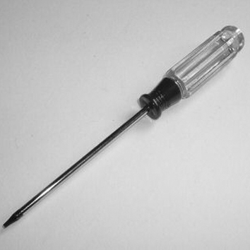 | f. Silicon glue  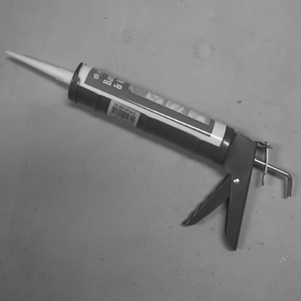

2. PLANE
a. | First of all, a suitable Bow Roller must be installed to support the anchor, chain and rope.
b | A bollard or snubbing device should be installed between the bow roller and the windlass as the rope should be tied on the bollard while laying anchor or securing the anchor in the fully raised position.  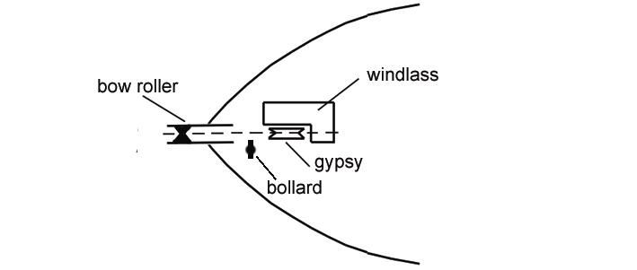
c. | Make sure the anchor well or the chain locker is deep enough to store chain and rope. The minimum depth is 40cm(11/3 ft) to store about 30 metre(100ft) of rope. If the anchor well is not deep enough the rope will build up very quickly and block the entry.  ● Flat deck:  Mount on the top of the deck.  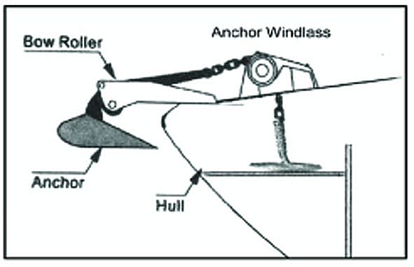  Attach plywood under the deck to spray the force, if it is an aluminum, or fibre glass deck thinner than 5mm.  ● If there is a hatch and anchor well below and without internal access to the cabin:  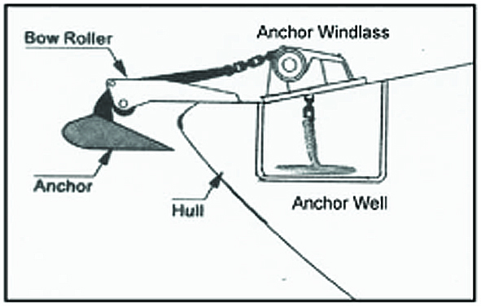  You may mount on the top of hatch and attach plywood under the hatch to spray the force.(You need to be able to open the hatch, if the rope gets tangled)  ● If there is a hatch and anchor well below and with internal access to the cabin:  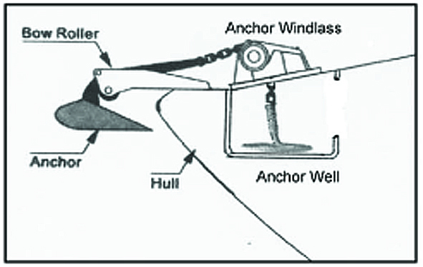  You can also mount on the top of hatch and attach plywood under the hatch to spray the force. The best result is to replace the hatch into plywood and secure the plywood to the deck.  Note: While anchored, always tie the rope to the bollard. Do not allow the windlass or the hatch to take the strength from the anchor rope.

3. CONSTRUCTION
a. | Place the windlass on the deck and find a suitable position for it, with reference to the vessel’s bow roller, rope and chain locker below.  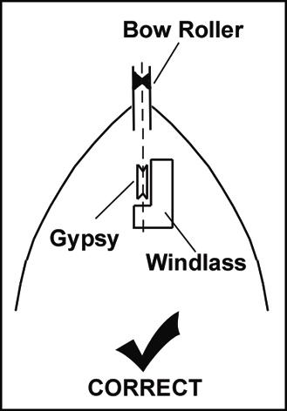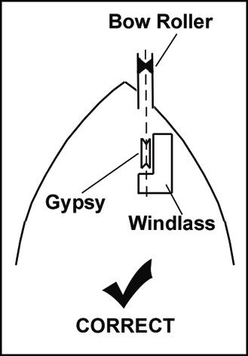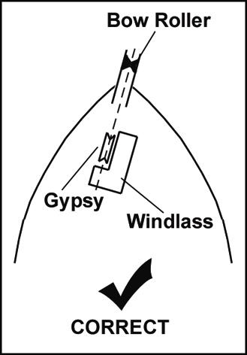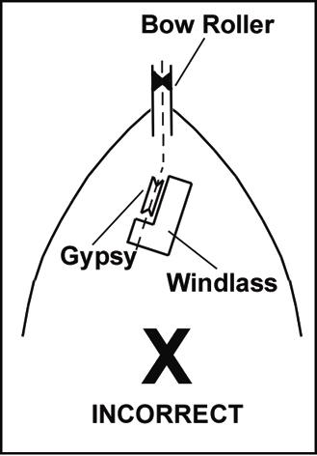
b. | Place the mounting template on the deck in the desired position for the windlass and hold it in place using adhesive tape
c. | Use a 10mm(3/8") diameter drill to make four holes for the mounting thread rods and make a fifth hole to pass power supply cables through.
d. | With a jig saw, cut the hole for the rope and chain to pass through. Use a file to smooth any rough edges. To avoid water absorption by the deck, apply paint to the cut hole edges.
e. | Place the sealant EVA form under neath the base of windlass and secure the windlass firmly to the deck from below using the bolts, nuts and washers supplied
f. | Mount control device at a suitable position either in the cabin or close to the operating area.
g. | Connect the windlass, control unit and power source using electric cable indicated below. Keep the power supply cable as short as possible. Too thin and/or too much length of electric cable will reduce the performance of the windlass or cause the circuit breaker to work incorrectly  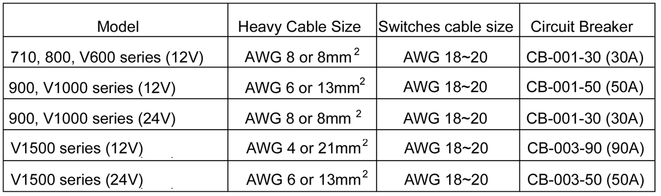
h. | There are two different control systems for South Pacific windlasses. Do not mix these two systems in one windlass.  1, Direct control system(standard):  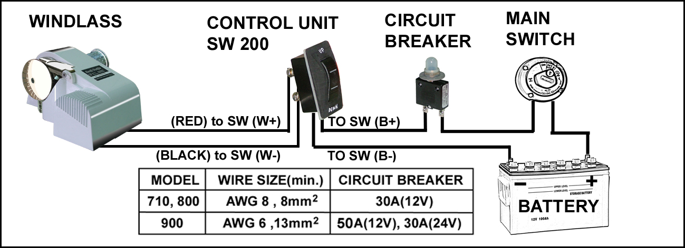  Note: For safety reason, do not connect the power source direct to the battery. Please connect the power cable to the main power switch on your boat.  SW-200 with dynamic brake, can not be parallel.  2, Indirect control system(option):  Using foot switches or hand held switch for multiple control, a solenoid(DC contactor) K-200 is necessary.  If you have an existing control unit (SW-032 or SW-200), you must remove it before installing this indirect control system. Also, do not attach control unit (SW-032 or SW-200) to K-200 as an up/down switch (SW-025).  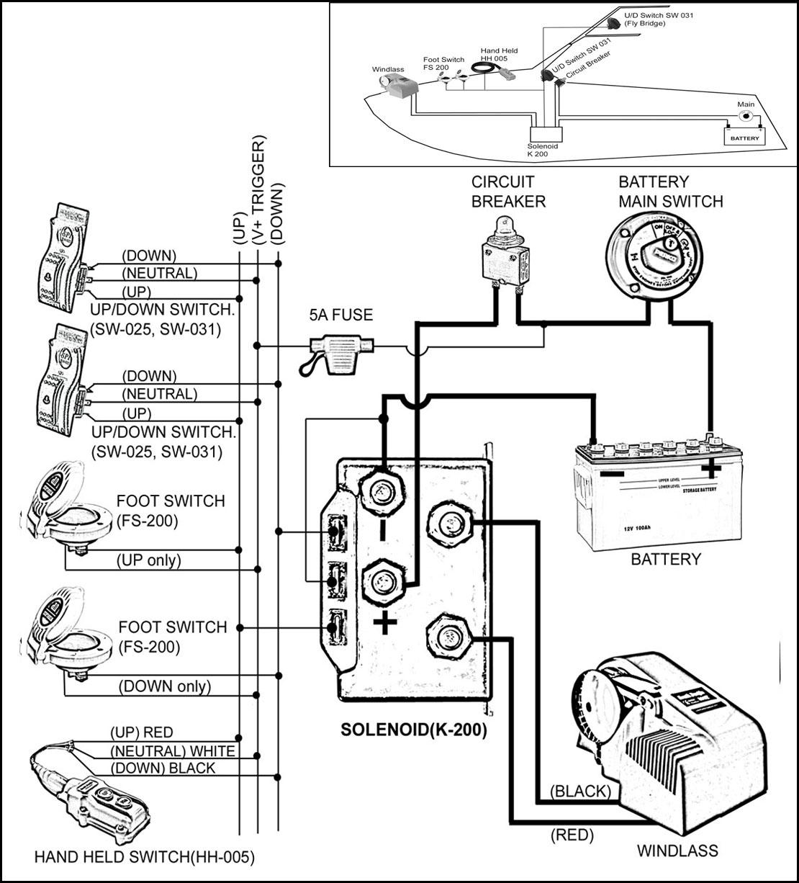
4. TO INSTALL ANCHOR ROPE AND CHAIN
To splice the rope to the chain, please follow the steps below.
Do not use a hook or shackle.
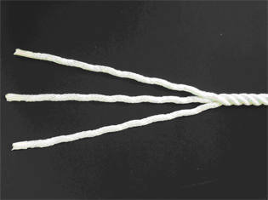 | STEP 1:  Unraveling the end of the rope for about 20cm and secure the end of the strands with tape.
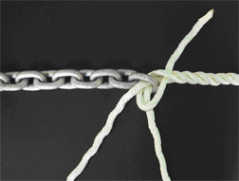 | STEP 2:  Pass three strands through the last link of the anchor chain. Untwist the rope to raise a strand just below the tie on the standing part of the rope and insert one strand under it, then pull the strand through. Twist the strand to keep it tightly wound as you pull it through.
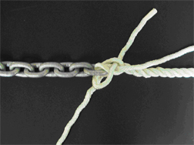 | STEP 3:  Take the next strand on the left. Tuck it under the next strand to the right of the one under which the first strand was tucked. Pull it through as before.
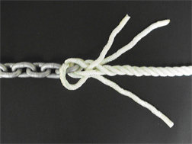 | STEP 4:  Now turn the whole eye over. Take the last strand and make the tuck as before under the only strand on the standing part of the rope not used yet. Stop and ensure that each working strand has gone over a strand and under a strand, and that the whole lot is pulled tight and twisted in its natural sense. No two strands should come from under the same strand.
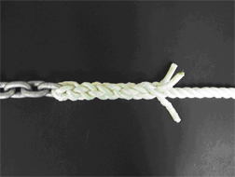 | STEP 5:  For the remaining rounds of tucks, take each end over one strand and under the next one to the right, in the same order as before.
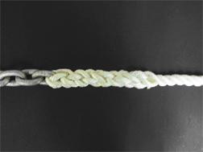 | STEP 6:  To finish, pull the ends tight. Cut the excess off with a hot knife. A good way to do this is by heating a butter knife with a butane torch, or a gas stove if handy. This cuts and seals the individual strands resulting in an excellent frayless finish.
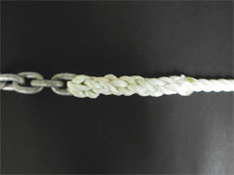 | STEP 7:  After you’ve spliced the rope to the chain, tie both ends of the splice rope to prevent the rope from loosening.

V OPERATING

1. | During operating, if the circuit breaker bounces it means the motor is overloaded. After about 10 seconds press the button to reset.  For free fall model only: When releasing anchor, press switch “DOWN” and hold it to free fall the anchor to the sea bed (It is normal for the windlass motor to be running and the clutch will stay at open), until the current has drifted the boat to a desired location and the anchor has cast firmly in the sea bed, release the switch to engage the clutch.  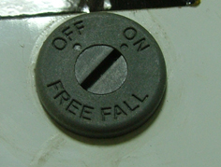  You can set the rotatable “free fall” switch(in the right hand side of windlass) by a flat screw driver to be a “on” free fall mode or “off” Power Out mode.  Note: Please free fall anchor to the bottom in one fall. (Do not release the control switch during the anchor’s fall.
2. | Pay out the rope and chain approximate 2~3 times the water’s depth for a firm casting while being anchored.  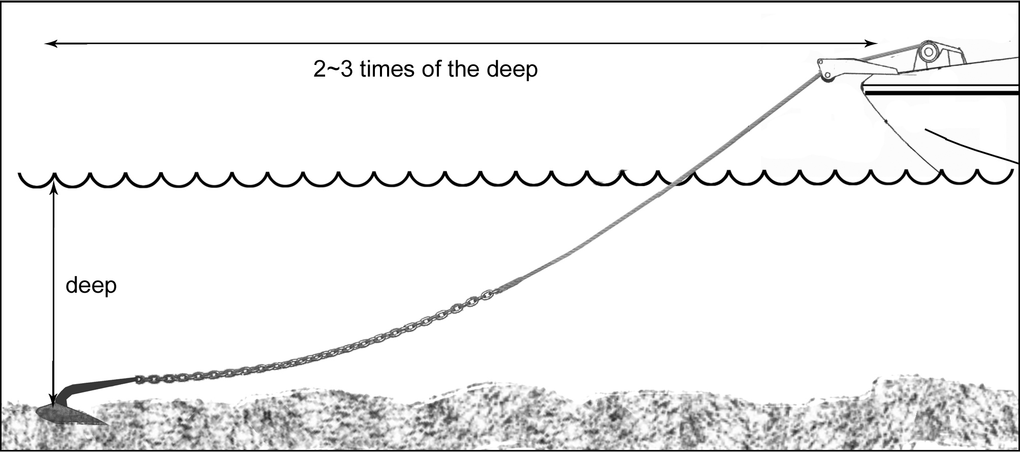
3. | Keep limbs, fingers, clothing and hair clear of the windlass and anchor to avoid possible personal injury during operation.
4. | Tie the anchor rope firmly to the bollard when the anchor is cast and the boat is moored. Do not allow the windlass to take the force of a boat’s drag.
5. | When retracting the anchor, untie the rope from bollard. move the boat above the anchor by boat’s engine power(not the windlass power)  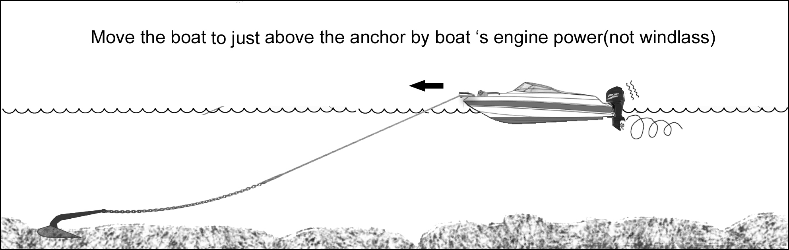  and switch on the windlass to drag it back. When the anchor is close to the bow roller, slow down the roll in by pausing the switch.  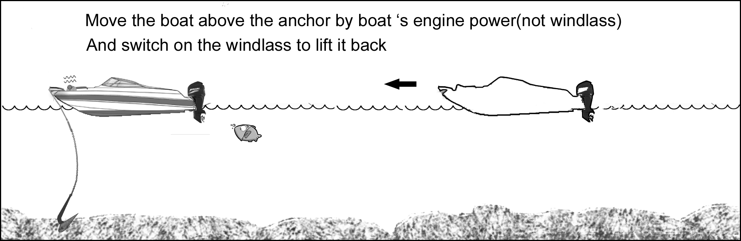 Note: The windlass is designed to lift the anchor rather than to drag the boat or for mooring.
6. | If the anchor is stuck on the seabed or reef, detach it by the boat’s engine power before operating the windlass or else it may cause damage or the load may overstrain the windlass.
7. | After use, secure the anchor firmly in place in the boat by extra device(such as hook, shackle…) to avoid damage caused by anchor falling during transport.
8. | The anchor windlass is not designed for continuous operation. Do not use for more than 15 minutes at a time under loading. Allow an interval of 20-30minutes after each operation.

★OPERATING SAFETY IS THE FIRST PRIORITY★

VI MAINTENANCE

1. | The windlasses come with a grease lubricated gear box. There is no need for extra lubrication
2. | In order to make the windlass perform at optimum capacity and extend its life, use fresh water to wash off salt water after each use.
3. | Periodically check the electric joiner and the silicon sealant.

VII WARRANTY

1. | The warranty is deemed as effective only under conditions of normal operation, maintenance and without modification of the product.
2. | CLAIMS  If the product needs servicing, please send it back (or bring it to us) with the proof of purchase and we will investigate the product free of charge before repairing. However, the cost of postage or removal from the boat will be borne by the owner.
3. | LIMITATIONS AND EXCLUSIONS  The warranty will be deemed effectively only if used on a non-commercial basis and will be invalid and excludes the following conditions:  - Operation exceeds the designed specifications  - Use for purposes other than indicated  - Disassembly or modification of the product  - Installation of other parts on the product  - Third party products even if associated or used together with this product.

VIII IMPORTANT INFORMATION

1. | In every circumstance, the operator must make safety as first priority. An inexperienced persons or a child should not operate this product. The manufacturer takes no responsibility for any damage, property loss or injury as a result of improper operation.
2. | If a product is accepted for refunding, the manufacturer is not responsible for any renovation of the boat.

IX PARTS LIST

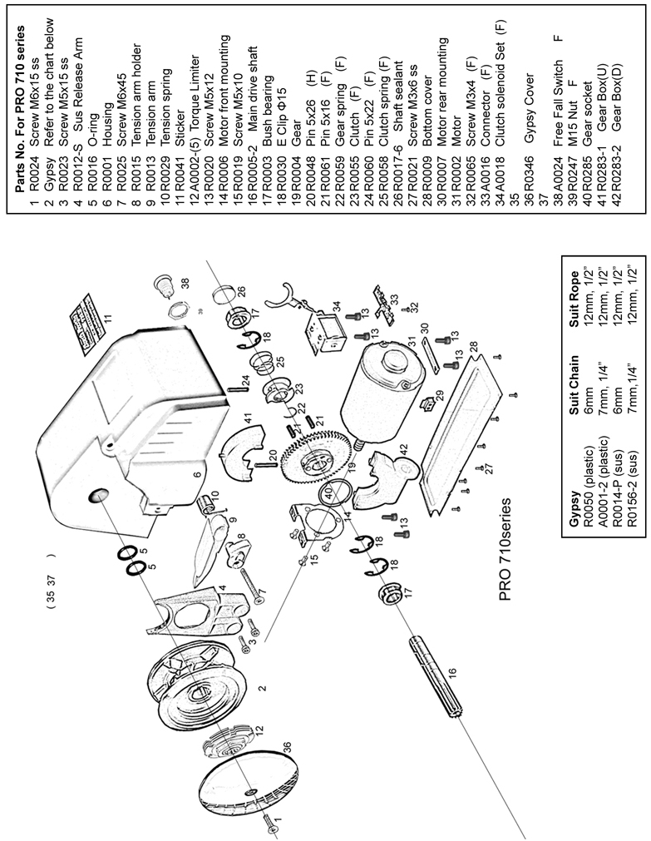

Thank you for choosing South Pacific products

Purchase Date: Model:
Supplier Name:
Address:
Phone: Fax:

