Network P2P WIFI IP CAMERAS
User manual
(Android & Iphone)

Installation guide for APP on Mobile phone

Step1 :Download App 163eye on your phone
- Download methods on iphone
1)Search and download 163eye in Apple APP store and install it .
2)Download 163eye APP from the website:http://163eye.cc
3)Scan the QR code that on the gift box by QQ, Baidu UC scanning browser to download the APP

2.Download methods on Android phone
1)Search and download 163eye in Google Play and install it .
2)Download 163eye APP from the website:http://163eye.cc
3)Scan the QR code that on the gift box by QQ, Baidu UC scanning browser to download the APP

Step2: Account registration
1.Start The APP 163eye
2.Click phone “register” to register an account
3.Choose register by mobile phone number or email

Register by mobile phone number : fill in phone number -----click “Next” fill in the captcha text message once you got it---------setting the password -----click “Next ”--------register is finished
Register by email: Fill in valid email , setting the password , click “Next” ,register is finished
Note : Don’t forget your account and password

Step3:Device connect to power

1.Make the device and phone near to router and make sure the wifi signal is good . (the device did not support 5G network)
2.After pluy in , about20 seconds , you can hear “ di-di -di ” from the device . If did not hear “ di-di -di ” , pls press the reset button that on the bottom of the device about 3 seconds and you can hear “ding’ to reset , and after 15 seconds later you will hear “ di-di -di ” from the device

Step4: “+” add the device by WiFi
1.Star APP 163eye
2.Click “+” that on the upper - right corner , click “Smartlink”
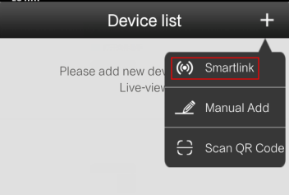
- When you hear “di-di-di”from the device , click “hear the connection prompt”
4.Fill in the wifi name and password , and click “Next”

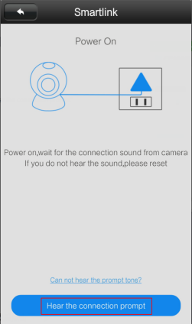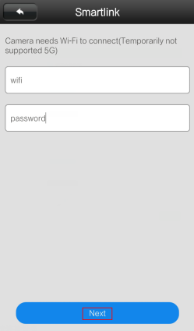

5. Follow the tips ,make phone’s sound louder and near to the device and waiting for connected .
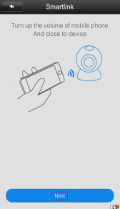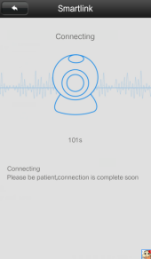

6.Fill in the password 123 once added the device successfully and save it
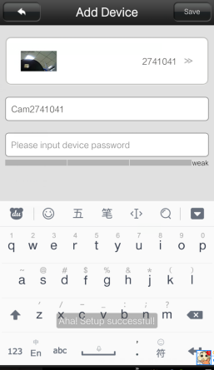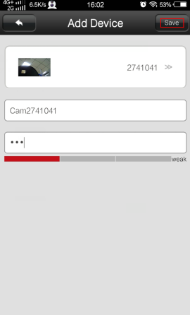

7. Click device on the device list to view the real time images
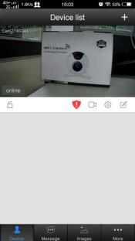

8.For safety ,pls changed the original password and remember it.
1). Click to modify the password
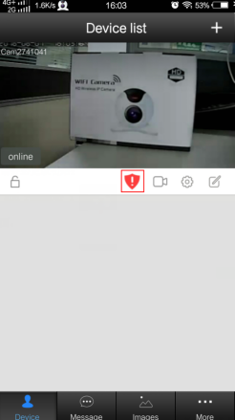

2).Fill in original password 123 , then fill in the new password 2 times
And click “Dome ”to save it

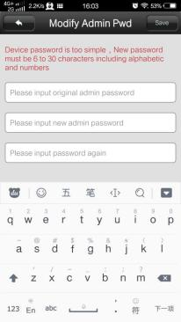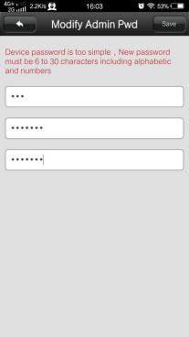

Step5 Add device by network cable
1.Pluy in power and connect to network cable . Make sure the network cable work well with the router and wifi from same router .

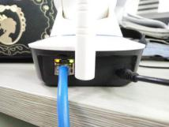

2. After that , about 30 seconds , start the app and pull and refresh the device list , you can view the device ID in LAN
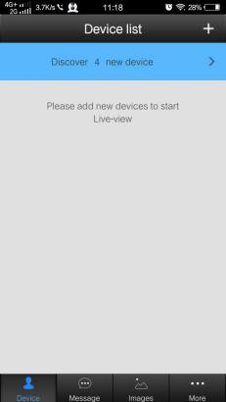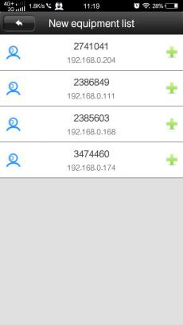
3. Click, that the the device ID right side to add the device , other steps pls follow Step4---6.

Step6 : Switch wired and WiFi network

1.Wired switch to wireless network
Click , Settings ----network setting -----choose the wifi from WiFi List --- click “change ”fill in the wifi password , -------switch successfully ----take off the network cable after 10 seconds
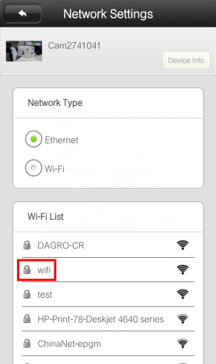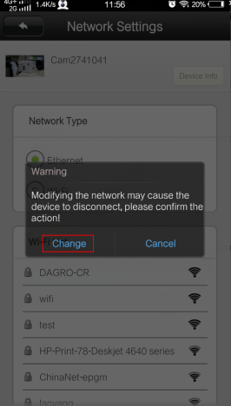

2.WiFi network switch to wired internet , connect the network cable to the device directly is OK , no need any setting .

PC client CMS operation guide

1.Download PC Client CMS
Download the PC Client from website:www.163eye to PC and install it
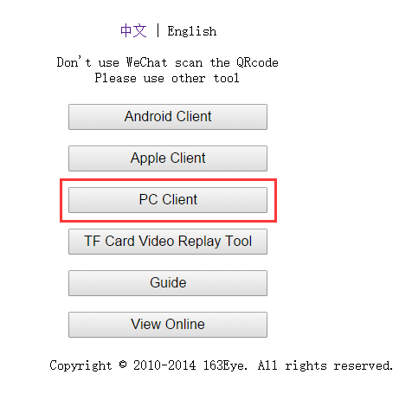

1.Login in PC Client
1) No need to register , just start CMS click “OK” to login directly is OK
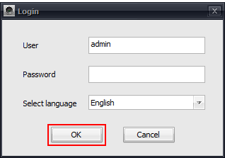

- Add local device and external network device on PC client

Add local device ： After logging in, the software will automatically search the current local area network equipment, and prompt the user to automatically add, if you do not need to add, please click “ignore”.
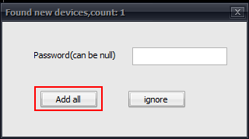
Add network device:
1)、In the left of CMS software interface, click on the "" button to add devices manually, and input device ID and password (It is recommended to identify the name of the device, the following is Office-1), and then click OK.
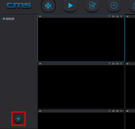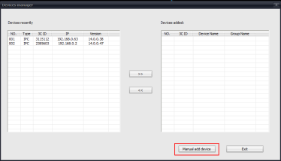
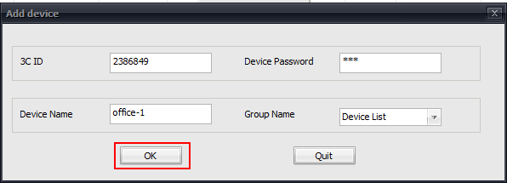

2)、After add the device successfully , click the exit button.
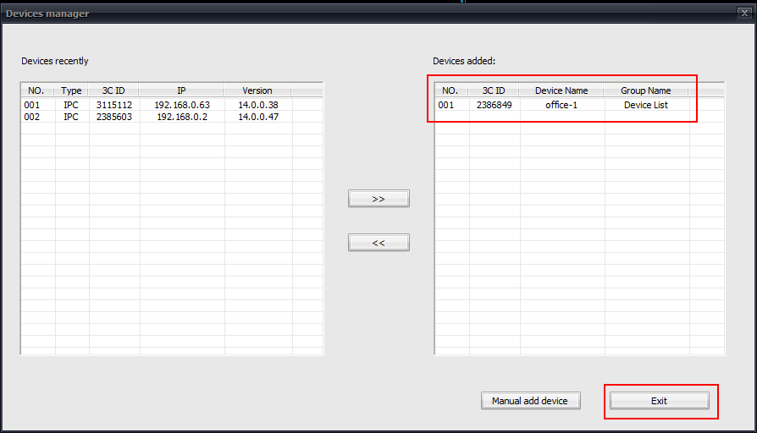

3)、Keeping the left mouse button depressed on your device “” , move to the right.Then, you are free to arrange the monitoring window.
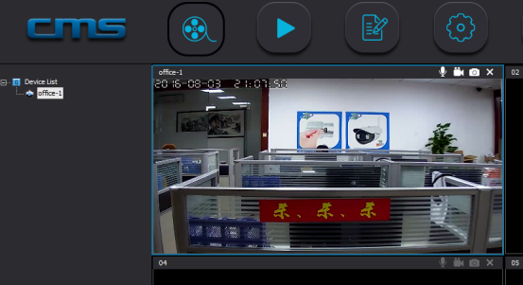

4, Video settings of computer client
1)、Video: the device can store video recording on the computer hard disk.
Method 1:

At the current monitoring window, click the right mouse button, pop-up "start video" button, click it and you can start recording.
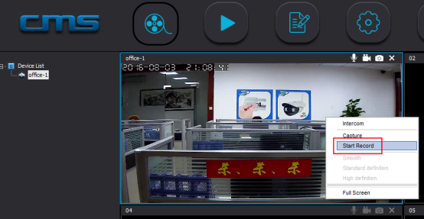

Method 2:

Click the CMS interface settings button, pop-up settings options, click "Browse" button, set the video storage location.
Keep “loop video” and “monitor automatically” open, and click the Save button to exit the current settings interface.
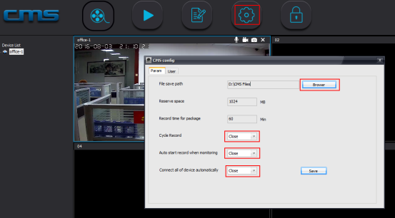

2), Playback: the device can playback on the computer.
In CMS software interface, click on the playback button, select the device, time, and click on the search button.
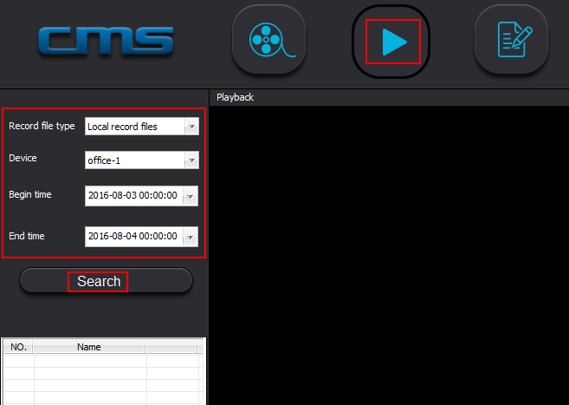

5,Wireless alarm learning to match code
Device (some devices )can be connected to 433wireless alarm sensor (for example door magnet , remote control , smoke detector,PIR ect.)learning to match code, establish wireless alarm system.
For example , the door magnet learing to match code to 1 channel in hall area:
Step1. Setting ---Defence Area---Hall---1---OK and trigger the door magnet at the same time , when show "learning success " , exit .
Step 2. Click" Alarm Settings" ---push "receive alarm message "buttomon on ---exit.
Step3. Make the lock locked . Once the door magnet triggered , the App would push the alarm message to your phone

F&Q
1), Q: APP did not prompt discovery of new equipment when adding equipment.
A: please check whether the camera and mobile phone are in the same LAN
Please check whether the network indicator light of the camera is always on.
If the camera and mobile phone is not in the same local area network, the user needs to use the ID number to manually add the camera.
2), Q: It prompted password error when I’m viewing real-time video.
A: Please check if the remote access password set by adding the camera is correct,
If it is not correct, please select Edit from the list of video cameras to reset the remote access password;
If you forget the password, it is recommended to press the "reset" button to restore the factory default settings. (The default password is 123) For the first time add a camera, you should click on the red shield with exclamation mark under the camera list. For more details, please refer to the operation guide for Step four > 8 )
3), Q: Device offline?
A: Please check whether the camera is connected to the network, and whether the network indicator light is always on;
Please check the router is working.
4) Q: Failed to search the video file when playback?
A: please check whether the SD card is damaged or not.
Please check the video file searching time, and the camera system time.
5) Q: The camera can not connect to WIFI?
A: Please confirm the WIFI password is correct.
The camera does not support the 5G network, please connect the phone to the WIFI 2.4G network.

