360EYES operation manual

1.1Download App
（1）Search and download 360eyes in Apple app store or Google play and install it .
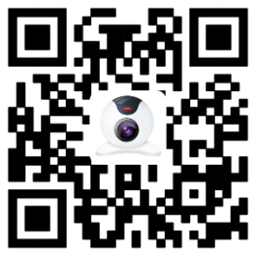
（2）Scan the QR code that on the gift box to download the APP.

Note: The Android system only supports android4.1 and above, the apple system only supports ios8.0 and above.

1.2 Account registration and device-addition operations
1.Account registration--Access to software interface after installation, and register as shown below
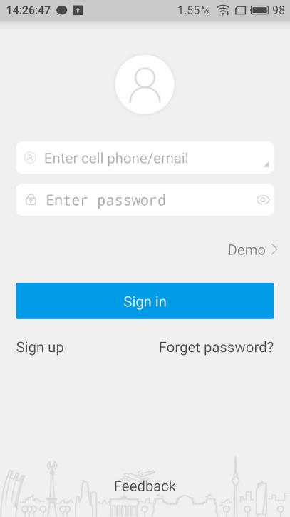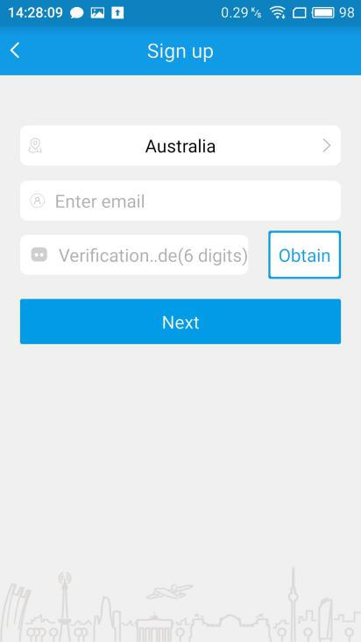
Note:
（1）Choose the right country, enter the exist and effective phone number / Email. The system will automatically send a verification code to you, please find in SMS / email.
（2）Mobile phone number / e-mail must be exist and effective, and make sure you can receive the verify code.
（3）Clicking the next step after enter the verification code.After set the password means register successfully
2.Device-addition operations--Access to software interface after register successfully, and add device as shown below:
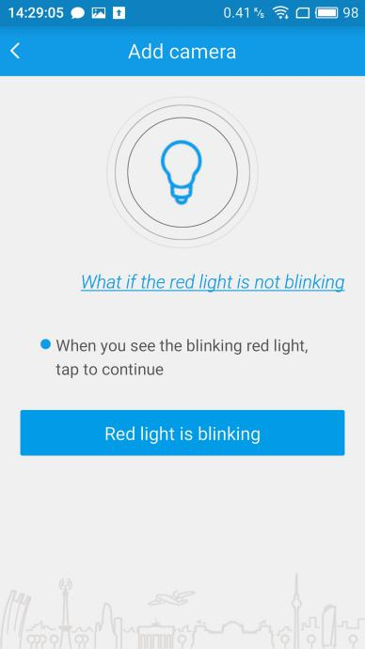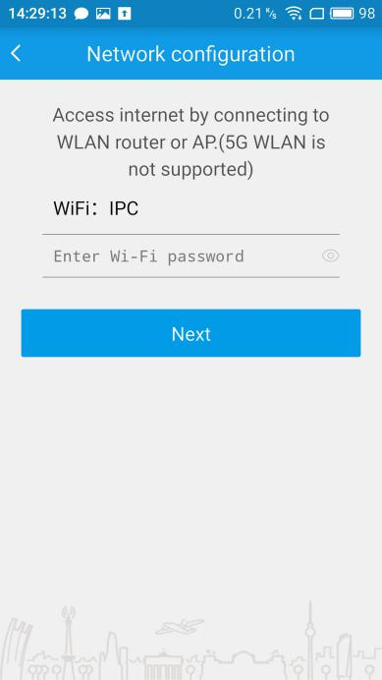

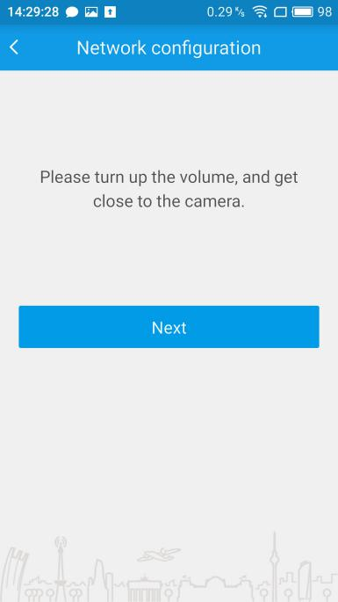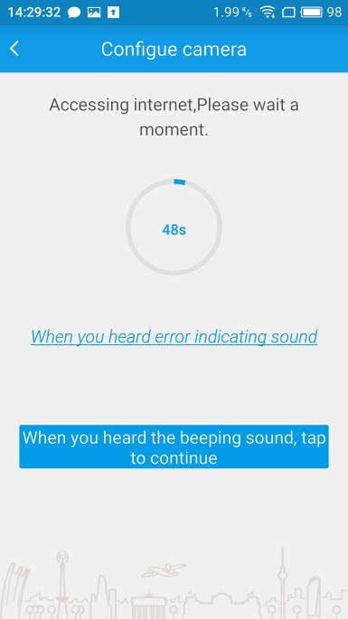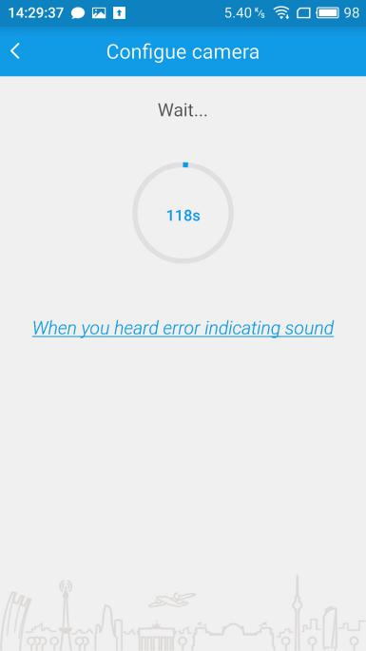
Note:
（1）After plug in , about20 seconds , you can hear “ di-di -da” from the device . Then you can add the device. If did not hear “ di-di -da” , pls press the reset button in the front of the device about 3 seconds. And you will hear “ di-di -di ” from the device, which means reset successfully.
（2）Input the password according to sound prompt. And click “next”after hearing "Ding Dong" sound. When the equipment broadcast"has access to the Internet”,and the device is in green light flashing. That means added successfully. Name your camera or skip this step to view the video screen on the phone
1.3 Forget password
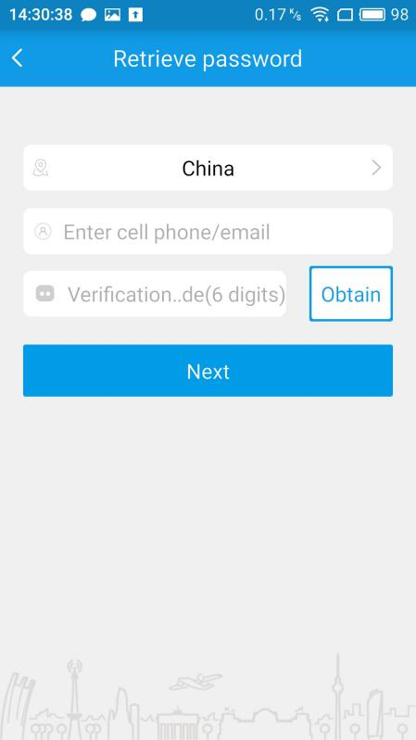
If you forget your password, please click on “Forget password”, and fill in information. Then, Click on “Obtian” get the verification code. Click next, reset the account password.
1.4 Real-time Viewing
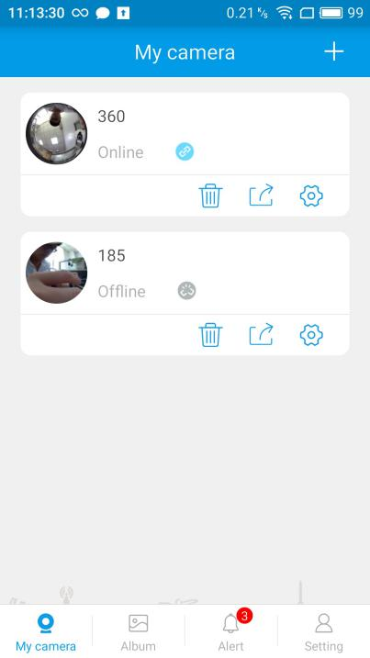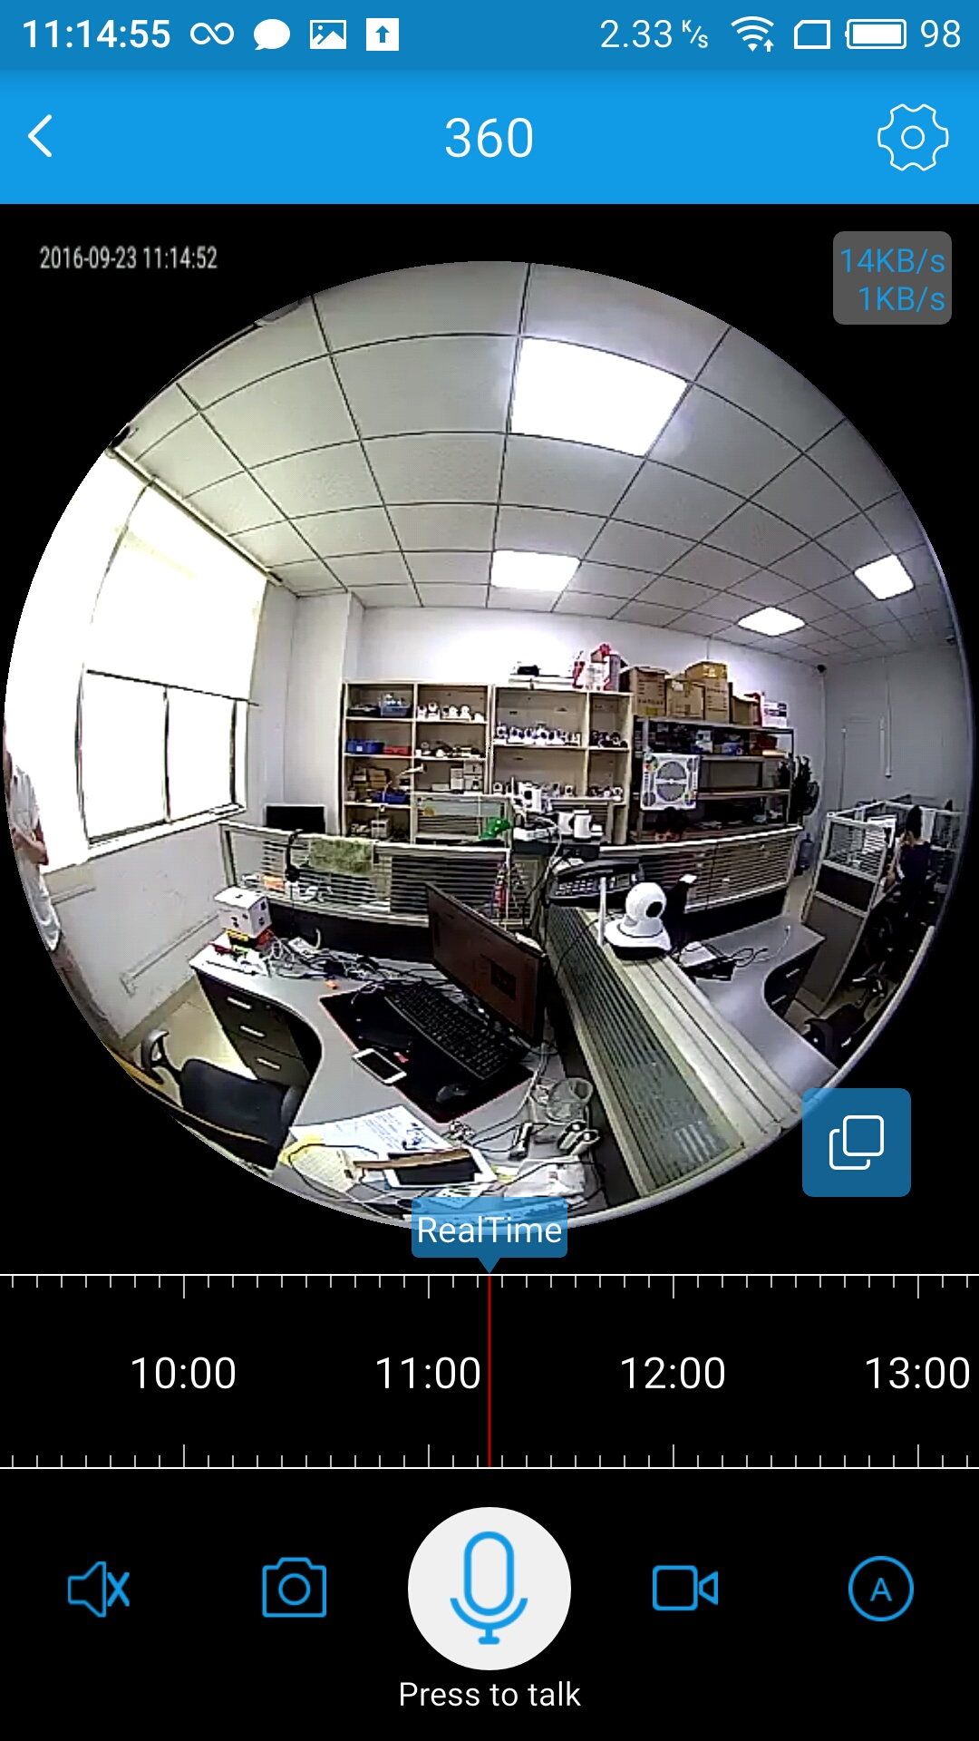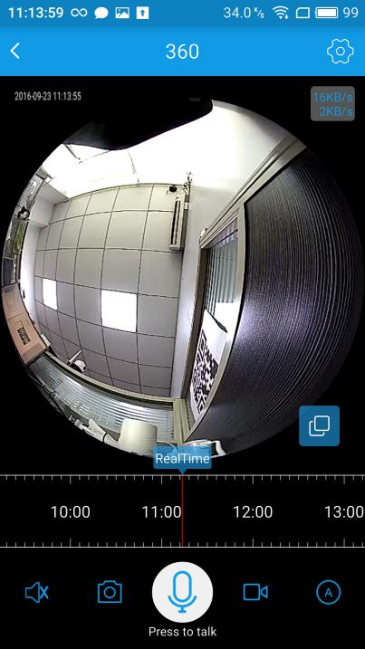
After the device is successfully added, it can be clicked into the real time preview state. The real time preview screen supports the 3D stereoscopic viewing function and can be used to slide the preview screen through gesture to monitor every corner of the preview screen.Slid up and down the screen to zoom in and out.Slid left and right the screen to move the monitor around the screen.
button | Function description
 | Close real-time screen, and switch to other cameras to watch
 | Click to enter camera settings
 | Close / open live sound
 | Switch to different picture quality mode: HD mode, standard mode, or adaptive mode.
 | Adjust the brightness of the LED lamp(Only for the bulb)
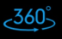 | Click to start stitching panorama (only for the type of PTZ camera)。
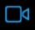 | Start local record
 | Stop local record
 | Screenshot
 | Click to open the intercom
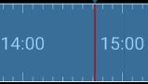 | Click to watch the video playback

1.5PTZ camera playing and panoramic stitching function
When you added a PTZ camera, you can see this button. Click on this button, the camera starts to rotate, and you will get 20 different pictures.
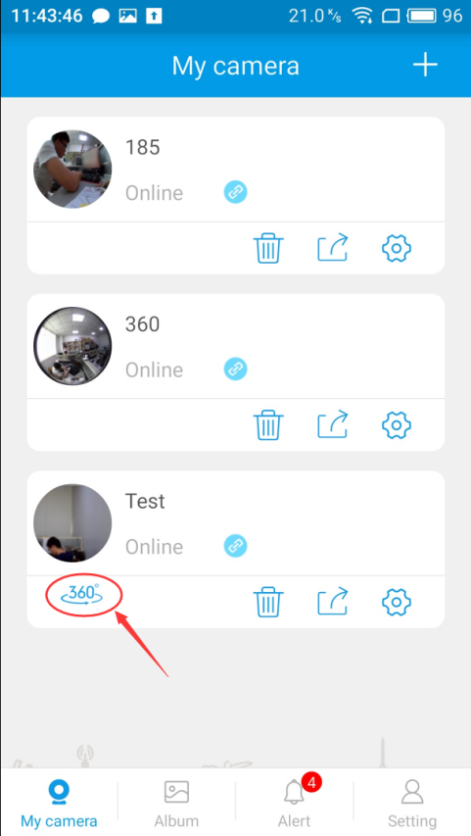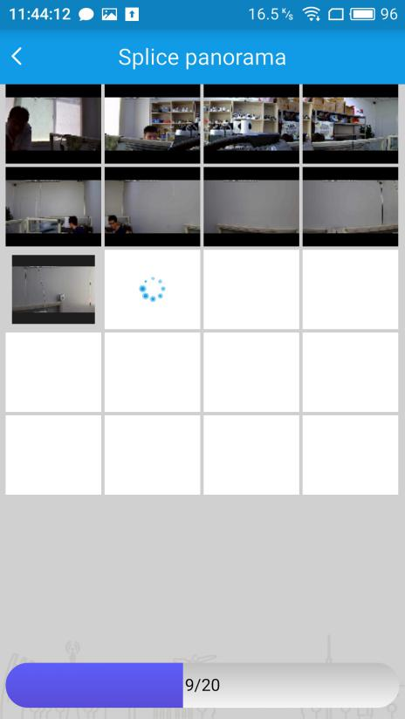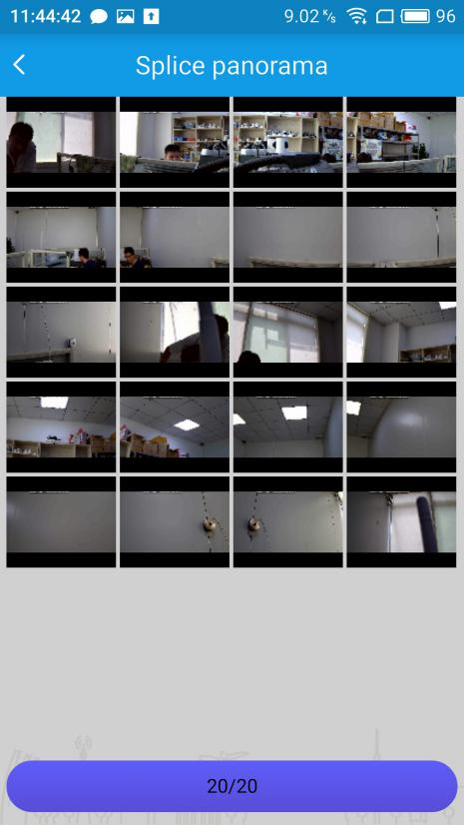

It will splice into a Panorama after intercepted 20 pictures
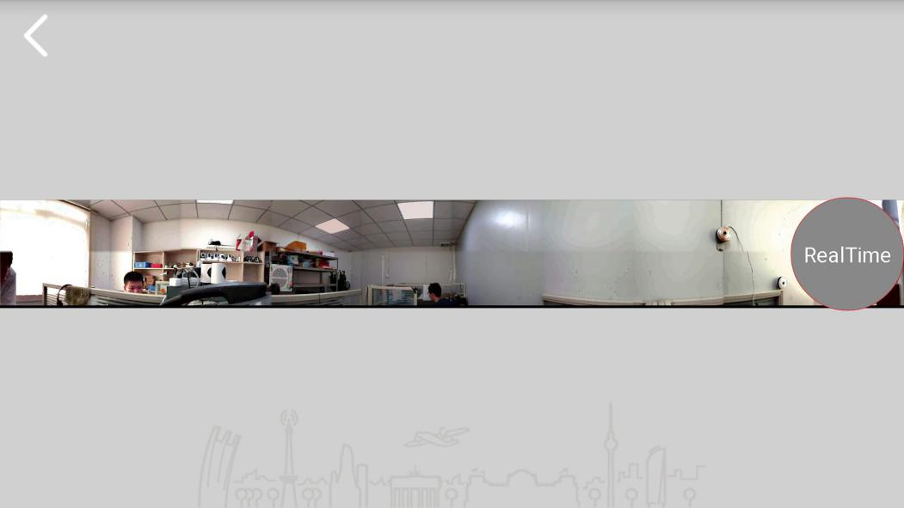

Then click on the play in real time, you can enter the play interface
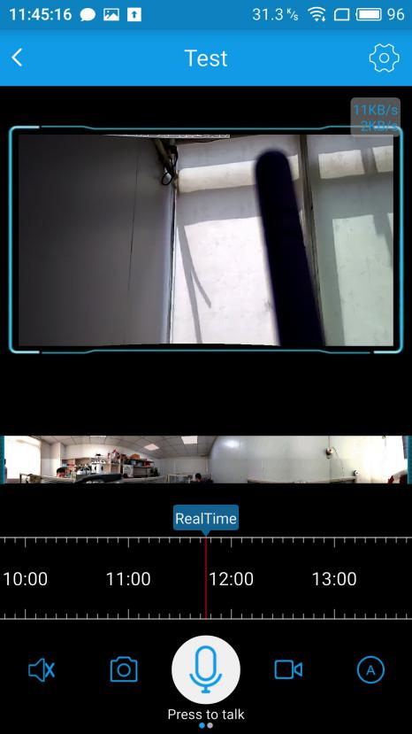
The player interface will have a video playback screen and a Panorama. You can control the camera by clicking the panorama. Where you point in the panorama, where the camera will turn to; you can also manually drag the playback screen to control the direction of the camera.
Horizontal screen viewing:

Slide to the left toolbar in the play page, you can also find the stitching panorama map button. Click 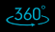 to enter the panorama stitching page.
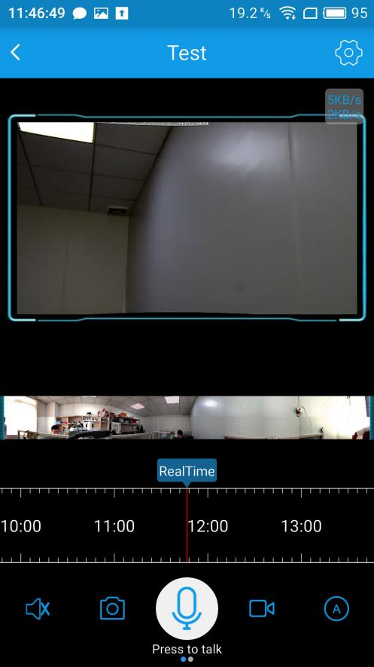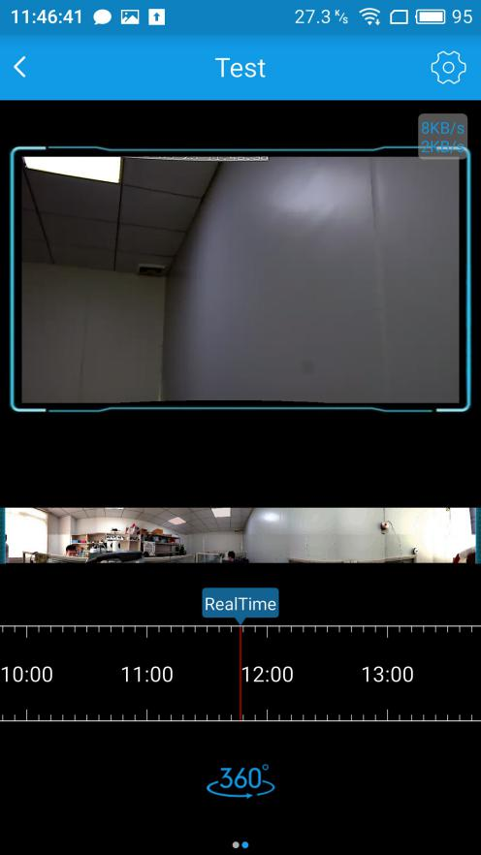
Of course, you can also directly enter the play page without panorama stitching operation after added a panoramic view. So that the interface only present a video playback screen without panoramagram.
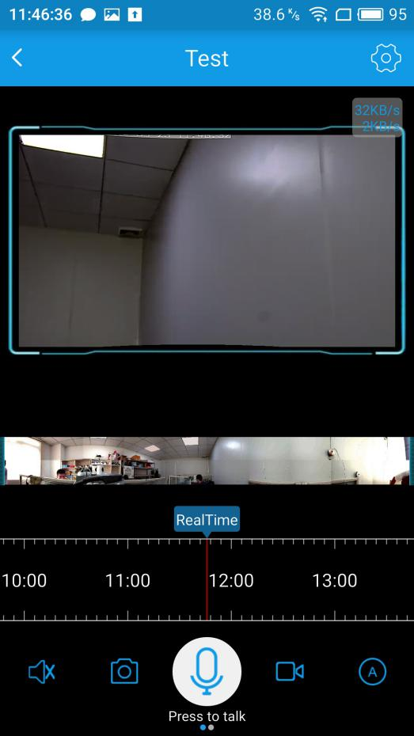

1.6 Remote playback
In the case where the camera is installed TF card, mobile client can remotely transfer of video data stored in the panoramic camera.
Drag this, and select the time which you want to view.Then,you can replay remote video.
Insertion and removal of TF card must make sure the camera is power off.In normal circumstances, the video file will display a blue band (as the picture). If there is no blue band, please confirm whether the TF card is in abnormal state,and pull of the plug.Try to remove and insert the TF card again.

1.6.1 Remote playback-- the way of video evidence collection
In the case where the camera is installed TF card,Drag the time bar, and select time period. Click start to take video from the camera,and click to stop and complete.Then you can directly view the video on the APP album; It also can be found in the mobile phone local storage to the folder "ipc360". The recorded video data is stored in the folder "Record" .
1.7 Motion detection
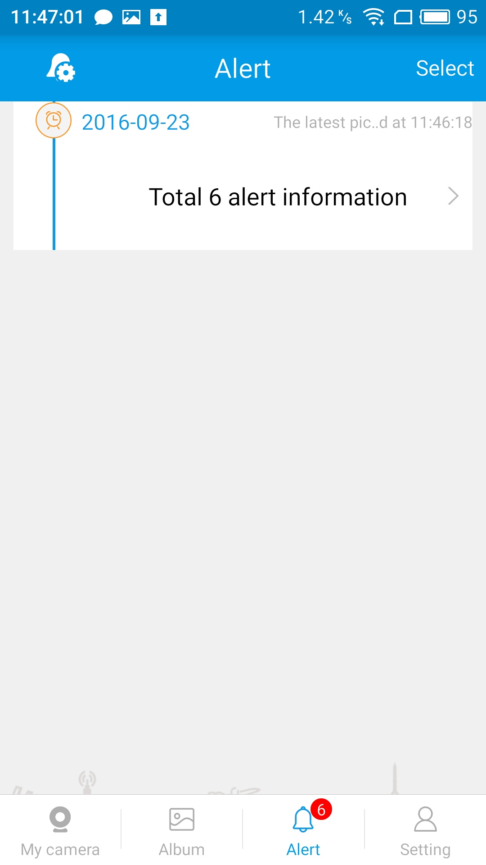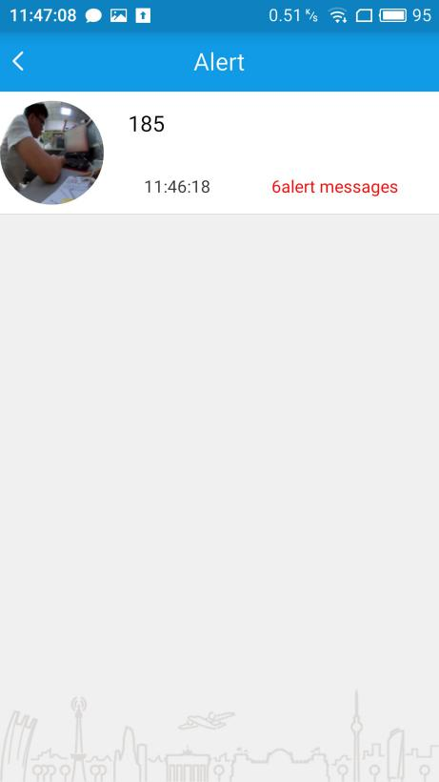

Click to enter the Alert interface. Only in the case of TF card has been inserted into the camera,you can download and view the alarm picture. Otherwise, it will only push the alarm information, and you cannot download alarm pictures.
Insertion and removal of TF card must make sure the camera is power off.If it is prompted to download failure,which may be related to the network environment. You can return and try more times.

1.7.1 Mobile detection - enhanced alarm settings
In the "alarm" page, click on the upper left corner of the alarm settings button to enter the alarm settings page. In this page, you can close / open the alarm function, set the alarm time of the equipment, change the alarm sensitivity and the warning area. You can set different alarm parameters according to their specific needs.
Click to re set, you can see the set of motion detection time, you can choose to let your equipment in a fixed time period for alarm.
Click the advanced settings, and you can carry out sensitivity settings. Sensitivity level is divided into 6 grades from 0 to 5. Level 0 represents the lowest sensitivity grade,and Level 5 represents the highest sensitivity grade. You can set the alarm sensitivity according to your needs.
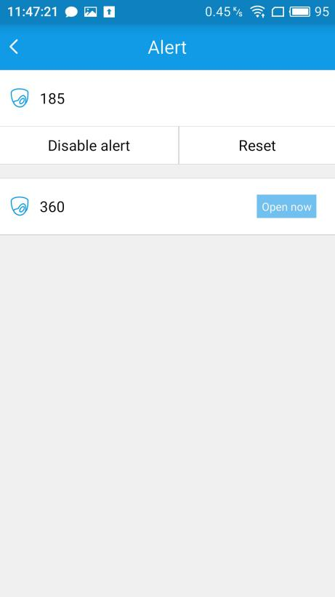
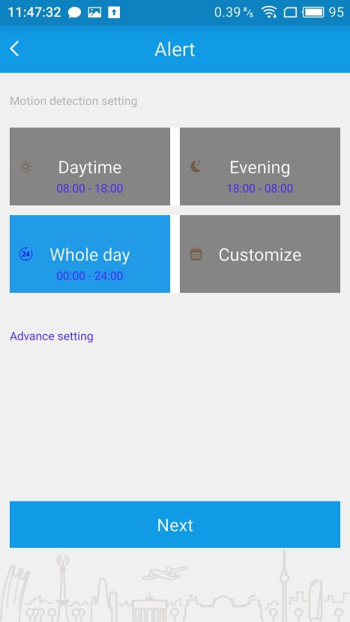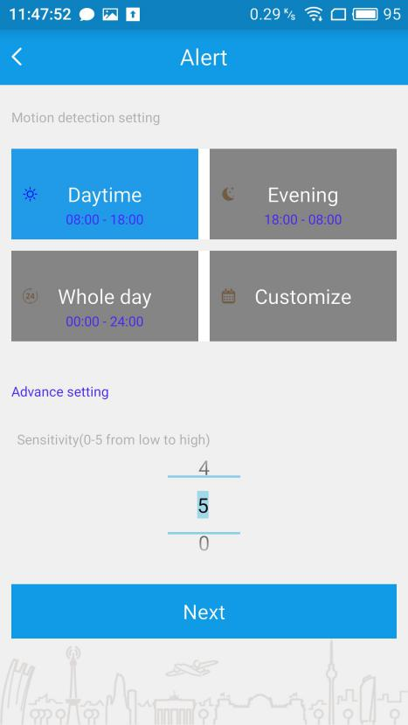
Choose the alarm period and sensitivity level you want, and click the next step. It will enter the alarm area settings, then continue to click on the next step, pull the screen and click "finish".
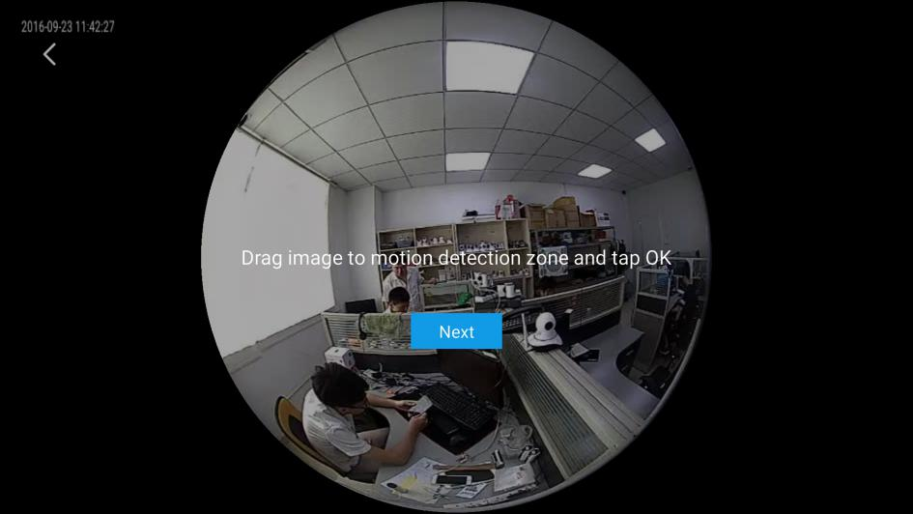
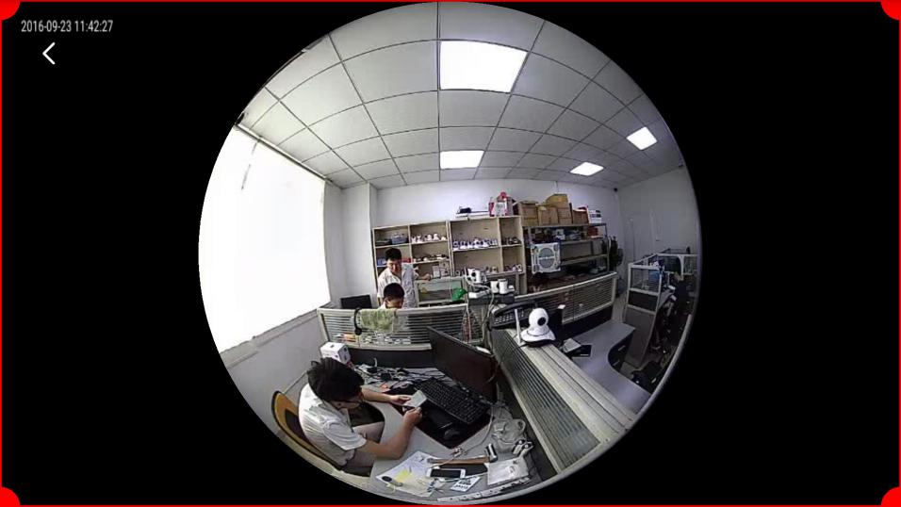

1.8 Device management
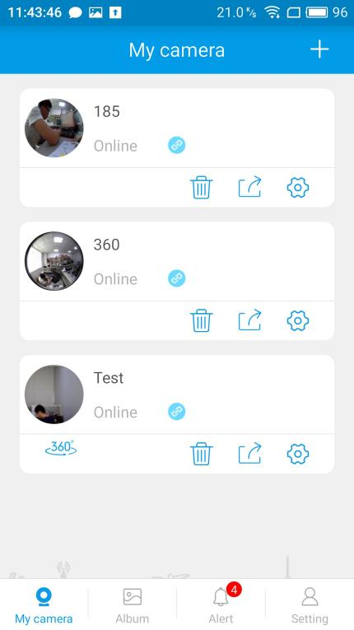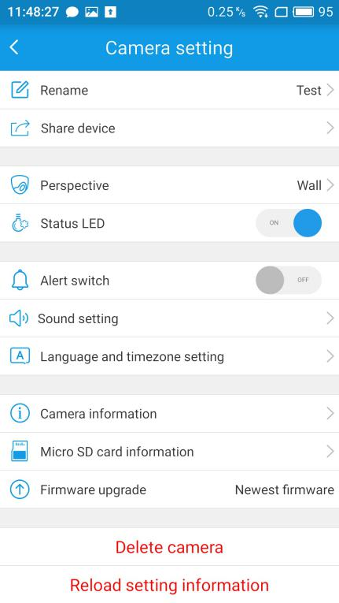
In the "my camera" interface，you can see "delete", "share", "setting" button. Click to enter the camera setup interface.
Main functions:
(1) Delete the device;
(2) Rename the device;
(3) The equipment can be shared to another account;
(4) Set the view of camera ;
(5) Adjust LED lamp mode;
(6) Turn on / off the indicator light;
(7) Turned on / off mobile alarm function;
(8) Adjust / turn off the broadcast voice of device;
(9) Broadcast language and time zone setting;
(10) Check camera information: such as the firmware version, the device MAC address;
(11) To view TF card information;
(12) To detect whether it is the latest firmware.

1.9 Album
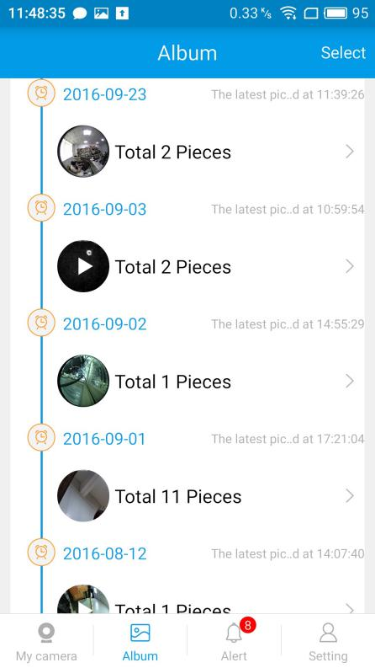
Click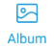to enter the album:
You can find the screen-shot images and manual video recorded MP4 files in here.
1.10 Application settings
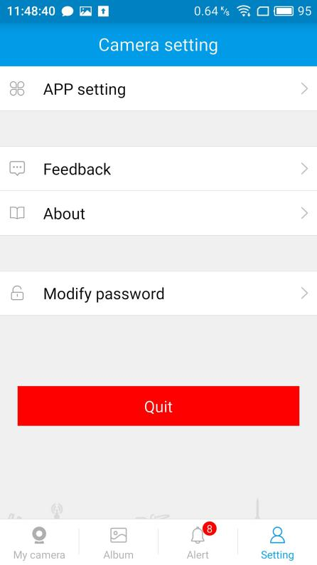
Click for application settings:
- It can be set if you need to receive alarm information after the shutdown of the APP . So that you can know the emergency situation in a timely manner.
(2) You can set the alarm prompt tone when the APP is turned on.
(3) It can be set whether to show the playback display ring.

1.11 Feedback
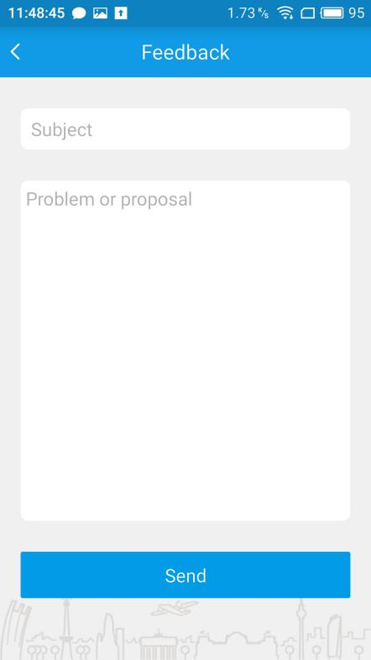
Click 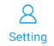to enter feedback:
If you have any problems or suggestions in the course of using our products,pls tell us . And we will try our best to solve your problems and meet your needs.

1.12 About
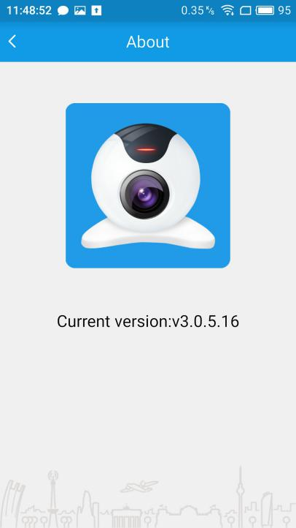
Click on to enter:
Check for updates: see if the current APP is the latest version;
1.13 Modify password
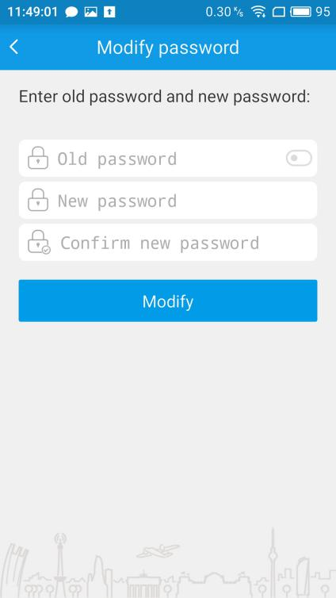
Click to enter the "modified password" option, where the user password is modified. Type your old password ,new password and confirm new password. Then, click “modify”.

1.14 Account switches
Click “setting” to enter the camera settings, and then click “Quit”, and return to the login interface.

