Ф.И.________________________________________________

ЭДУАРД ШИМ
«Жук на ниточке»
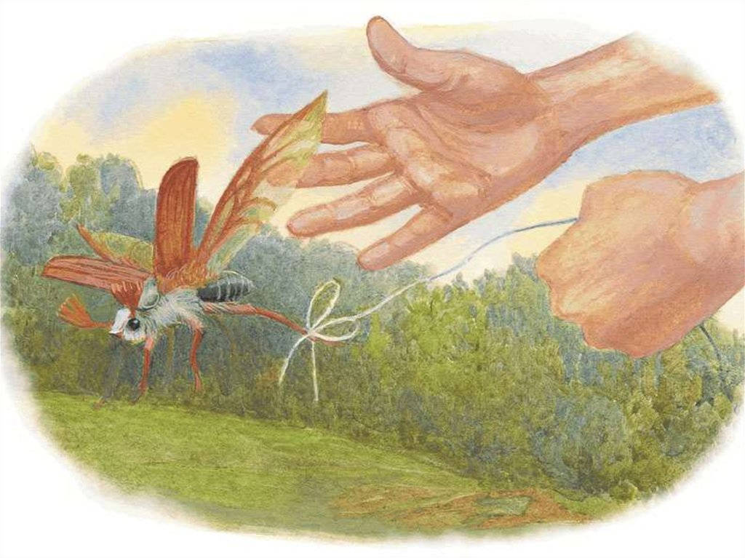

- Чтобы ты посоветовал герою данного произведения?
Напиши мальчику письмо.

_________________________________________________________________________________________________________________________________________________________________________________________________________________________________________________________________________________________________________________________________________________________________________________________________________________________________________________________________________________________________________________________________________________________________________________________________________________________________________________________________________________________________________________________________________________________________________________________________________________________________________________________________________________________________________________________________________________________________________________________________________________________________________________________________________________________________________________________________________________________________________________________________________________________________________________________________________________________________________________________________________________________________________________________________________________________________________________________________________________________________________________________________________________________________________________________________________________________________________________________________________________________________________________________________________________________________________________________________________________________________________________________________________________________________________________________________________________________________________________________________________________________________

- Найди интересный факт о майском жуке.
__________________________________________________________________________________________________________________________________________________________________________________________________________________________________________________________________________________________________________________________________________________________________________________________________________________________________________________________________________________________________________________________________________________________________________________________________________________________________________________________________________________________________________________________________________________________________________________________________________________________________________________________________________________________________________________
