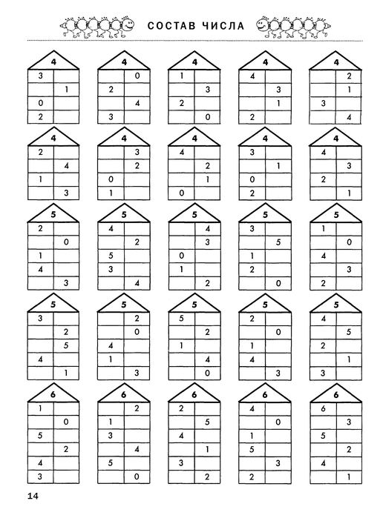

Ф.И.____________________________________________________

Ф.И.____________________________________________________

