

***Центр искусства***

|  |  |  |  |  |  |
| --- | --- | --- | --- | --- | --- |
|  |  |  |  |  |  |
|  |  |  |  |  |  |

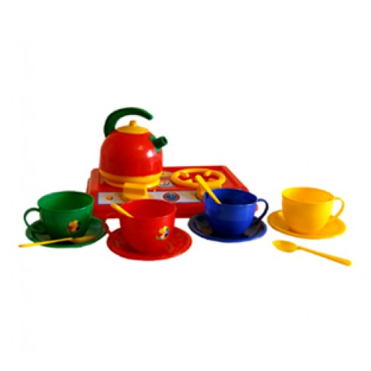

***Центр кулинарии***

|  |  |  |  |  |  |
| --- | --- | --- | --- | --- | --- |
|  |  |  |  |  |  |
|  |  |  |  |  |  |

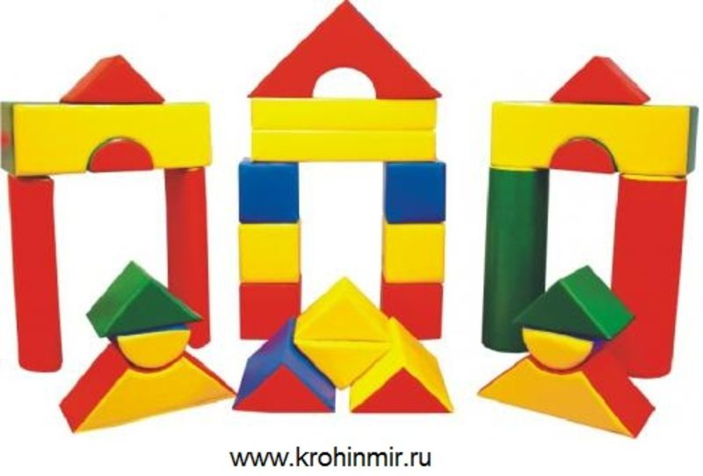

***Центр строительства***

|  |  |  |  |  |  |
| --- | --- | --- | --- | --- | --- |
|  |  |  |  |  |  |
|  |  |  |  |  |  |

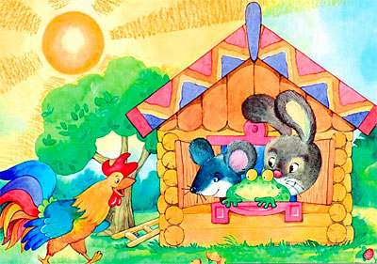

***Центр драматизации***

|  |  |  |  |  |  |
| --- | --- | --- | --- | --- | --- |
|  |  |  |  |  |  |
|  |  |  |  |  |  |



***Центр литературы***

|  |  |  |  |  |  |
| --- | --- | --- | --- | --- | --- |
|  |  |  |  |  |  |
|  |  |  |  |  |  |

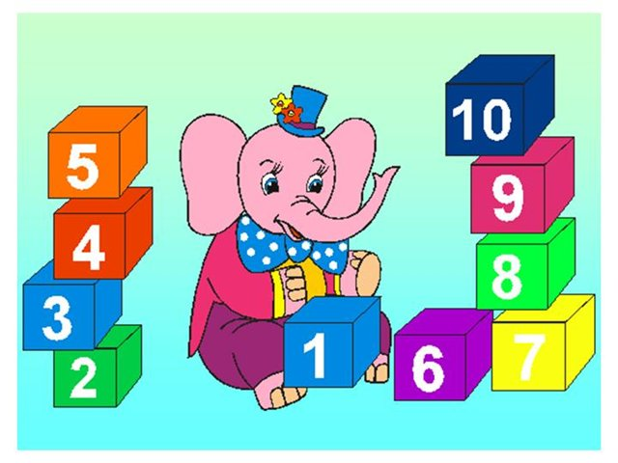

***Центр математики***

|  |  |  |  |  |  |
| --- | --- | --- | --- | --- | --- |
|  |  |  |  |  |  |
|  |  |  |  |  |  |

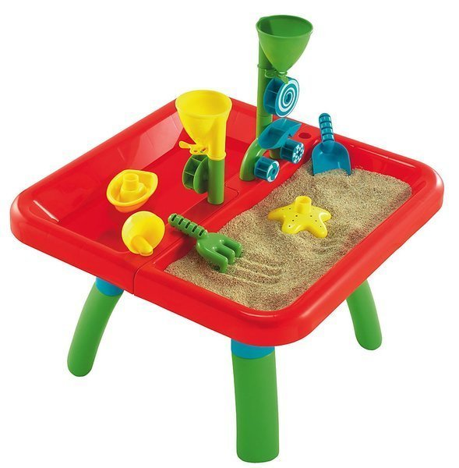

***Центр воды и песка***

|  |  |  |  |  |  |
| --- | --- | --- | --- | --- | --- |
|  |  |  |  |  |  |
|  |  |  |  |  |  |

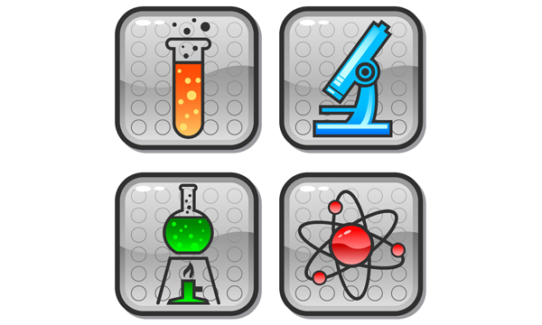

***Центр естествознания***

|  |  |  |  |  |  |
| --- | --- | --- | --- | --- | --- |
|  |  |  |  |  |  |
|  |  |  |  |  |  |