[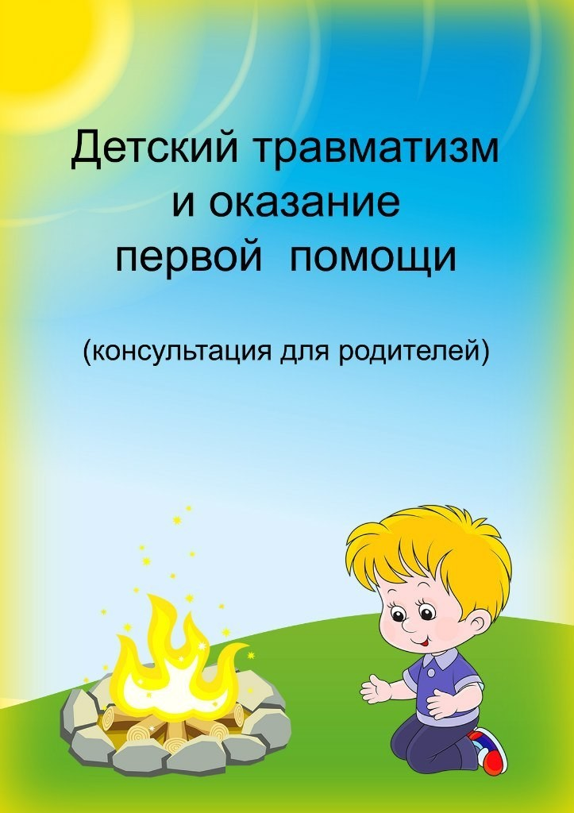](https://ok.ru/dk?cmd=PopLayerPhoto&st.layer.cmd=PopLayerPhotoOuter&st.layer.type=GROUP&st.layer.revNav=off&st.layer.limitedUi=false&st.layer.sphotoIds=839531058076;839531057820;839531057564;839531057308;839531057052;839531056796;839531056540;839531056284;839531056028;839531055772&st.layer.showNav=on&st.layer.photoAlbumId=51799475749020&st.layer.epm=off&st.layer.photoId=839531058076&st.layer.opl=off&st.layer.navStartPhotoId=839531058076&st.layer.sbd=off&st.cmd=altGroupMain&st.groupId=51799460479132&st._aid=GroupTopicLayer_openPhotoLayer)

[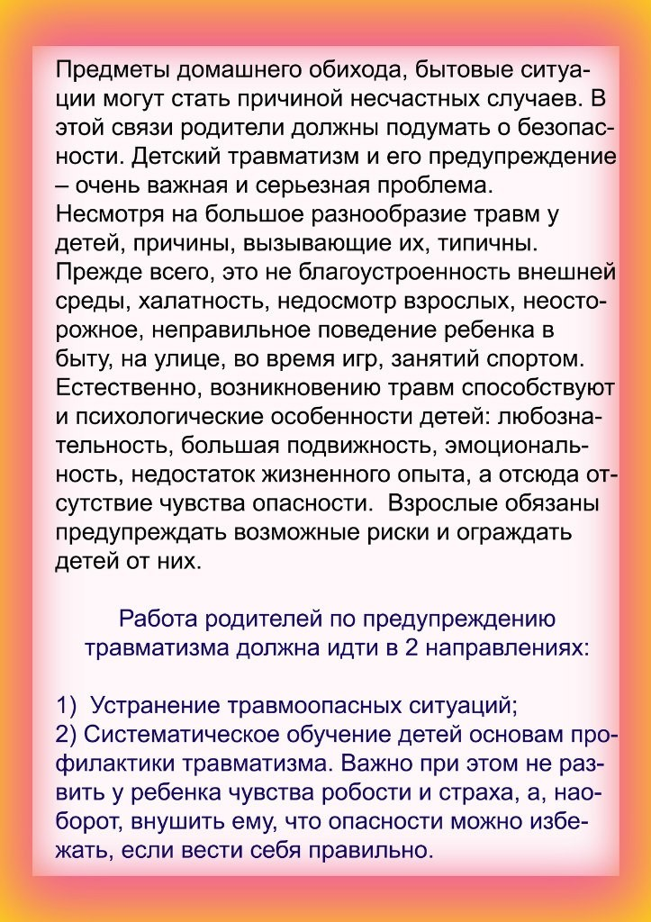](https://ok.ru/dk?cmd=PopLayerPhoto&st.layer.cmd=PopLayerPhotoOuter&st.layer.type=GROUP&st.layer.revNav=off&st.layer.limitedUi=false&st.layer.sphotoIds=839531058076;839531057820;839531057564;839531057308;839531057052;839531056796;839531056540;839531056284;839531056028;839531055772&st.layer.showNav=on&st.layer.photoAlbumId=51799475749020&st.layer.epm=off&st.layer.photoId=839531057820&st.layer.opl=off&st.layer.navStartPhotoId=839531057820&st.layer.sbd=off&st.cmd=altGroupMain&st.groupId=51799460479132&st._aid=GroupTopicLayer_openPhotoLayer)

[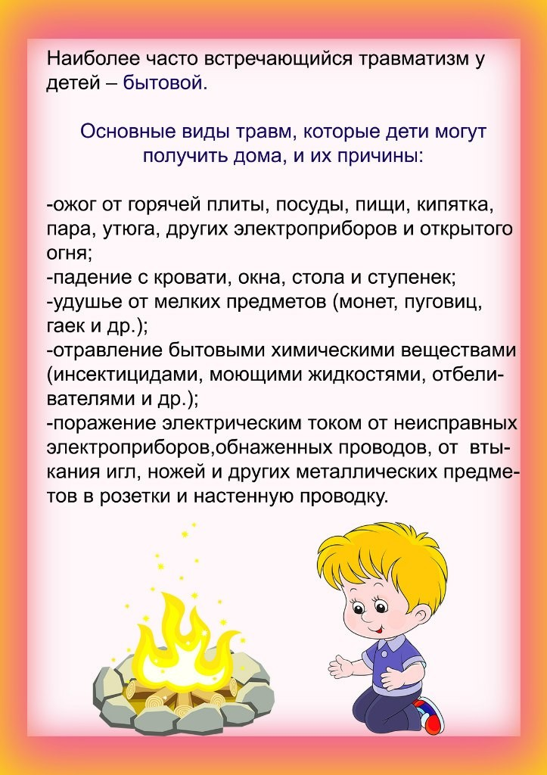](https://ok.ru/dk?cmd=PopLayerPhoto&st.layer.cmd=PopLayerPhotoOuter&st.layer.type=GROUP&st.layer.revNav=off&st.layer.limitedUi=false&st.layer.sphotoIds=839531058076;839531057820;839531057564;839531057308;839531057052;839531056796;839531056540;839531056284;839531056028;839531055772&st.layer.showNav=on&st.layer.photoAlbumId=51799475749020&st.layer.epm=off&st.layer.photoId=839531057564&st.layer.opl=off&st.layer.navStartPhotoId=839531057564&st.layer.sbd=off&st.cmd=altGroupMain&st.groupId=51799460479132&st._aid=GroupTopicLayer_openPhotoLayer)

[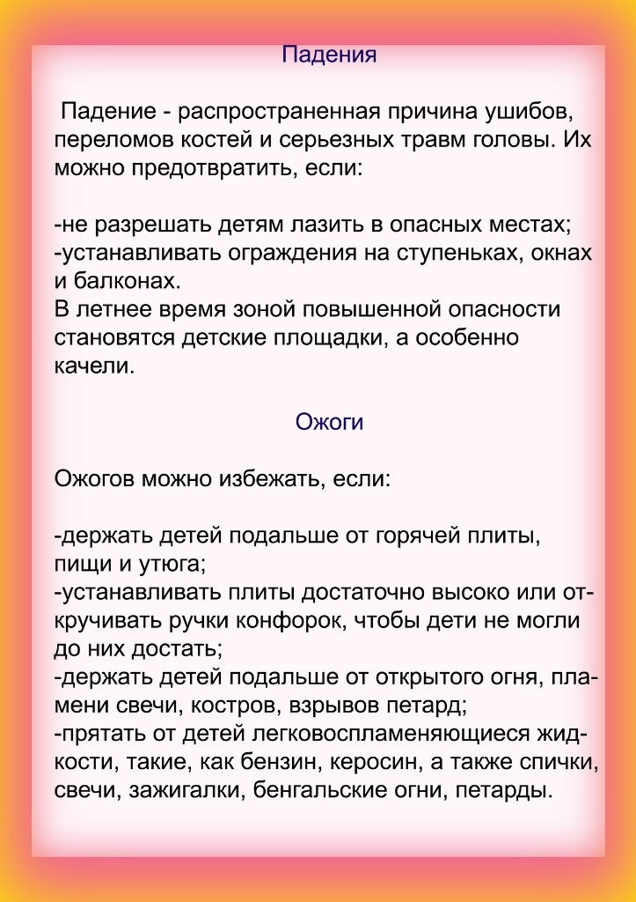](https://ok.ru/dk?cmd=PopLayerPhoto&st.layer.cmd=PopLayerPhotoOuter&st.layer.type=GROUP&st.layer.revNav=off&st.layer.limitedUi=false&st.layer.sphotoIds=839531058076;839531057820;839531057564;839531057308;839531057052;839531056796;839531056540;839531056284;839531056028;839531055772&st.layer.showNav=on&st.layer.photoAlbumId=51799475749020&st.layer.epm=off&st.layer.photoId=839531057308&st.layer.opl=off&st.layer.navStartPhotoId=839531057308&st.layer.sbd=off&st.cmd=altGroupMain&st.groupId=51799460479132&st._aid=GroupTopicLayer_openPhotoLayer)

[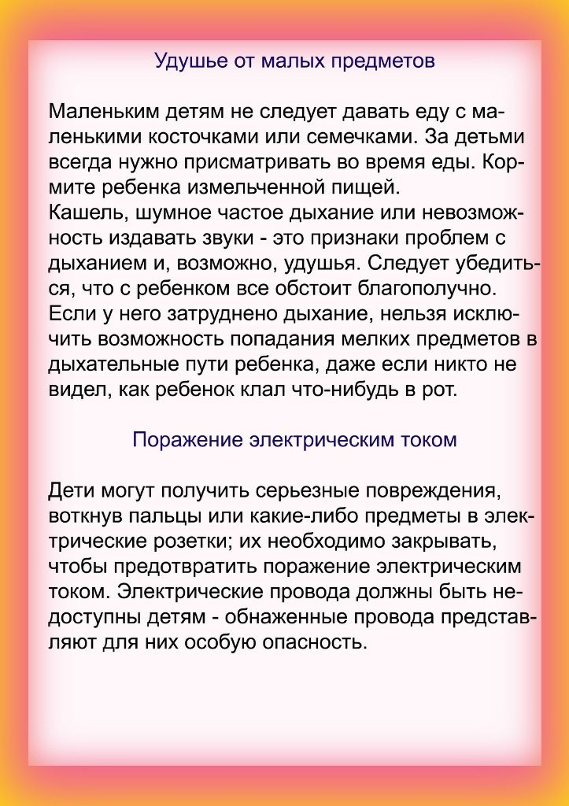](https://ok.ru/dk?cmd=PopLayerPhoto&st.layer.cmd=PopLayerPhotoOuter&st.layer.type=GROUP&st.layer.revNav=off&st.layer.limitedUi=false&st.layer.sphotoIds=839531058076;839531057820;839531057564;839531057308;839531057052;839531056796;839531056540;839531056284;839531056028;839531055772&st.layer.showNav=on&st.layer.photoAlbumId=51799475749020&st.layer.epm=off&st.layer.photoId=839531057052&st.layer.opl=off&st.layer.navStartPhotoId=839531057052&st.layer.sbd=off&st.cmd=altGroupMain&st.groupId=51799460479132&st._aid=GroupTopicLayer_openPhotoLayer)

[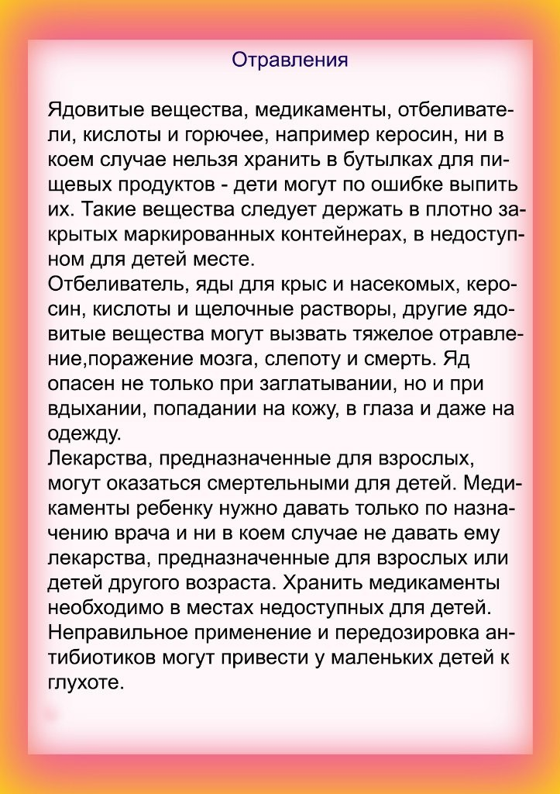](https://ok.ru/dk?cmd=PopLayerPhoto&st.layer.cmd=PopLayerPhotoOuter&st.layer.type=GROUP&st.layer.revNav=off&st.layer.limitedUi=false&st.layer.sphotoIds=839531058076;839531057820;839531057564;839531057308;839531057052;839531056796;839531056540;839531056284;839531056028;839531055772&st.layer.showNav=on&st.layer.photoAlbumId=51799475749020&st.layer.epm=off&st.layer.photoId=839531056796&st.layer.opl=off&st.layer.navStartPhotoId=839531056796&st.layer.sbd=off&st.cmd=altGroupMain&st.groupId=51799460479132&st._aid=GroupTopicLayer_openPhotoLayer)

[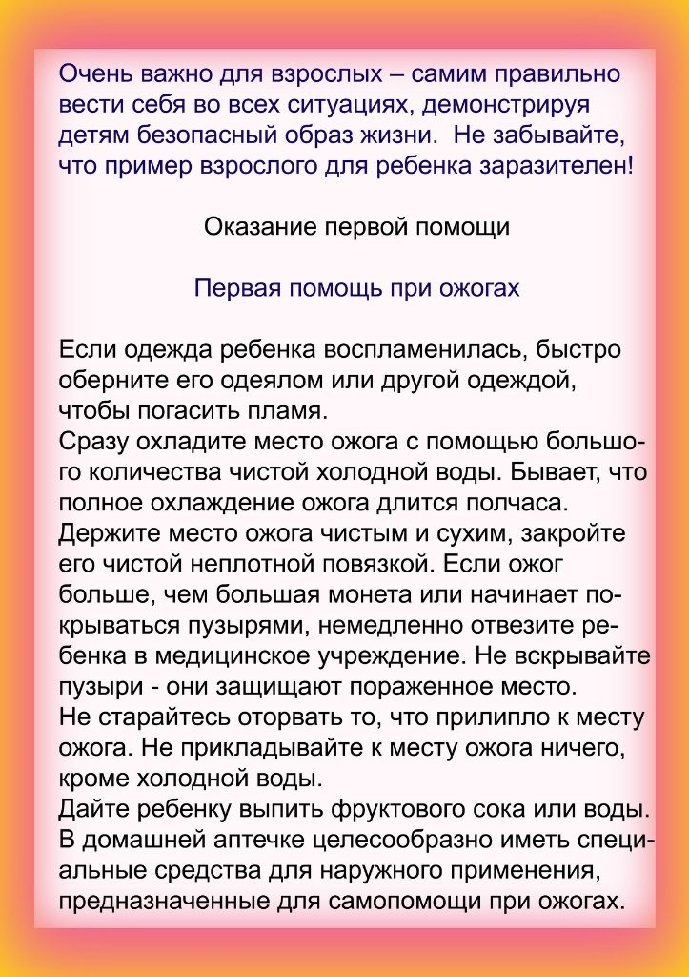](https://ok.ru/dk?cmd=PopLayerPhoto&st.layer.cmd=PopLayerPhotoOuter&st.layer.type=GROUP&st.layer.revNav=off&st.layer.limitedUi=false&st.layer.sphotoIds=839531058076;839531057820;839531057564;839531057308;839531057052;839531056796;839531056540;839531056284;839531056028;839531055772&st.layer.showNav=on&st.layer.photoAlbumId=51799475749020&st.layer.epm=off&st.layer.photoId=839531056540&st.layer.opl=off&st.layer.navStartPhotoId=839531056540&st.layer.sbd=off&st.cmd=altGroupMain&st.groupId=51799460479132&st._aid=GroupTopicLayer_openPhotoLayer)

[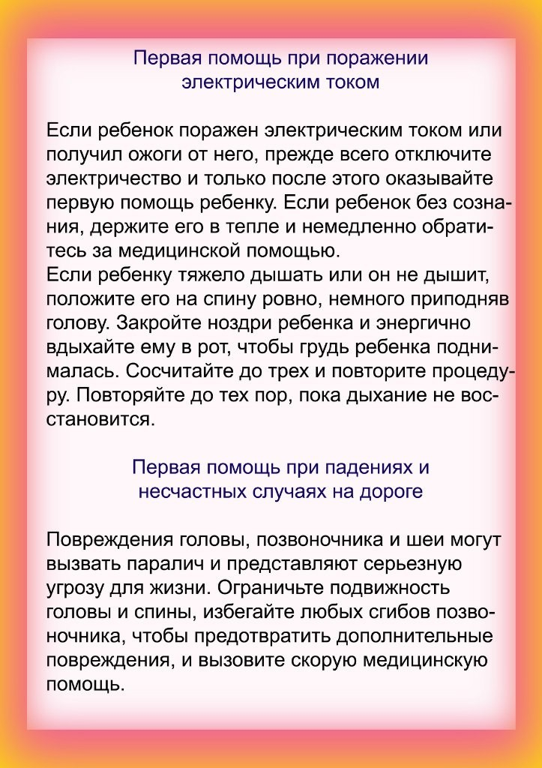](https://ok.ru/dk?cmd=PopLayerPhoto&st.layer.cmd=PopLayerPhotoOuter&st.layer.type=GROUP&st.layer.revNav=off&st.layer.limitedUi=false&st.layer.sphotoIds=839531058076;839531057820;839531057564;839531057308;839531057052;839531056796;839531056540;839531056284;839531056028;839531055772&st.layer.showNav=on&st.layer.photoAlbumId=51799475749020&st.layer.epm=off&st.layer.photoId=839531056284&st.layer.opl=off&st.layer.navStartPhotoId=839531056284&st.layer.sbd=off&st.cmd=altGroupMain&st.groupId=51799460479132&st._aid=GroupTopicLayer_openPhotoLayer)

[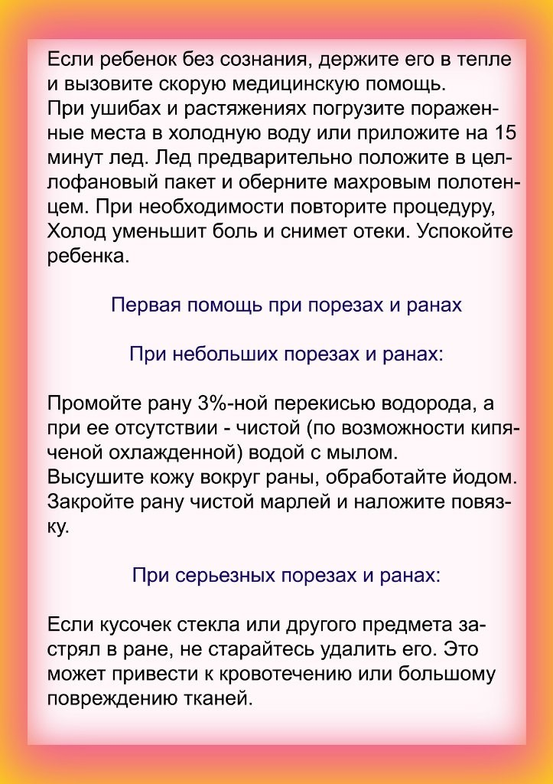](https://ok.ru/dk?cmd=PopLayerPhoto&st.layer.cmd=PopLayerPhotoOuter&st.layer.type=GROUP&st.layer.revNav=off&st.layer.limitedUi=false&st.layer.sphotoIds=839531058076;839531057820;839531057564;839531057308;839531057052;839531056796;839531056540;839531056284;839531056028;839531055772&st.layer.showNav=on&st.layer.photoAlbumId=51799475749020&st.layer.epm=off&st.layer.photoId=839531056028&st.layer.opl=off&st.layer.navStartPhotoId=839531056028&st.layer.sbd=off&st.cmd=altGroupMain&st.groupId=51799460479132&st._aid=GroupTopicLayer_openPhotoLayer)

[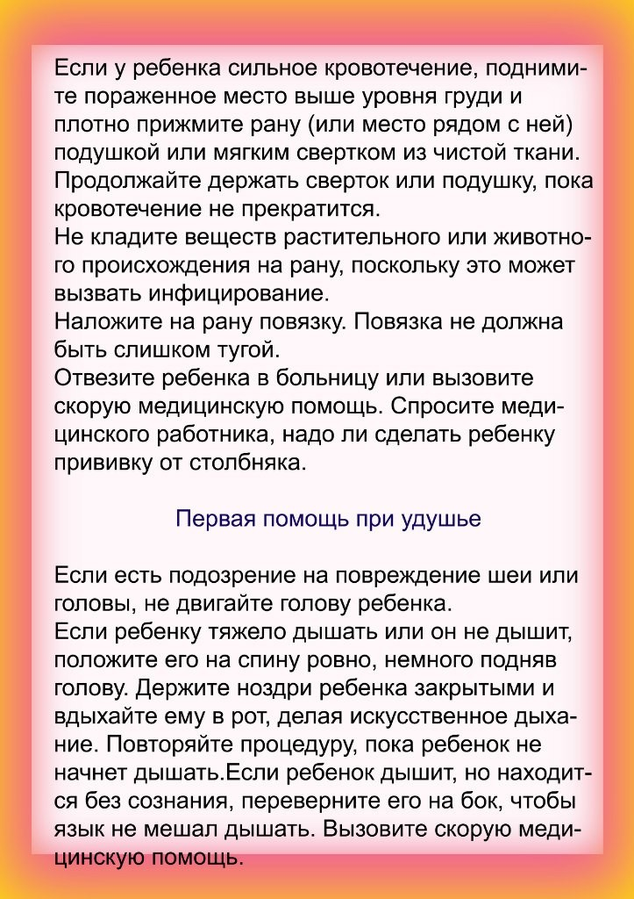](https://ok.ru/dk?cmd=PopLayerPhoto&st.layer.cmd=PopLayerPhotoOuter&st.layer.type=GROUP&st.layer.revNav=off&st.layer.limitedUi=false&st.layer.sphotoIds=839531058076;839531057820;839531057564;839531057308;839531057052;839531056796;839531056540;839531056284;839531056028;839531055772&st.layer.showNav=on&st.layer.photoAlbumId=51799475749020&st.layer.epm=off&st.layer.photoId=839531055772&st.layer.opl=off&st.layer.navStartPhotoId=839531055772&st.layer.sbd=off&st.cmd=altGroupMain&st.groupId=51799460479132&st._aid=GroupTopicLayer_openPhotoLayer)