[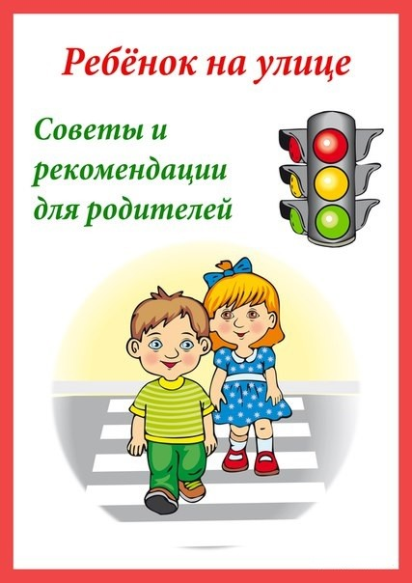](https://ok.ru/dk?cmd=PopLayerPhoto&st.layer.cmd=PopLayerPhotoOuter&st.layer.type=GROUP&st.layer.revNav=off&st.layer.limitedUi=false&st.layer.sphotoIds=837022176412;837022176156;837022175900;837022175644;837022175388;837022175132&st.layer.showNav=on&st.layer.photoAlbumId=51799475749020&st.layer.epm=off&st.layer.photoId=837022176412&st.layer.opl=off&st.layer.navStartPhotoId=837022176412&st.layer.sbd=off&st.cmd=altGroupMain&st.groupId=51799460479132&st.referenceName=doshkolnik&st._aid=GroupTopicLayer_openPhotoLayer)

[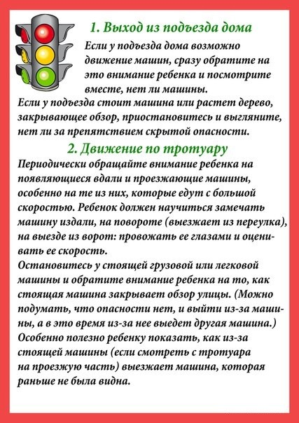](https://ok.ru/dk?cmd=PopLayerPhoto&st.layer.cmd=PopLayerPhotoOuter&st.layer.type=GROUP&st.layer.revNav=off&st.layer.limitedUi=false&st.layer.sphotoIds=837022176412;837022176156;837022175900;837022175644;837022175388;837022175132&st.layer.showNav=on&st.layer.photoAlbumId=51799475749020&st.layer.epm=off&st.layer.photoId=837022176156&st.layer.opl=off&st.layer.navStartPhotoId=837022176156&st.layer.sbd=off&st.cmd=altGroupMain&st.groupId=51799460479132&st.referenceName=doshkolnik&st._aid=GroupTopicLayer_openPhotoLayer)

[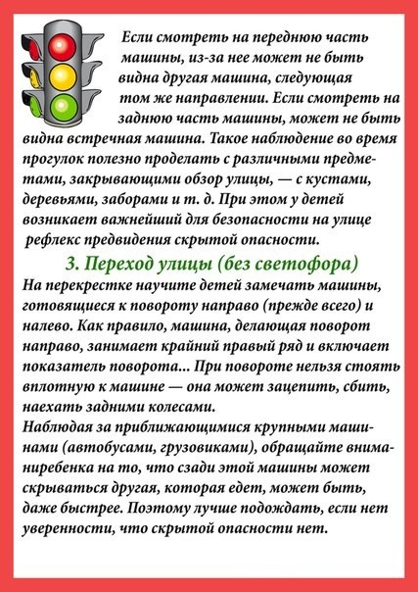](https://ok.ru/dk?cmd=PopLayerPhoto&st.layer.cmd=PopLayerPhotoOuter&st.layer.type=GROUP&st.layer.revNav=off&st.layer.limitedUi=false&st.layer.sphotoIds=837022176412;837022176156;837022175900;837022175644;837022175388;837022175132&st.layer.showNav=on&st.layer.photoAlbumId=51799475749020&st.layer.epm=off&st.layer.photoId=837022175900&st.layer.opl=off&st.layer.navStartPhotoId=837022175900&st.layer.sbd=off&st.cmd=altGroupMain&st.groupId=51799460479132&st.referenceName=doshkolnik&st._aid=GroupTopicLayer_openPhotoLayer)

[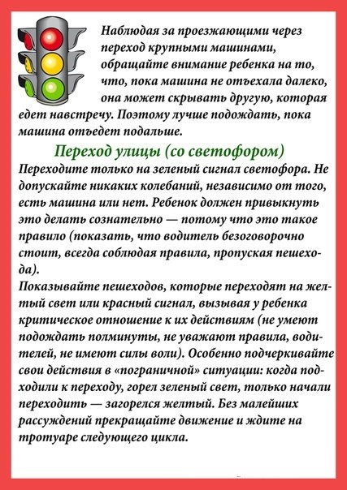](https://ok.ru/dk?cmd=PopLayerPhoto&st.layer.cmd=PopLayerPhotoOuter&st.layer.type=GROUP&st.layer.revNav=off&st.layer.limitedUi=false&st.layer.sphotoIds=837022176412;837022176156;837022175900;837022175644;837022175388;837022175132&st.layer.showNav=on&st.layer.photoAlbumId=51799475749020&st.layer.epm=off&st.layer.photoId=837022175644&st.layer.opl=off&st.layer.navStartPhotoId=837022175644&st.layer.sbd=off&st.cmd=altGroupMain&st.groupId=51799460479132&st.referenceName=doshkolnik&st._aid=GroupTopicLayer_openPhotoLayer)

[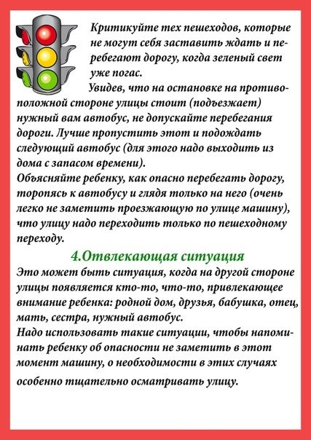](https://ok.ru/dk?cmd=PopLayerPhoto&st.layer.cmd=PopLayerPhotoOuter&st.layer.type=GROUP&st.layer.revNav=off&st.layer.limitedUi=false&st.layer.sphotoIds=837022176412;837022176156;837022175900;837022175644;837022175388;837022175132&st.layer.showNav=on&st.layer.photoAlbumId=51799475749020&st.layer.epm=off&st.layer.photoId=837022175388&st.layer.opl=off&st.layer.navStartPhotoId=837022175388&st.layer.sbd=off&st.cmd=altGroupMain&st.groupId=51799460479132&st.referenceName=doshkolnik&st._aid=GroupTopicLayer_openPhotoLayer)

[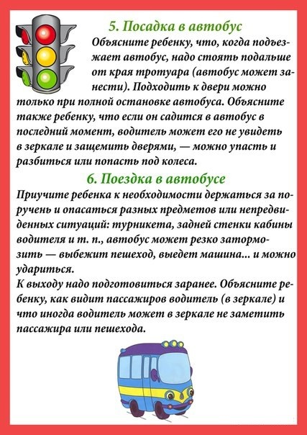](https://ok.ru/dk?cmd=PopLayerPhoto&st.layer.cmd=PopLayerPhotoOuter&st.layer.type=GROUP&st.layer.revNav=off&st.layer.limitedUi=false&st.layer.sphotoIds=837022176412;837022176156;837022175900;837022175644;837022175388;837022175132&st.layer.showNav=on&st.layer.photoAlbumId=51799475749020&st.layer.epm=off&st.layer.photoId=837022175132&st.layer.opl=off&st.layer.navStartPhotoId=837022175132&st.layer.sbd=off&st.cmd=altGroupMain&st.groupId=51799460479132&st.referenceName=doshkolnik&st._aid=GroupTopicLayer_openPhotoLayer)