[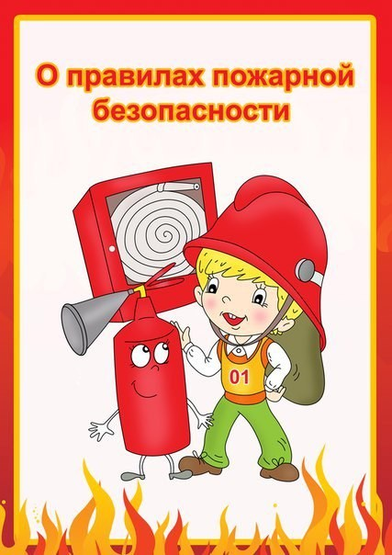](https://ok.ru/dk?cmd=PopLayerPhoto&st.layer.cmd=PopLayerPhotoOuter&st.layer.type=GROUP&st.layer.revNav=off&st.layer.limitedUi=false&st.layer.sphotoIds=837139654300;837139654044;837139653788;837139653532;837139653276&st.layer.showNav=on&st.layer.photoAlbumId=51799475749020&st.layer.epm=off&st.layer.photoId=837139654300&st.layer.opl=off&st.layer.navStartPhotoId=837139654300&st.layer.sbd=off&st.cmd=altGroupMain&st.groupId=51799460479132&st.referenceName=doshkolnik&st._aid=GroupTopicLayer_openPhotoLayer)

[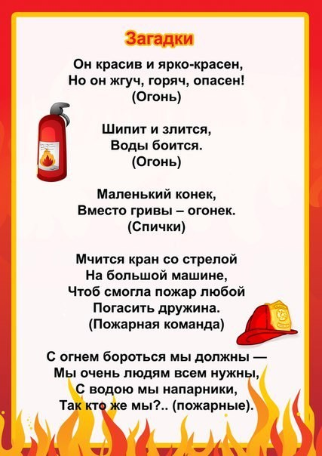](https://ok.ru/dk?cmd=PopLayerPhoto&st.layer.cmd=PopLayerPhotoOuter&st.layer.type=GROUP&st.layer.revNav=off&st.layer.limitedUi=false&st.layer.sphotoIds=837139654300;837139654044;837139653788;837139653532;837139653276&st.layer.showNav=on&st.layer.photoAlbumId=51799475749020&st.layer.epm=off&st.layer.photoId=837139654044&st.layer.opl=off&st.layer.navStartPhotoId=837139654044&st.layer.sbd=off&st.cmd=altGroupMain&st.groupId=51799460479132&st.referenceName=doshkolnik&st._aid=GroupTopicLayer_openPhotoLayer)

[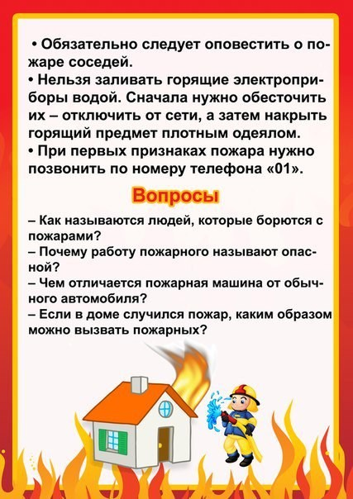](https://ok.ru/dk?cmd=PopLayerPhoto&st.layer.cmd=PopLayerPhotoOuter&st.layer.type=GROUP&st.layer.revNav=off&st.layer.limitedUi=false&st.layer.sphotoIds=837139654300;837139654044;837139653788;837139653532;837139653276&st.layer.showNav=on&st.layer.photoAlbumId=51799475749020&st.layer.epm=off&st.layer.photoId=837139653788&st.layer.opl=off&st.layer.navStartPhotoId=837139653788&st.layer.sbd=off&st.cmd=altGroupMain&st.groupId=51799460479132&st.referenceName=doshkolnik&st._aid=GroupTopicLayer_openPhotoLayer)

[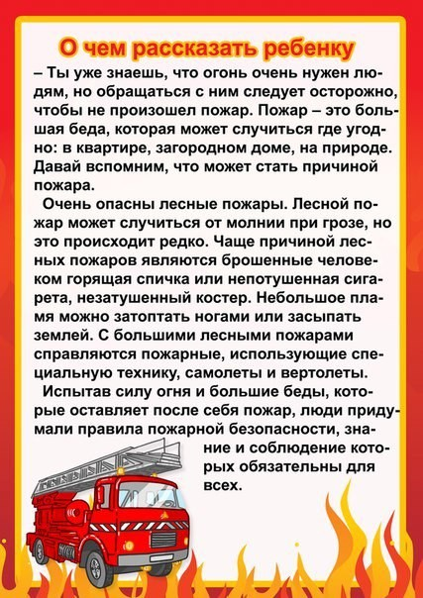](https://ok.ru/dk?cmd=PopLayerPhoto&st.layer.cmd=PopLayerPhotoOuter&st.layer.type=GROUP&st.layer.revNav=off&st.layer.limitedUi=false&st.layer.sphotoIds=837139654300;837139654044;837139653788;837139653532;837139653276&st.layer.showNav=on&st.layer.photoAlbumId=51799475749020&st.layer.epm=off&st.layer.photoId=837139653532&st.layer.opl=off&st.layer.navStartPhotoId=837139653532&st.layer.sbd=off&st.cmd=altGroupMain&st.groupId=51799460479132&st.referenceName=doshkolnik&st._aid=GroupTopicLayer_openPhotoLayer)

[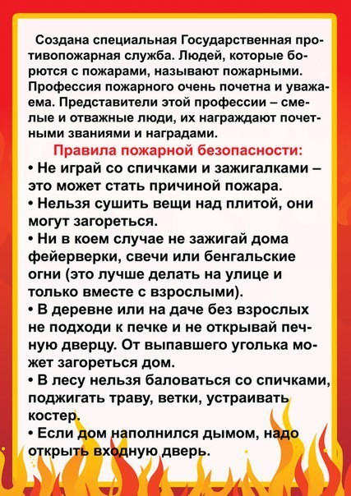](https://ok.ru/dk?cmd=PopLayerPhoto&st.layer.cmd=PopLayerPhotoOuter&st.layer.type=GROUP&st.layer.revNav=off&st.layer.limitedUi=false&st.layer.sphotoIds=837139654300;837139654044;837139653788;837139653532;837139653276&st.layer.showNav=on&st.layer.photoAlbumId=51799475749020&st.layer.epm=off&st.layer.photoId=837139653276&st.layer.opl=off&st.layer.navStartPhotoId=837139653276&st.layer.sbd=off&st.cmd=altGroupMain&st.groupId=51799460479132&st.referenceName=doshkolnik&st._aid=GroupTopicLayer_openPhotoLayer)