[](https://ok.ru/dk?cmd=PopLayerPhoto&st.layer.cmd=PopLayerPhotoOuter&st.layer.type=GROUP&st.layer.revNav=off&st.layer.limitedUi=false&st.layer.sphotoIds=839596025756;839596025500;839596025244;839596024988;839596024732;839596024476;839596024220&st.layer.showNav=on&st.layer.photoAlbumId=51799475749020&st.layer.epm=off&st.layer.photoId=839596025756&st.layer.opl=off&st.layer.navStartPhotoId=839596025756&st.layer.sbd=off&st.cmd=altGroupMain&st.groupId=51799460479132&st.referenceName=doshkolnik&st._aid=GroupTopicLayer_openPhotoLayer)[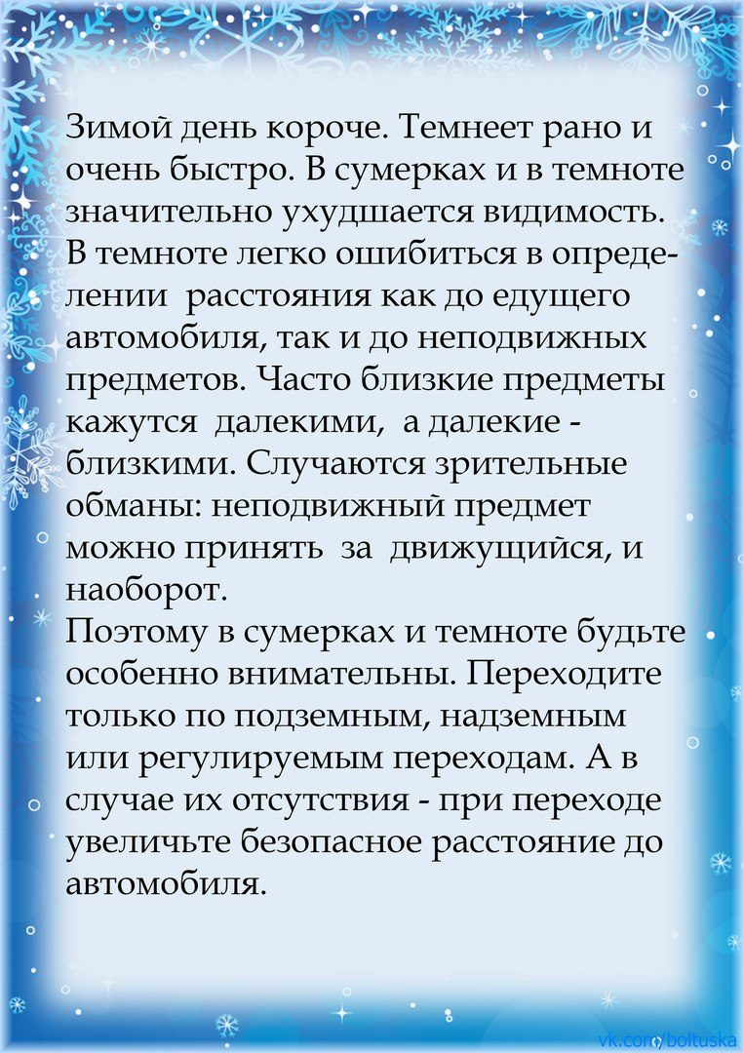](https://ok.ru/dk?cmd=PopLayerPhoto&st.layer.cmd=PopLayerPhotoOuter&st.layer.type=GROUP&st.layer.revNav=off&st.layer.limitedUi=false&st.layer.sphotoIds=839596025756;839596025500;839596025244;839596024988;839596024732;839596024476;839596024220&st.layer.showNav=on&st.layer.photoAlbumId=51799475749020&st.layer.epm=off&st.layer.photoId=839596025500&st.layer.opl=off&st.layer.navStartPhotoId=839596025500&st.layer.sbd=off&st.cmd=altGroupMain&st.groupId=51799460479132&st.referenceName=doshkolnik&st._aid=GroupTopicLayer_openPhotoLayer)[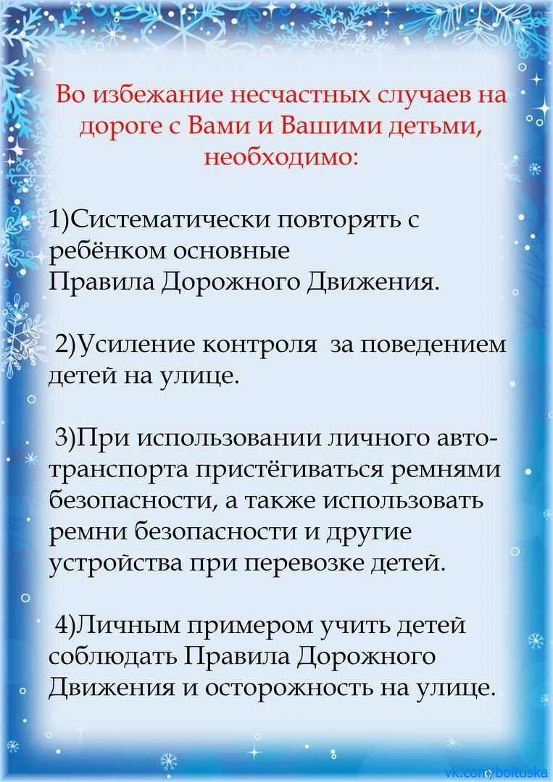](https://ok.ru/dk?cmd=PopLayerPhoto&st.layer.cmd=PopLayerPhotoOuter&st.layer.type=GROUP&st.layer.revNav=off&st.layer.limitedUi=false&st.layer.sphotoIds=839596025756;839596025500;839596025244;839596024988;839596024732;839596024476;839596024220&st.layer.showNav=on&st.layer.photoAlbumId=51799475749020&st.layer.epm=off&st.layer.photoId=839596025244&st.layer.opl=off&st.layer.navStartPhotoId=839596025244&st.layer.sbd=off&st.cmd=altGroupMain&st.groupId=51799460479132&st.referenceName=doshkolnik&st._aid=GroupTopicLayer_openPhotoLayer)[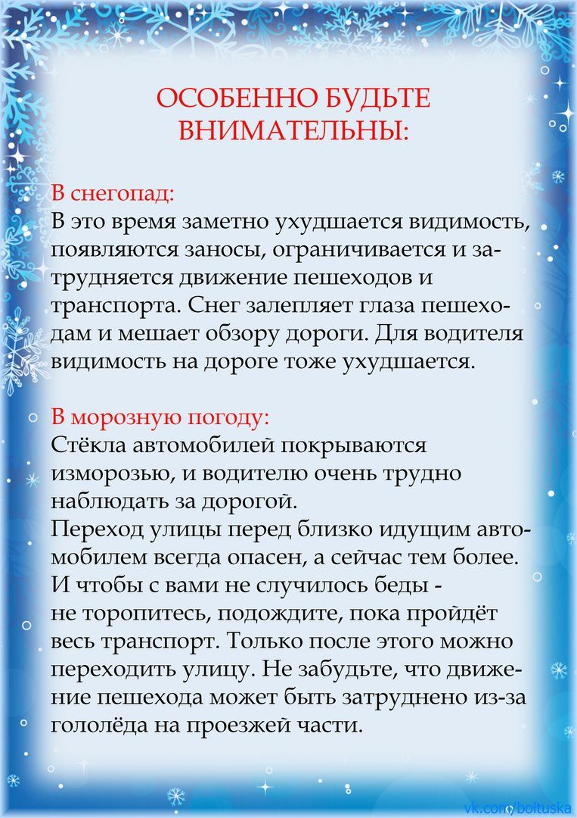](https://ok.ru/dk?cmd=PopLayerPhoto&st.layer.cmd=PopLayerPhotoOuter&st.layer.type=GROUP&st.layer.revNav=off&st.layer.limitedUi=false&st.layer.sphotoIds=839596025756;839596025500;839596025244;839596024988;839596024732;839596024476;839596024220&st.layer.showNav=on&st.layer.photoAlbumId=51799475749020&st.layer.epm=off&st.layer.photoId=839596024988&st.layer.opl=off&st.layer.navStartPhotoId=839596024988&st.layer.sbd=off&st.cmd=altGroupMain&st.groupId=51799460479132&st.referenceName=doshkolnik&st._aid=GroupTopicLayer_openPhotoLayer)[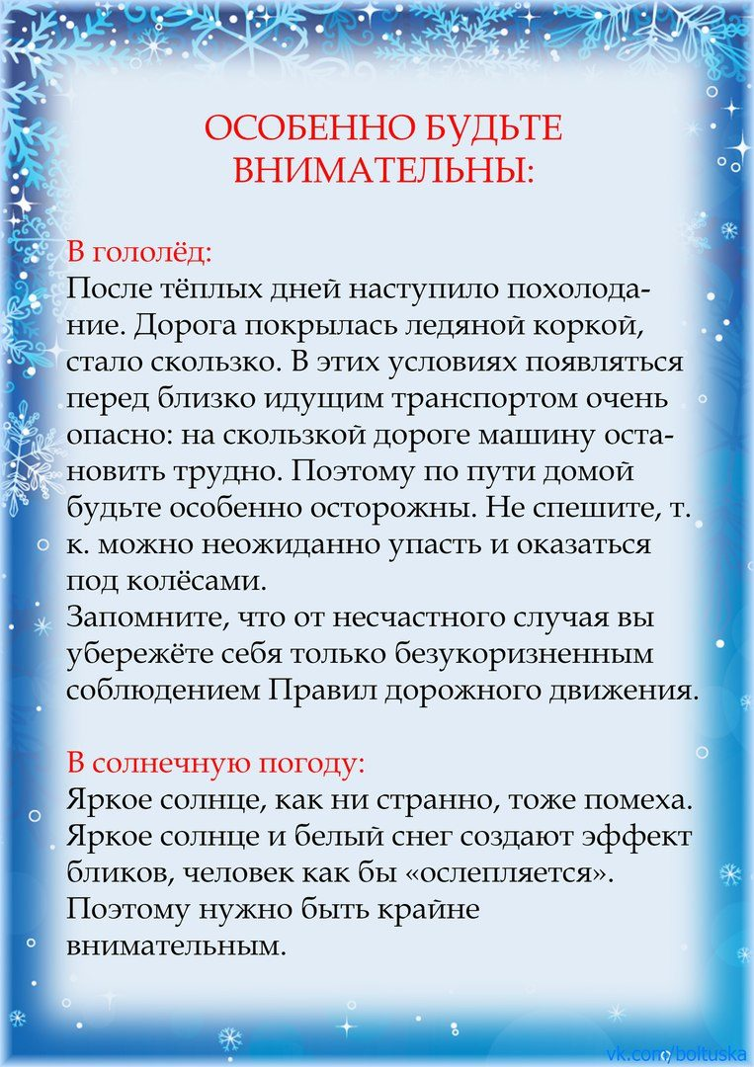](https://ok.ru/dk?cmd=PopLayerPhoto&st.layer.cmd=PopLayerPhotoOuter&st.layer.type=GROUP&st.layer.revNav=off&st.layer.limitedUi=false&st.layer.sphotoIds=839596025756;839596025500;839596025244;839596024988;839596024732;839596024476;839596024220&st.layer.showNav=on&st.layer.photoAlbumId=51799475749020&st.layer.epm=off&st.layer.photoId=839596024732&st.layer.opl=off&st.layer.navStartPhotoId=839596024732&st.layer.sbd=off&st.cmd=altGroupMain&st.groupId=51799460479132&st.referenceName=doshkolnik&st._aid=GroupTopicLayer_openPhotoLayer)[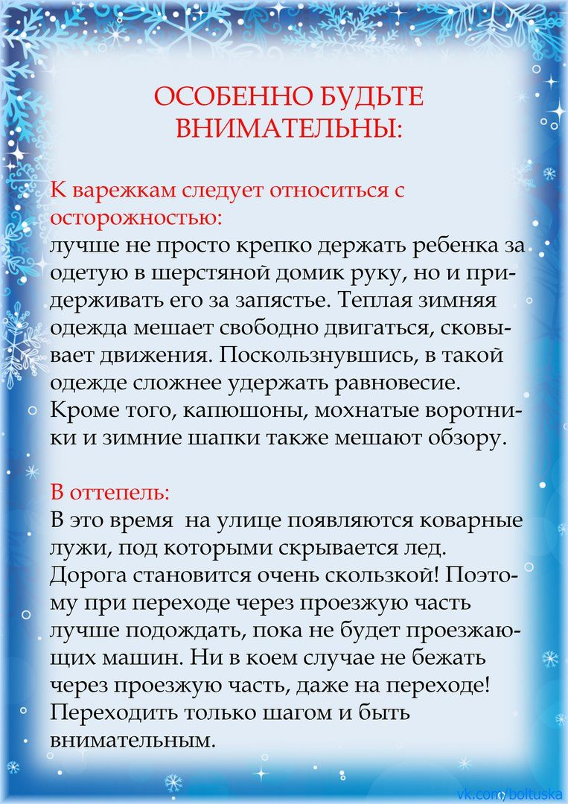](https://ok.ru/dk?cmd=PopLayerPhoto&st.layer.cmd=PopLayerPhotoOuter&st.layer.type=GROUP&st.layer.revNav=off&st.layer.limitedUi=false&st.layer.sphotoIds=839596025756;839596025500;839596025244;839596024988;839596024732;839596024476;839596024220&st.layer.showNav=on&st.layer.photoAlbumId=51799475749020&st.layer.epm=off&st.layer.photoId=839596024476&st.layer.opl=off&st.layer.navStartPhotoId=839596024476&st.layer.sbd=off&st.cmd=altGroupMain&st.groupId=51799460479132&st.referenceName=doshkolnik&st._aid=GroupTopicLayer_openPhotoLayer)[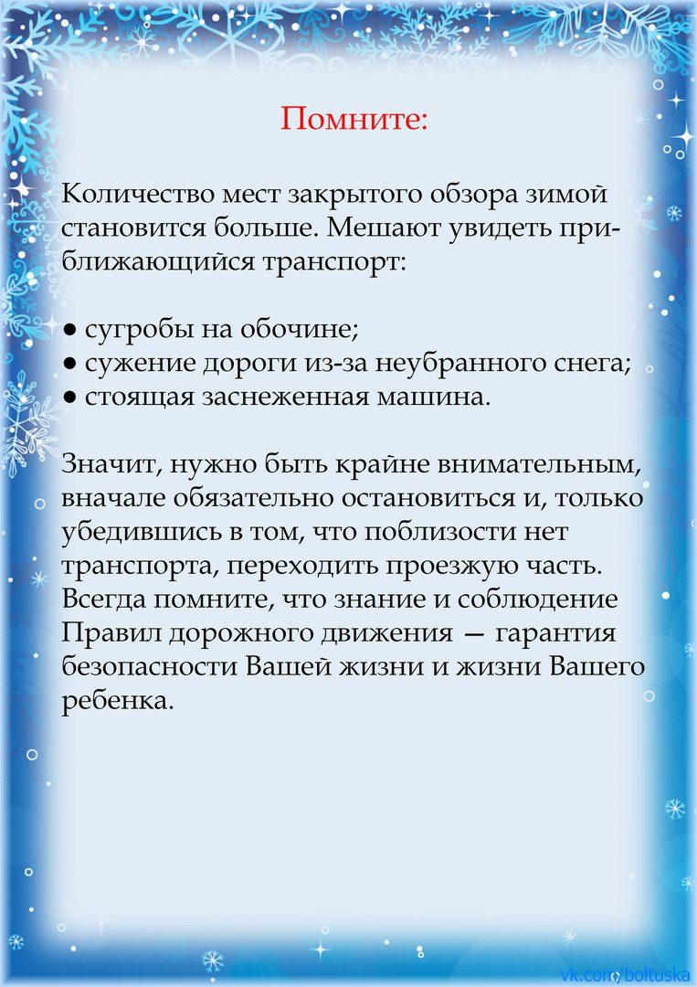](https://ok.ru/dk?cmd=PopLayerPhoto&st.layer.cmd=PopLayerPhotoOuter&st.layer.type=GROUP&st.layer.revNav=off&st.layer.limitedUi=false&st.layer.sphotoIds=839596025756;839596025500;839596025244;839596024988;839596024732;839596024476;839596024220&st.layer.showNav=on&st.layer.photoAlbumId=51799475749020&st.layer.epm=off&st.layer.photoId=839596024220&st.layer.opl=off&st.layer.navStartPhotoId=839596024220&st.layer.sbd=off&st.cmd=altGroupMain&st.groupId=51799460479132&st.referenceName=doshkolnik&st._aid=GroupTopicLayer_openPhotoLayer)