[](https://ok.ru/dk?cmd=PopLayerPhoto&st.layer.cmd=PopLayerPhotoOuter&st.layer.type=GROUP&st.layer.revNav=off&st.layer.limitedUi=false&st.layer.sphotoIds=838368098204;838368097948;838368097692;838368097436;838368097180;838368103068;838368102812;838368102556;838368102300;838368102044;838368101788;838368105372;838368105116;838368104860;838368104604;838368104348;838368104092;838368103836&st.layer.showNav=on&st.layer.photoAlbumId=51799475749020&st.layer.epm=off&st.layer.photoId=838368098204&st.layer.opl=off&st.layer.navStartPhotoId=838368098204&st.layer.sbd=off&st.cmd=altGroupMain&st.groupId=51799460479132&st.referenceName=doshkolnik&st._aid=GroupTopicLayer_openPhotoLayer)

[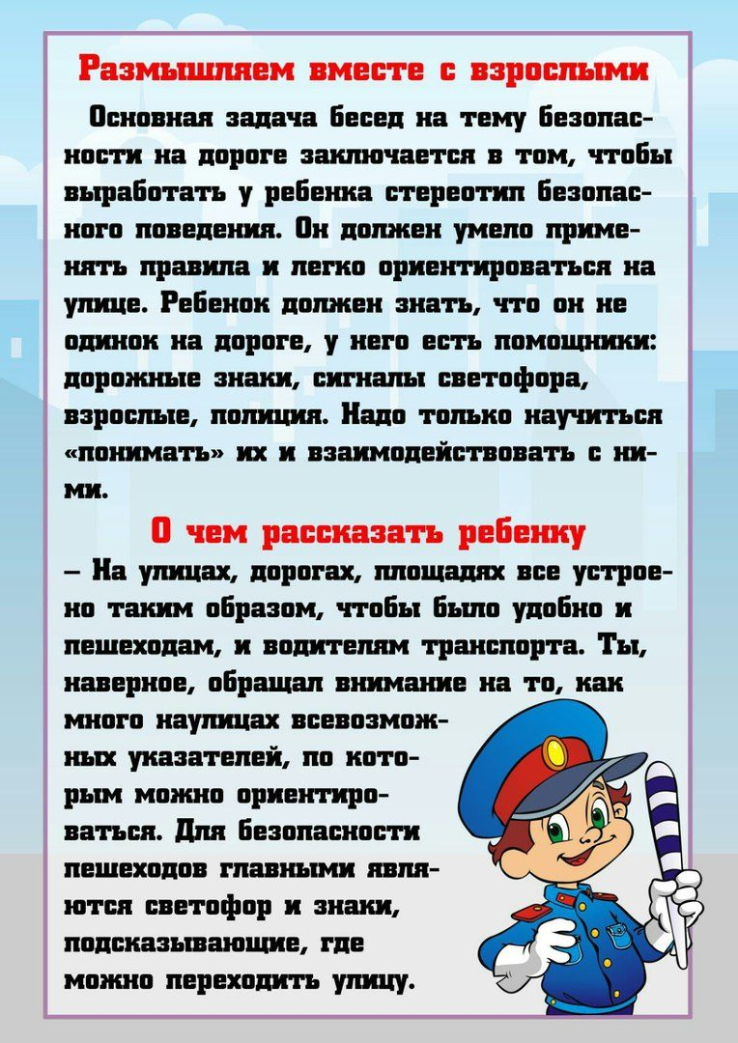](https://ok.ru/dk?cmd=PopLayerPhoto&st.layer.cmd=PopLayerPhotoOuter&st.layer.type=GROUP&st.layer.revNav=off&st.layer.limitedUi=false&st.layer.sphotoIds=838368098204;838368097948;838368097692;838368097436;838368097180;838368103068;838368102812;838368102556;838368102300;838368102044;838368101788;838368105372;838368105116;838368104860;838368104604;838368104348;838368104092;838368103836&st.layer.showNav=on&st.layer.photoAlbumId=51799475749020&st.layer.epm=off&st.layer.photoId=838368097948&st.layer.opl=off&st.layer.navStartPhotoId=838368097948&st.layer.sbd=off&st.cmd=altGroupMain&st.groupId=51799460479132&st.referenceName=doshkolnik&st._aid=GroupTopicLayer_openPhotoLayer)

[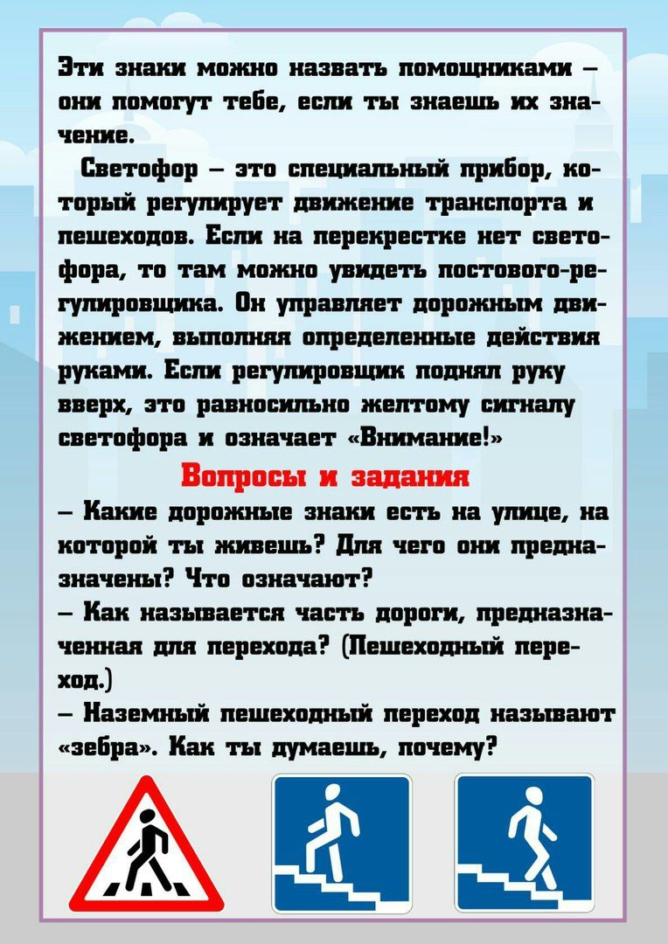](https://ok.ru/dk?cmd=PopLayerPhoto&st.layer.cmd=PopLayerPhotoOuter&st.layer.type=GROUP&st.layer.revNav=off&st.layer.limitedUi=false&st.layer.sphotoIds=838368098204;838368097948;838368097692;838368097436;838368097180;838368103068;838368102812;838368102556;838368102300;838368102044;838368101788;838368105372;838368105116;838368104860;838368104604;838368104348;838368104092;838368103836&st.layer.showNav=on&st.layer.photoAlbumId=51799475749020&st.layer.epm=off&st.layer.photoId=838368097692&st.layer.opl=off&st.layer.navStartPhotoId=838368097692&st.layer.sbd=off&st.cmd=altGroupMain&st.groupId=51799460479132&st.referenceName=doshkolnik&st._aid=GroupTopicLayer_openPhotoLayer)

[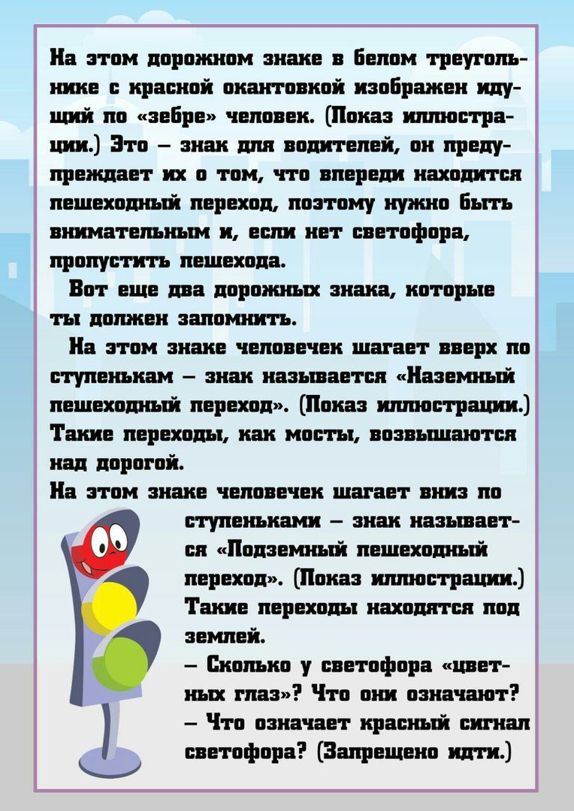](https://ok.ru/dk?cmd=PopLayerPhoto&st.layer.cmd=PopLayerPhotoOuter&st.layer.type=GROUP&st.layer.revNav=off&st.layer.limitedUi=false&st.layer.sphotoIds=838368098204;838368097948;838368097692;838368097436;838368097180;838368103068;838368102812;838368102556;838368102300;838368102044;838368101788;838368105372;838368105116;838368104860;838368104604;838368104348;838368104092;838368103836&st.layer.showNav=on&st.layer.photoAlbumId=51799475749020&st.layer.epm=off&st.layer.photoId=838368097436&st.layer.opl=off&st.layer.navStartPhotoId=838368097436&st.layer.sbd=off&st.cmd=altGroupMain&st.groupId=51799460479132&st.referenceName=doshkolnik&st._aid=GroupTopicLayer_openPhotoLayer)

[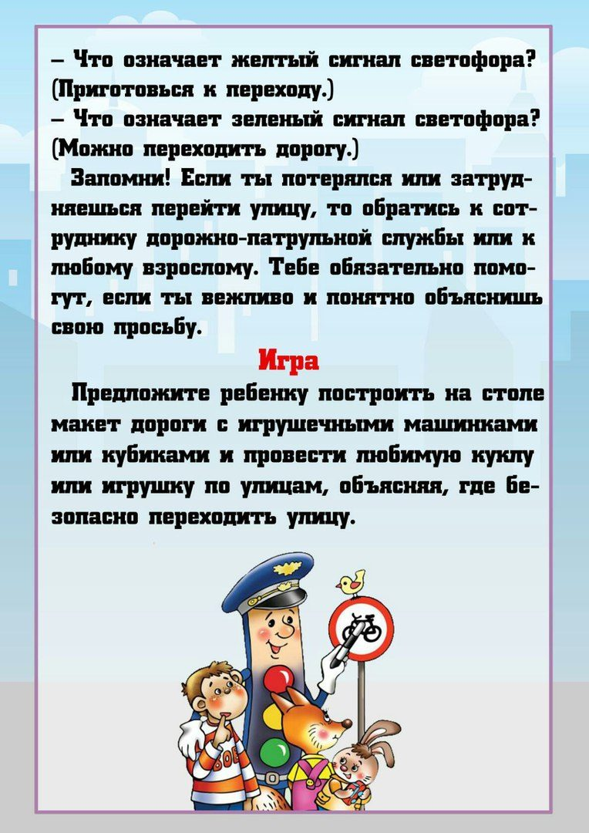](https://ok.ru/dk?cmd=PopLayerPhoto&st.layer.cmd=PopLayerPhotoOuter&st.layer.type=GROUP&st.layer.revNav=off&st.layer.limitedUi=false&st.layer.sphotoIds=838368098204;838368097948;838368097692;838368097436;838368097180;838368103068;838368102812;838368102556;838368102300;838368102044;838368101788;838368105372;838368105116;838368104860;838368104604;838368104348;838368104092;838368103836&st.layer.showNav=on&st.layer.photoAlbumId=51799475749020&st.layer.epm=off&st.layer.photoId=838368097180&st.layer.opl=off&st.layer.navStartPhotoId=838368097180&st.layer.sbd=off&st.cmd=altGroupMain&st.groupId=51799460479132&st.referenceName=doshkolnik&st._aid=GroupTopicLayer_openPhotoLayer)