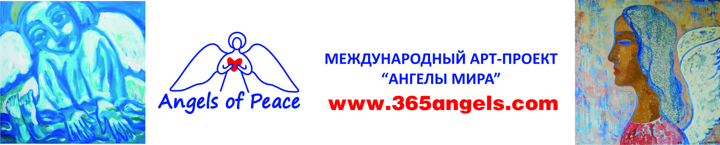

Application
for a painting to be donated

Me, ____________, passport (ID card) number _______ issued by _________ on ________ as the author , donate my painting sized 1 m x 1 m '______' to the international art project of 'Angels of Peace' (ANO Art proekt «Angely Mira») represented by the following organisers:
- Rovda Oleg Vyacheslavovich, passport number 0415 _________ issued by the Krasnoyarsk Department of the Russian Migration Service in Sovetskiy District of Krasnoyarsk on 25.08.2015
- Yatsenko Natalya Valentinovna, passport number 0418 _________ issued by the Russian Home Affairs Department in Sovetskiy district of Krasnoyarsk on 20.06.2018.

I do not mind images of my painting being used in advertisements and messages informing on the activity of the project and in exhibition announcements and in souvenirs and other kinds of materials. I admit having no financial and any other claims towards the organisers.

Signature

Date

