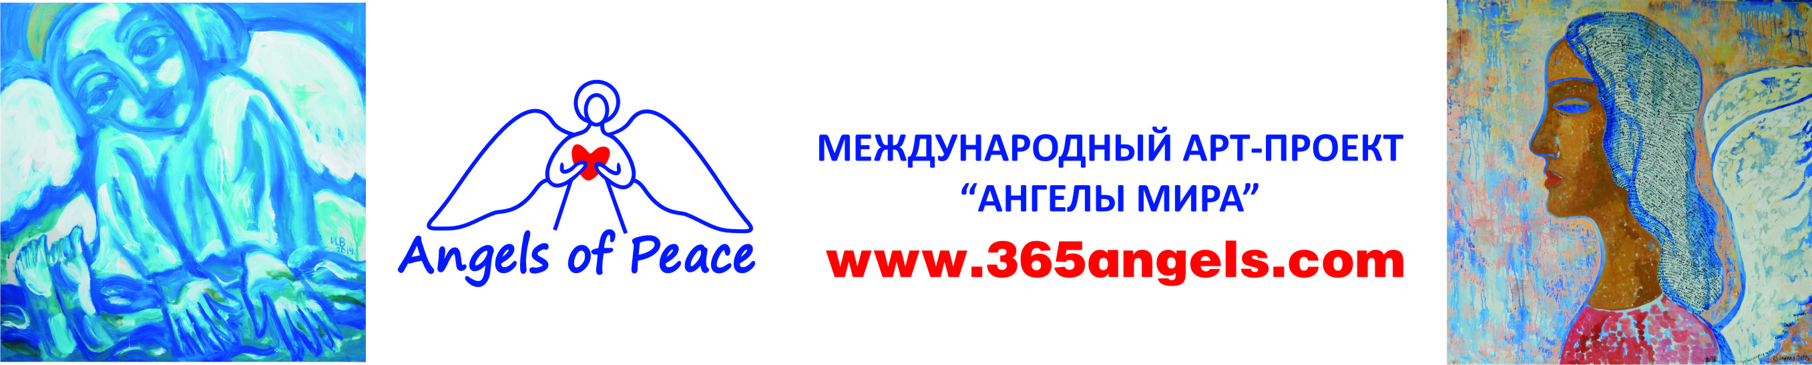
The Head of the International Art Project ‘Angels of Peace’
Nataly Valentinovna Yatsenko

Issue #01/2018
01/01/2018
Official Invitation for Artists
Dear Artists!
We invite painters from various cities and countries to take part in the International Art-Project ‘Angels of Peace’. The project is focused on wide exhibition activity both in Russia and abroad. At the end of the project there will be published a catalogue including all the works and will be created a permanently working museum for the pictures of the project. Collection of paintings completed in 2021.
The main idea of the project is:
A positive, inspiring exhibition, originating from Siberia, but travelling all around the world and constantly enlarging with new works. The name of the project is ‘Angels of Peace’ and it is implemented by like-minded people from all over the world. We decided to unite artists from different countries and continents in order to create an international exhibition containing 365 works (by the number of days in a year). 365 square metres of painting devoted to the image of the Guardian-Angel and higher powers, helping people move forward for the sake of Love, Creation, keeping peace on the Earth and both physical and mental recovery.
The main values of the project are Love, Inspiration, Selflessness, Gratitude and Unity.
There have already been several exhibitions in Moscow, St. Petersburg, Krasnoyarsk, Minsk, the Czech Republic, Croatia, the Republic of Serbian and Spain. The first part of the pictures is in Prague at the moment. The exposition now contains 225 paintings by artists from 20 countries (Russia (from Vladivostok to Moscow), Croatia, Czech Republic, Bulgaria, France, Finland, Canada, Italy, Bosnia and Herzegovina, Macedonia, Belarus, Great Britain, the USA, Ukraine, Slovenia, Spain, Kazakhstan, India, Uzbekistan, Singapore).
Participants of the Project:
In order to explicit the diversity of views on this matter we invite artists from all over the world no matter what style they prefer. The main criterion is understanding of this theme, feeling it and the ability to transfer the warmest, the most constructive humane feelings onto the canvas.
The organizers invite artists themselves and are ready to consider any works of artists who are willing to participate (preview of sketches and works is necessary). The organizers reserve the right to choose and approve the works for the exhibition.
The participant of the project chooses one day in a year (there will be 365 pictures in total) and creates a picture on the theme of the Guardian-Angel. Picture size is supposed to be 1x1 metre (canvas, oil/acrylic). Works are handed over to the project on either a permanent basis.
Picture (in a stretcher, without the frame) are accepted on the address: 660098, Russia, Krasnoyarsk, Aviatorov prospect 62, ‘Angels of Peace’, Oleg Rovda. For more details visit: www.365angels.com.
The project is organised with the support the Russian Artists Association.
We are glad to have your city presented with exciting, impressive works!
_______________________________________________________________________________________________
Contact us:
Nataly Yatsenko (the head of the project) - e-mail: dm@hotpresso.ru , tel. +7-913-837-23-21
Project web-site: www.365angels.com
Pictures Delivery Address: 660098, Krasnoyarsk, Aviatorov prospect 62, Mail and Messenger Service ‘‘Angels of Peace’’, Oleg Rovda. For more details visit: www.365angels.com.

