International social Art Project «Angels of Peace»

- General Terms and Project Objectives
A vivid, positive exhibition travelling around the world and constantly accepting new works, originating from Siberia. The art project ‘Angels of Peace’ is an international art project which is supposed to be implemented for 7 years by like-minded people from all over the world. During this period there will be 365 pictures collected, painted by 365 artists from different cities and countries. All of them will reveal the theme of the Guardian-Angel.
Exhibitions are regularly held at different sites both in Russia and abroad since the very beginning of the project (April, 2014). At the moment the first part of pictures is in the Czech Republic. There will be large exhibitions of the project held and a permanent museum of the project will be open as soon as ‘Angels of Peace’ collect enough works.
This project is non-commercial one. It is realized due to sponsors’ donations and partners of the project as well as souvenir selling.

Key objectives are the creation of a unique art-object and a permanently working museum of this project, cultural exchange and introducing Russian artists and their works to the foreign audience (as the major part of the exposition will consist of Russian artists from different cities), as well as the peace-making mission of art, cooperation with various charity organizations.

The main idea:

We decided to unite artists from different countries and continents in order to create an international exhibition consisting of 365 pictures (according to 365 days a year). 365 square metres of paintings, devoted to the image of the Guardian-Angel and higher powers, helping people move forward for the sake of Creation, Love, keeping Peace on Earth and Recovery both physical and moral. The main values of the project are Love, Inspiration, Selflessness, Gratitude and Unity.

There are a lot of negative events, violence and military conflicts around the world these days. With the help of this project we wish to bring more kindness, spiritual warmth and light, to try to transform the negative energy accumulated on the Earth. And art, paintings do have the Power to do all this!

The project pursues no particular religious aims. Being at the exhibition, a visitor will see all the diversity and polyphony of the images, will feel those warm emotions which the authors intended to reveal.

There are charity events for handicapped children taking place at the project exhibitions (in cooperation with charity organizations and funds). Artists hold master-classes on painting, picture contests devoted to the theme of ‘Angels’, donate picture posters to decorate medical and children institutions, support money-raising for charity funds, award prizes, purchased on the project partners’ and sponsors’ funds.

The origins of the project
In 1997 a young artist Julia Ivanova has fallen ill and found herself between life and death. Even doctors were rather doubtful about her recovery. Then she decided to paint an angel a day as her gratitude for one more day alive, for the chance to see her little son. And she did manage to recover and she keeps on painting Angels for others and for herself. It was her idea to create project ‘Angels of Peace ’. 365 artists as one Creator inspired by the World!

- Order and conditions of Participation

The project accepts pictures sized 1x1 metre in a stretcher, without the frame devoted to the theme of the Guardian-Angel. Canvas, oil/ acrylic. Each artist can give only one work. Works or sketches pre-view is obligatory. The organizers reserve the right to choose and approve the works for the exhibition. Along with a sketch or a photo of the picture an application should also contain the information about the author, his photo, a briefly described idea of the picture and the date one wishes to connect the work to. The list of dates is available at the project web-site (www.365angels.com, section ‘Participation in the Project’).

The main criterion is understanding of this theme, feeling it and the ability to transfer the warmest, the most constructive humane feelings onto the canvas. You can also see pictures of the project participants at our web-site in section ‘Artists of the Project’. An example of the exhibition decoration can be found in Appendix 2.

E-mail for applications and sketches: dm@hotpresso.ru, orovda@yandex.ru.
The pictures approved should be sent/ brought by their authors to the organizers’ office (or to next exhibition address).
The address of the office ‘Angels of Peace’ art-project :
660098, Russia, Krasnoyarsk, Aviatorov Prospekt, 62 ‘Angels of Peace ’, Oleg Rovda (Tel. +7 913 532 54 16)

Works transferring includes signing of the Application on a Picture Permanent Transfer (Donation) to the Project. It is the author of the project who decides on the form in which his work will take part in the project. Application form can be found in Appendix 1. As the project finishes, permanent pictures will make up the permanent exposition of ‘Angels of Peace’ Museum.

- Project Timing
Project Start – April, 2014
Final Christmas exhibitions, catalogue publishing – 25th December, 2020 and 7th January, 2021
Exhibitions in the countries-participants – 2015-2021
Dates can be changed.

Exhibition timing:
http://365angels.com/page/223409 Page - Еxhibition schedule
The earlier the picture enters the project, the more exhibitions it will be displayed at.

- Publishing Set of the Project
The publishing set includes announcements, leaflets, participant badges, diplomas, calendars, postcards, catalogues and souvenirs.
The organizers either send or give in person diplomas and pins (along with the full catalogue of the project) to all the participants of the project ‘Angels of Peace’ as it finishes.
An example of the Diploma can be found in Appendix 3.

- Organisers Contacts
Nataly Yatsenko (the head of the project) - e-mail: dm@hotpresso.ru , tel. +7-913-837-23-21
The ideologist of the project is Julia Ivanova, a Member of the Russian Artists Association. e-mail: 365angels2014@gmail.com, моб. тел. +7-902-918-74-64
PR-director of the project – Oleg Rovda, orovda@yandex.ru , +7 913 532 54 16.
Project web-site: www.365angels.com

Appendix 1

Application
for a painting to be donated

Me, ____________, passport (ID card) number _______ issued by _________ on ________ as the author , donate my painting sized 1 m x 1 m '______' to the international project of 'Angels of Peace' represented by the following organisers:
- Yulia Ivanovna Ivanova, passport number 0410 ________ issued by the Krasnoyarsk Department of the Russian Migration Service in Kirovskiy District of Krasnoyarsk on 28.05.2010
- Rovda Oleg Vyacheslavovich, passport number 0415 ________ issued by the Krasnoyarsk Department of the Russian Migration Service in Sovetskiy District of Krasnoyarsk on 25.08.2015
- Yatsenko Natalya Valentinovna, passport number 0418 _____________ issued by the Russian Home Affairs Department in Sovetskiy district of Krasnoyarsk on 20.06.2018.

I do not mind images of my painting being used in advertisements and messages informing on the activity of the project and in exhibition announcements and in souvenirs and other kinds of materials. I admit having no financial and any other claims towards the organisers.

Signature

Date

CONSENT TO THE PROCESSING OF PERSONAL DATA
International Project «Angels of Peace»
(in accordance with the Federal law of 27.07.2006 N 152-FZ)

"___" _________ __ ,

I _________________________________________________________________________________
_________________________________________________ No._______________________ issued
(type the main ID document)
___________________________________________________________________________________
(authority and date of issue)
resident(s) at the following address:______________________________________________________
acconsents to provide its personal data to ANO Art proekt «Angely Mira» (International Project «Angels of Peace») 660098, Russia, Krasnoyarsk, Aviatorov Prospekt, 62 (hereinafter named as “Personal Data Operator”) and give my consent to processing them freely, by its own will and its own interest under the following conditions:
1. the purpose of the processing of personal data is providing services to participate my painting in all the activities of the International art project "Angels of Peace";
2. The consent is given in relation to the following personal data: surname, name, patronymic, date of birth, identification document data, passport data, sex, marital status, address, contact telephone number, information about employment/study activities;
3. The consent is given for the following operations with personal data: collection, systematization, accumulation, storage, specification (update, change), the extraction, use, transfer (providing, access), depersonalization, blocking, destruction, destruction of personal data;
4. The Consent to the processing of personal data is given for 10 (ten) years;
5. The Consent may be withdrawn by a notification in writing to the Personal Data Operator with the request to terminate the processing of personal data.

________________________________
(Name, Surname, Patronymic name)

Appendix 2
Information about artists.

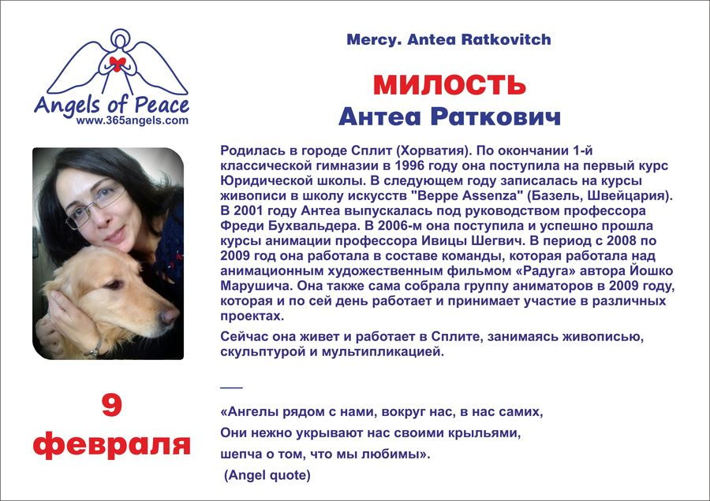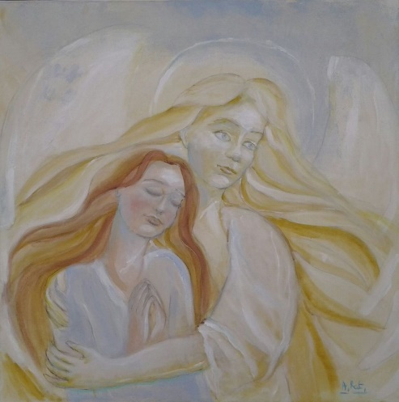
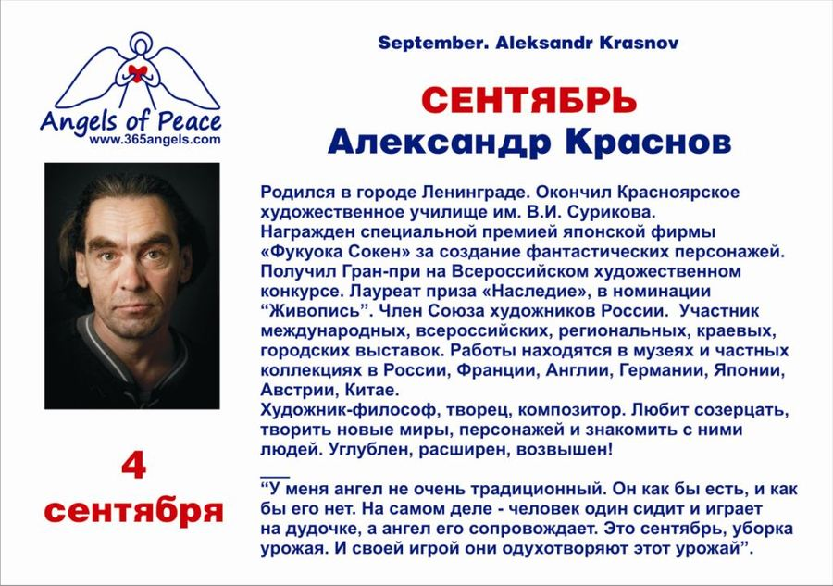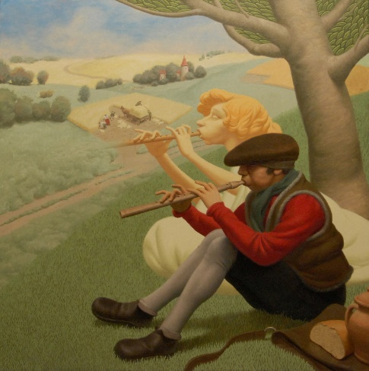
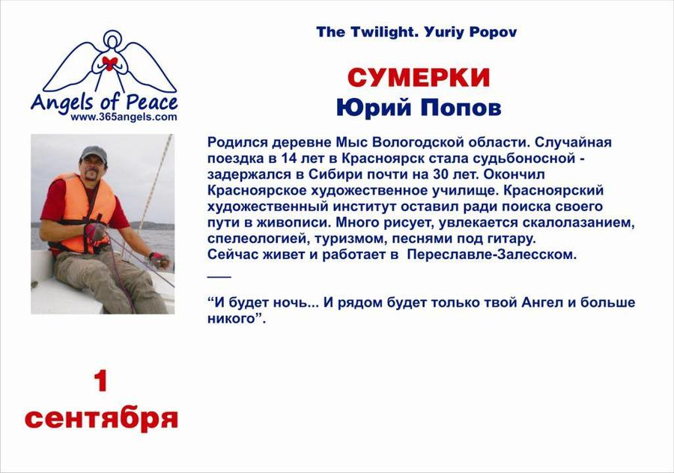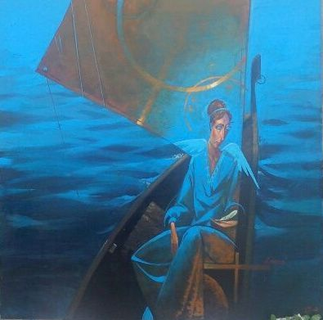

Appendix 3
Diploma of Project
