Mass Spectrometry Report
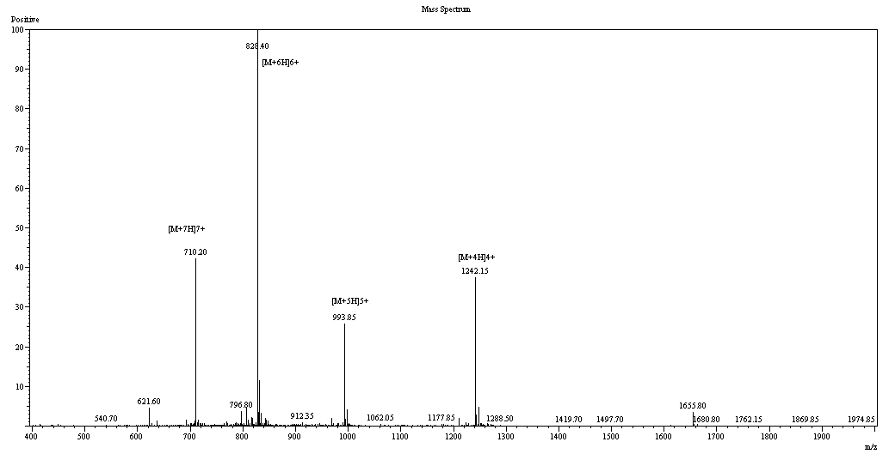
 | Sample Description |  | Instrument | SHIMADZU LCMS-2020
 | Analyzed date: | 2017-6-9 | Probe: | ESI |  | Probe Bias: | ＋4.5kv
 | Analyst: | SHAO | Nebulizer Gas Flow: | 1.5L/min |  | Detector: | 1.5kv
 | Sample: | TB-500 | CDL: | -20.0v |  | T. Flow: | 0.2ml/min
 | M.W.: | 4963.49 | CDL Temp.: | 250 | ºC | B. Conc.: | 50%H2O/50%ACN
 | Lot. No.: | P170310-CQ505880 | Block Temp.: | 200 | ºC

